MINISTRY OF ENERGY
Nairobi
Republic of Kenya

Investment Project Financing Kenya: Off-grid Solar Access Project for Underserved Counties (P160009)

Environmental & Social Impact Assessment, Social Assessment and Vulnerable & Marginalized Groups

KENYA OFF-GRID SOLAR ACCESS PROJECT (KOSAP) FOR UNDERSERVED COUNTIES

Component 1: Mini grids for Community Facilities, Enterprises, and Households

COMPREHENSIVE PROJECT REPORT (CPR) FOR THE PROPOSED ELGOLICHA MINI OFF-GRID SOLAR PROJECT IN MANDERA COUNTY

2023

CERTIFICATION
This Comprehensive Project Report (CPR) has been prepared by ESIA /EA firm of experts, Centric Africa and Norken International. The report has been written with diligence in accordance with the World Bank Operational Procedures OP, Environmental Safeguards Standards (ESS), the EMCA 1999 (Amended, 2015) and the Environmental and Social Impact Assessment and Audit Regulations, 2003 to bring out the true nature of the intended development. The report was prepared based on the information provided by various stakeholders and village elders at Elgolicha in Mandera County as well as from primary and secondary sources. It is therefore issued without any prejudice.
We, the undersigned, certify that the particulars in this CPR are correct and righteous to the best of our knowledge.
PROPONENT:
Name and Address of Firm of Experts:

Signed: ____________________________ Date: _____________________
Isaiah B. Kegora
Lead EIA/EA Expert (NEMA Reg. No 1893)
For: Norken International Ltd & Centric Africa Ltd

Name and Address of the Proponent:
Ministry of Energy,
P.O. Box 30582-00100,
Kawi Complex, Nairobi, Kenya

Signed: ____________________________ Date: _____________________

Rodney I. Sultani
Project Co-ordinator – KOSAP

LIST OF ACRONYMS
CBO | Community Based Organization
CDI | County Development Index
CGRC | County Grievance Redress Committees
CoC | Code of Conduct.
Covid 19, | CoronaVirus Diseases 2019
CPR | Comprehensive Project Report
CPS | Country Partnerships Strategy
CRA | Commission on Revenue Allocation
DOSHS | Directorate of Occupational Safety and Health Services
ECD | Early Childhood Development
EHS | Environmental and Health Standards
EMCA | Environment Management Coordination Act
EPRA | Energy and Petroleum Regulatory Authority
EPT: | Energy and Petroleum Tribunal
ESI | Electricity Supply Industry
ESIA | Environmental and Social Impact Assessment
ESM | Environmental and Social Management
ESMP | Environmental and Social Management Plan
FGD | Focus Group Discussions
GBV | Gender Based Violence
GDC | Geothermal Development Company
HIV/STD | Human Immune Deficiency syndromes/Sexually transmitted diseases
IA | Impact Assessment
KETRACO: | The Kenya Electricity Transmission Company
KII | Key Informant Interview
KOSAP | Kenya Off-Grid Solar Access Project
KPLC | Kenya Power and Lighting Company
LEP | Labour & Employment Plan
LGRC | Locational Grievance Redress Committees
MoE | Ministry of Energy
NEMA | National Environmental management Authority
NGOs | Non-Government organizations
NGRC | National Grievances Redress Committee
NLC | National Lands commission
OP | Operation procedures
OP/BP | Operational Procedures/bank policy
PLWDs | People living with disabilities
REREC | Rural Electrification and Renewable Energy Corporation
SA | Social Assessment
SEA/SH | Sexually Exploitation Activity/Sexual Harassment
TSC | Teachers Service Commission
VMGs | Vulnerable and Marginalized Groups
WB | World Bank

Table of Contents
CERTIFICATION ii
LIST OF ACRONYMS iii
LIST OF TABLES xiii
LIST OF PHOTOS xiv
LIST OF FIGURES xv
EXECUTIVE SUMMARY xvi
CHAPTER ONE 1
1.0 INTRODUCTION 1
1.1 Project Background 1
1.2 KOSAP Objective: 1
1.2.1 Mini grids for Community Facilities, Enterprises, and Households 1
1.3 Project Justification 2
1.4 Institutional and Implementation Arrangements 2
1.5 Environmental and Social Impact Assessment (ESIA) Report 2
1.5.1 Justification for the ESIA 2
1.5.2 Objectives of the Study 3
1.5.3 Scope of the ESIA study 3
1.5.4 Terms of Reference (ToR) for the ESIA Process 4
1.6 ESIA Approach and Methodology 4
1.6.1 Desk study/literature review 5
1.6.2 Environmental, Socio-economic and Cultural Setting/Status 5
1.6.3 Public Consultations 5
1.6.4 Stakeholder Identification and Mapping 6
1.6.5 Approach and Methodology used in Carrying Out the Public Participation 6
1.6.6 Mobilization for the Community Meeting 6
1.6.7 Meeting with Mandera County Key Stakeholders 6
1.6.8 Public Forum/Meeting 7
1.7 Focus Group Discussions 7
1.7.1 Key Informant Interviews 7
1.7.2 Stakeholder Engagement Schedule 7
1.8 ESIA Procedure 9
1.9 Target Group for the ESIA Report 9
1.10 Assumptions 10
1.11 Uncertainties in Compiling Information 10
CHAPTER TWO 11
2.0 PROJECT DESCRIPTION 11
2.1 Introduction 11
2.2 Project Location 12
2.3 Project Site Setting 13
2.5 Description of the Proposed Solar Mini-grid 14
2.5.1 Nature of the Project 14
2.5.2 PV Hybrid Mini-Grid Sizing 14
2.5.3 Architecture and Basic Design Specifications 15
2.5.4 The PV Generator 17
2.5.5 Powerhouse 18
2.5.6 Multi-mode Inverter 18
2.5.7 Battery 18
2.5.8 Diesel Genset 19
2.5.9 Substation 20
2.5.10 Distribution Line and Energy Meters 20
2.6 Land Tenure 20
2.7 Compensation Details 20
2.8 Site Ownership 20
2.9 Access to the Site 20
2.10 Fencing and Security 20
2.11 Fire Safety 21
2.12 Vegetation Undergrowth 21
2.13 Project Activities 21
2.14 Construction Procedures 21
2.14.1 Construction Activities Outline 21
2.15 Mini-grid Components 23
2.16 Operation Phase Activities 23
2.16.1 Construction Contractor 23
2.16.2 Operation and Maintenance (O&M) Contractor 23
2.17 Project’s Decommissioning Activities 24
2.18 Construction Materials, Equipment and services 24
2.18.1 Input Materials and Equipment & Machinery 25
2.18.2 Use of Services and Resources 25
2.19 Products, By-Products and Waste 26
2.19.1 Construction Phase 26
2.19.2 Operation Phase 27
2.19.3 Decommissioning Phase 28
2.20 Safety of the Facility 28
2.21 Natural Disasters 28
2.21.1 Malicious Damage or Theft 29
2.22 Hazard Risk Assessment 29
CHAPTER THREE 30
3.0 ANALYSIS OF PROJECT ALTERNATIVES 30
3.1 Consideration of Project Alternatives 30
3.2 Relocation Option 30
3.3 Zero or No Project Alternative 30
3.4 Alternative Sources of Energy 31
3.4.1 Thermal Power Generation 31
3.4.2 Hydro Electric Power – HEP 31
3.4.3 Other Sources of Energy 31
3.5 Analysis of Alternative Construction Materials and Technology 32
3.6 Solid Waste Management Alternatives 32
3.7 Alternative Solar Mini-grid Site 32
CHAPTER FOUR 34
4.0 BASELINE SETTINGS- ENVIRONMENT, ECOLOGY AND SOCIAL 34
4.1 INTRODUCTION 34
4.2 Environment Baseline 34
4.2.1 Project Location 34
4.2.2 Geology and Soil 35
4.2.3 Topography 35
4.2.4 Hydrogeology and Drainage 35
4.2.5 Ground Water Development 35
4.2.6 Ecological Conditions 36
4.2.7 Climatic Conditions 36
4.3 Socio-Economic Environment 36
4.3.1 Community Profile 36
4.3.2 Socio-Economic Status of Study Area 37
CHAPTER FIVE 40
5.0 RELEVANT LEGISLATIVE AND REGULATORY FRAMEWORKS 40
5.1 Introduction 40
5.2 Environmental Policy Framework 40
5.3 Institutional, Regulatory and Legal Framework 40
5.3.1 National Environment Management Authority (NEMA) 41
5.3.2 County Environment Committees 41
5.3.3 National Environmental Complaints Committee 41
5.3.4 National Environment Action Plan Committee 41
5.3.5 National Environment Tribunal 42
5.3.6 National Environment Council (NEC) 42
5.4 Relevant Statutes 42
5.5 World Bank Environment and Social Safeguards Policies 56
5.6 Environmental and Social Management Framework (ESMF) for KOSAP 59
5.7 Resettlement Policy Framework (RPF) for KOSAP 59
5.8 Vulnerable and marginalized Groups Framework (VMGF) for KOSAP 60
5.9 Comparison between the World Bank and Kenyan Laws to this Project 60
CHAPTER SIX 63
6.0 STAKEHOLDER ENGAGEMENT 63
6.1 Introduction 63
6.2 Legal requirement for Stakeholder Engagement 63
6.3 Objectives of Public Participation 63
6.4 Stakeholders Identification and Consultation 64
6.5 Summary of Community Consultation Meeting Leading to Land Identification and GRC Constitution- (screening level) 65
6.5.1 Land for the Project 66
6.5.2 key feedback received during stakeholder consultation process 66
6.5.3 Area Chief’s Remarks 66
6.5.4 Consultant’s Remarks 67
6.5.5 Positive Comments about the Project from the Participants 67
6.5.6 The Potential Projects negative impacts 67
6.5.8 Consultant’s Response 68
6.5.9 Consent 69
6.6 Community Presentation 69
6.6.1 Adult to youth Representation 69
6.6.2 Gender Representation 69
6.6.3 Heads of Households 69
6.7 Focused Group Discussions Analysis 69
6.7.1 Female Stakeholders’ Consultation and Participation 70
6.7.2 Male Stakeholders’ Consultation and Participation 73
6.7.3 Youth Stakeholders’ Consultation and Participation 75
6.7.4 Vulnerable and Marginalized Group (VMG) 76
6.7.5 Education Stakeholders’ Consultation and Participation (KI) 78
6.7.6 Health Stakeholders’ Consultation and Participation 78
6.8 Disclosure of ESIA to the Stakeholders 79
6.9 Stakeholder Engagement and Grievance Management Post ESIA 79
6.10 Objectives and Principles of Stakeholder Engagement 80
CHAPTER SEVEN 80
7.0 IMPACT ASSESSMENT AND MITIGATION MEASURES 80
7.1 Introduction 80
7.2 Impact Assessment Methodology 81
7.3 Defining Impact 81
7.4 Assessment of Significance 81
7.5 Magnitude of Impact 83
7.6 Sensitivity of Resources and Receptors 84
7.7 Likelihood 84
7.8 Definition of Mitigation Measures 84
7.9 Assessing Residual Impacts 85
7.10 Positive Impacts During Construction Phase 85
7.10.1 Creation of Employment Opportunities 85
7.10.2 Improving local economy Provision of Market for Supply of Building Materials 86
7.10.3 Boosting of Businesses 86
7.11 Positive Impacts during Operation Phase 86
7.11.1 Quality, Reliable Power Supply 86
7.11.2 Employment Creation 87
7.11.3 Reduction of Pollution Associated with Thermal Power Generation, Kerosene and Wood Fuel Usage: 87
7.11.4 Improvement of Local and National Economy 87
7.11.5 Education 88
7.11.6 Health Benefits of the Project 88
7.11.7 Improved Standard of Living 88
7.11.8 Security 88
7.11.9 Communications 88
7.12 Positive Impacts during Decommissioning Phase 89
7.12.1 Employment Opportunities 89
7.12.2 Site Rehabilitation 89
7.13 Negative Impacts during Pre-construction Phase 89
7.13.1 Land Take 89
7.13.2 Wayleaves 89
7.14 Negative Impacts During Construction Phase 90
7.14.1 Vegetation Clearance 90
7.14.2 Soil Erosion Impact 90
7.14.3 Contamination of Soil from Fossil Fuels 91
7.14.4 Dust Emissions 91
7.14.5 Vehicle Exhaust Emissions 92
7.14.6 Pollution from Solid Waste Generation 92
7.14.7 Impacts on Water Resources and Water Quality 93
7.14.8 Noise and vibration 93
7.14.9 Impacts from Hazardous Materials 94
7.14.10 Accidental Oil Spills or Leaks 95
7.14.11 Fire Hazards 95
7.14.12 Impacts of construction material sourcing (e.g., quarrying) 96
7.14.13 Increased Water Demand 96
7.14.14 Energy Consumption 96
7.14.15 Occupational Health and Safety Impacts 97
7.14.16 Community Safety -Access to Site by General Public 97
7.14.17 Spread of HIV/AIDS and STIs 98
7.14.18 Increase in competition for scarce resources and strain on public utilities 98
7.14.19 Labour Influx and Related Impacts 99
7.14.20 Child Labour 99
7.14.21 Gender Based Violence- SEA and SH 100
7.14.22 Public Health Impacts 101
7.14.23 Public Health Impacts Sanitary Waste 102
7.14.24 Forced Labour 102
7.14.25 Risks related to Inadequate Stakeholder Engagement 102
7.15 Negative impacts during Operation phase of the project 103
7.15.1 Solid Waste Generation 103
7.15.2 Liquid Waste/Oils Generation 103
7.15.3 Increased oil Consumption 104
7.15.4 Increased Storm Water Flow 104
7.15.5 Fire Outbreaks 104
7.15.6 Visual Impacts 105
7.15.7 Water Demand 105
7.15.8 Sanitary Waste 105
7.15.9 Flooding 106
7.15.10 Workers Occupation Health and Safety 106
7.15.11 Hazardous Waste 106
7.15.12 Noise and Vibration 107
7.15.13 Electric and Magnetic Fields (EMFs) 107
7.15.14 Shocks and Electrocutions to the Beneficiaries 107
7.15.15 Community safety -Access to the Facility by General Public 107
7.15.16 Risks Related to Poor or Inadequate Stakeholder Engagement (Conflict) 108
7.15.17 Gender Based Violence- SEA/ SH 108
7.15.18 Public Health Impacts –HIV/AIDs 109
7.15.19 Public health Impacts -Covid 19 Disease 109
7.15.20 Dust Emissions 110
7.15.21 Vehicle Exhaust Emissions 110
7.16 Negative Impacts During Decommissioning Phase 110
7.16.1 Noise and Vibration 110
7.16.2 Solid Waste Generation 111
7.16.3 Dust Emissions 111
7.16.4 HIV/AIDs Awareness and Prevention 112
7.16.5 Social Protection 112
7.16.6 Social Inclusion 112
CHAPTER EIGHT 113
8.0 ENVIRONMENTAL AND SOCIAL MANAGEMENT PLAN (ESMP) 113
8.1 Introduction 113
8.2 Monitoring 114
8.2.1 Plan Monitoring 114
8.3 Environmental and Social Monitoring by Contractors 115
8.4 Approach to Environmental Impact Management 148
8.5 Management Plan during Construction Phase 148
8.5.1 Construction Management Plan 148
8.5.2 Control of Access 149
8.5.3 Rehabilitation and Site Closure Plan 149
8.5.4 Local Recruitment Plan 150
8.5.5 Workplace Health and Safety Plan 150
8.5.6 Community Health and Safety Plan 150
8.5.7 Emergency Preparedness Plan 151
8.5.8 SEA/SH Prevention and Response Action Plan 151
8.5.9 Stakeholder Engagement Management Plan 151
8.6 Grievance Redress Mechanism 152
8.6.1 Grievance Redress Principles 152
8.6.2 Grievance Redress Committee Capacity Building 152
8.6.3 Grievance Procedures 153
8.6.4 Grievance Log 153
8.6.5 National Grievances Redress Committee (NGRC) 154
8.6.6 County Grievance Redress Committees (CGRC) 154
8.6.7 Locational Grievance Redress Committee (LGRC) 155
8.6.8 Existence of a Local Grievance Redress Mechanism in Elgolicha 157
8.7 World Bank Grievances Redress Mechanism 158
8.7.1 World Bank Grievances Redress Service 158
8.7.2 World Bank Inspection Panel 158
8.8 Government Management of Land Acquisition Disputes 159
8.9 Labour Influx Management Plan 159
8.10 Rehabilitation and Decommissioning Management Plan 159
8.10.1 Planning for Closure 160
8.10.2 Decommissioning 160
8.10.3 Post Closure 160
8.11 Institutional Implementation Arrangements for the Proposed Project 160
8.11.1 Proponent -Ministry of Energy and Petroleum (MoEP) 160
8.11.2 KOSAP Project Implementation Unit 160
8.11.3 The Implementing Agency (KPLC) 160
8.11.4 County Government of Mandera 161
8.11.5 National Environmental Management Authority 161
8.11.6 Roles and Responsibilities of the Supervising Consultant 161
8.11.7 Roles and Responsibilities of the Contractor 161
8.12 Management of Impacts during Operation Phase 163
CHAPTER NINE 164
9.0 IMPACT SUMMARY AND CONCLUSION 164
9.1 Conclusion 164
9.2 Recommendations 165
9.3 Recommendations 166
9.4 Authorization Opinion 166
APPENDICES 167
Appendix 1:ESIA Stakeholder meeting minutes 169
Appendix 2:ESIA Stakeholder meeting attendance List 174
Appendix 3: Land allocation meeting minutes 187
Appendix 4: NEMA ESIA Expert License 201
Appendix 5: Abbreviated Resettlement Action Plan(A-RAP) 203

LIST OF TABLES

Table 1:Summary of Pre-Construction Impacts xx
Table 2: Summary of Construction and Decommissioning Phases Impacts xx
Table 3: Summary of Operation Phase Impacts xxi
Table 4: Component of the proposed Solar Mini-Grid 11
Table 5:Inputs and Equipment required for construction 23
Table 6:Demographic profile of Elgolicha 36
Table 7:National Laws and policies 42
Table 8: Comparison between the WB safeguard policies and the Kenya legislation 60
Table 9: The consultative meeting representation 69
Table 10: Categories of significance 81
Table 11: Overall significance criteria for Environmental Impacts 82
Table 12: Explanation of Terms used for likelihood of Occurrence 83
Table 13: Environmental and Social Management Plan(ESMP) 116

LIST OF PHOTOS
Plate 1: Elgolicha community participating in the ESIA consultation exercise 66
Plate 2: KPLC representative addressing the baraza 68
Plate 3: Female FDG at Elgolicha 69
Plate 4: Youth FDG at Elgolicha 75

LIST OF FIGURES
Figure 1: Summary of ESIA procedure 9
Figure 2: Proposed site for the Elgolicha Solar Minigrid 12
Figure 3: Map showing the KOSAP counties Lot 3 14
Figure 4: Illustration sketch of the proposed design of the proposed project 16
Figure 5: KOSAP Grievance Redress Mechanism 154

EXECUTIVE SUMMARY
- Introduction and Project Brief
The Ministry of Energy (MOE) hereinafter refer to as proponent is implementing the Kenya Off-Grid Solar Access Project (KOSAP) in 14 underserved counties in Kenya. The aim of the project is to provide clean and modern energy services through off-grid solar solutions. The Proponent is coordinating the implementation of the project through the implementing agencies; Kenya Power (KP) and the Rural Electrification and Renewable Emergency Corporation (REREC). The project is funded by the World Bank Group with $150 million and a $5million grant from the Carbon Initiative for Development. The goal of the project is to bring electricity to around 250,000 households, 476 community facilities, and 380 boreholes in the target counties, benefiting low-income groups. It also includes the sale and installation of 150,000 efficient cook stoves. The project focuses on marginalized areas based on the County Development Index (CDI) and aims to address infrastructure deficits, lack of access to roads, electricity, water, and social services in these underserved counties. To ensure sustainability, the project relies on public funding, local community participation, and the institutional capacity of KP, REREC, and the MOE.
The KOSAP consists of four main components. The first component focuses on the implementation of mini-grids to provide electricity to community facilities, enterprises, and households in areas where mini-grids are the most cost-effective option. The second component aims to electrify households through standalone solar systems in areas without load clusters where standalone systems are the best technical and financial solution. The third component supports the electrification of public institutions and community facilities using standalone solar systems. It also includes the installation of solar PV-powered water pumps for consumptive purposes. Lastly, the fourth component, provides funding for implementation support, technical assistance, and capacity building activities to ensure the sustainability and impact assessment of the interventions carried out under the other components of KOSAP.
In Mandera County, one of the target counties, the Proponent is proposing to develop 27 No. mini grid facilities including Elgolicha Mini Grid discussed in this report. In order to adhere to both national and donor requirements, the Proponent engaged the services to the consortium of Norken International Limited and Centric Africa Limited to undertake the ESIA. The ESIA has been conducted following the requirements outlined in the Environmental Management and Coordination Act (EMCA) 1999 and its amendments, as well as international environmental and social policies such as the World Bank's OP 4.01 on environmental assessment.

- Project Categorization and Justification
In the World Bank context, there have been several projects supported by the organization that aim to provide electricity to communities located far from the national grid. These projects utilize off-grid approaches, meaning they are independent of a national or regional grid. The experience gained from these projects provides valuable guidance for designing sustainable off-grid electrification initiatives, particularly those targeting dispersed and economically disadvantaged communities. The Elgolicha proposed site aligns with this category of projects that the World Bank has been involved in.
In the Kenyan context, the Environmental Management and Coordination Act (EMCA) of 1999, as amended in April 2019 through Legal Notice No. 31, classifies solar power farms and plants as medium risk projects. This categorization provides a framework for assessing and managing the potential environmental and social impacts associated with such projects. By categorizing the Elgolicha site as a solar power facility, it falls within the medium risk project category as per the Kenyan legislative framework.

- Approach and Methodology
The Environmental and Social Impact Assessment (ESIA) for the proposed project followed a structured process, beginning with kick-off meetings and online discussions involving the Proponent, Implementing agencies, and the World Bank Environmental and Social Safeguard Team. These consultations were instrumental in establishing the project's scope, deliverables, timeline, and methodology. Subsequently, screening and scoping exercises were conducted to evaluate potential social and environmental risks. A thorough desk-based review was also undertaken to assess existing project documentation, legal requirements, and relevant plans.
The study employed a comprehensive approach to gather primary and secondary data for the project. Both qualitative and quantitative methods were utilized, with secondary data obtained through literature reviews. Primary data collection involved various techniques, including physical observations, photography, interviews, and stakeholder consultations. This comprehensive approach enabled a comprehensive examination of the project's environmental and social aspects, ensuring a holistic understanding of its potential impacts.
The study further involved the identification and assessment of potential impacts throughout the project's life cycle. Key areas of evaluation included land use, water resources, biodiversity, air quality, noise levels, community health and safety, and socio-economic conditions. To mitigate adverse effects, the study developed environmental and social management and monitoring plan, aiming to address both positive and negative impacts that may arise from the project. These measures aimed to ensure the project's sustainability and enhance its overall environmental and social performance.

- Legislative Regulatory Framework
The evaluation, planning, and implementation of the proposed project is guided by the World Bank's Environmental and Social Framework, the national legislative framework, and the project's safeguard instruments. These measures aim to ensure environmental sustainability, protect the rights and needs of indigenous peoples and marginalized groups, and minimize adverse impacts through effective management and mitigation measures.
The Government of Kenya established the Environmental Management and Coordination Act (EMCA) in 1999, providing a legal framework for environmental management. EMCA takes precedence over other sectoral laws related to the environment. In 2013, the government formulated a national Environmental Policy with the goal of promoting sustainable management and use of the environment.
Collaboration and consultation among government agencies and stakeholders are essential for coordinating environmental management effectively. Key institutions in Kenya responsible for environmental issues include the National Environment Management Authority (NEMA), County Environment Committees, National Environmental Complaints Committee, National Environment Action Plan Committee, Standards and Enforcement Review Committee, National Environment Tribunal, and National Environment Council (NEC).
The project also adheres to the World Bank Safeguard Policies, which aim to improve decision-making processes, promote sustainable project options, and involve affected people in consultations. The applicable operational policies for this project include Environment Assessment, Natural Habitats, Indigenous Peoples, and Involuntary Resettlement. The Environmental and Social Impact Assessment (ESIA) considers these policies and addresses potential environmental and social concerns.
Additionally, the ESIA references other Safeguard Instruments prepared under the Kenya Off-Grid Solar Access Project (KOSAP), including the Environmental and Social Management Framework (ESMF), Resettlement Policy Framework (RPF), and Vulnerable and Marginalized Groups Framework (VMGF). These instruments provide procedures and guidelines for assessing and managing environmental and social aspects specific to the proposed subprojects under KOSAP.

- Environmental Setting
The project area is in Elgolicha village, Mandera South Subcounty, Mandera County, and exhibits a semi-arid climate with irregular rainfall patterns and scarce natural resources. Water scarcity poses a significant challenge, affecting both the local population and livestock. The vegetation predominantly comprises drought-tolerant shrubs, thorny bushes, and arid-adapted grasses. Overgrazing and deforestation have resulted in land degradation and soil erosion, further exacerbating the environmental issues. Agricultural practices face hurdles due to limited fertile soils and inadequate irrigation infrastructure. The region is also prone to natural hazards like flash floods and sandstorms.
The topography of the project area is diverse, featuring vast plains, scattered low-lying hills, and occasional rocky outcrops towards Kenya-Ethiopia border. It is part of a semi-arid landscape with undulating terrain. The flat plains offer space for livestock grazing, while the hills provide some relief and shelter. However, the irregular topography poses challenges to agriculture and water management, influencing water runoff and drainage patterns. Overall, the project site is relatively flat.
The area is characterized by high levels of poverty, unemployment, and limited access to essential services such as education and healthcare. Livestock herding and small-scale enterprises are the primary economic activities, but opportunities for economic growth are constrained. Gender disparities persist, with women having limited decision-making power and economic empowerment. Infrastructure development, including roads, electricity, and water supply, is insufficient to meet the needs of the community.

- Project Description
The Elgolicha Mini Grid project aims to provide electricity to approximately 160 residential users in Elgolicha Village at Elgolicha Sub-location, Elgolicha Location, Elwak North Ward in Mandera County.
The project consists of two main components: Hybrid Mini-Grids and power line reticulation lines. The Hybrid Mini-Grids will combine solar panels and diesel power generation. These energy sources will be integrated through a centralized photovoltaic plant connected to a 3-phase AC busbar line. The configuration is designed to prioritize direct supply from the solar generator during daylight hours, reducing reliance on battery storage. The battery storage will primarily be used when solar generation is low or demand is high. The construction of power line reticulation lines will ensure the efficient distribution of electricity to residential, commercial, and other consumers, ensuring a reliable and efficient power supply.
The project will utilize solar photovoltaic panels, a Battery Energy Storage System, and a Diesel Generator to generate electricity. A Low Voltage Power Distribution Network will be established to distribute the power to customers. The project utilizes solar panels with a total capacity of 47 kWp to harness solar energy. Solar power is a clean and renewable energy source that will provide a significant portion of the electricity needed for the project. A 152 kWh Battery Energy Storage System is incorporated to store excess solar energy during the day, ensuring a consistent power supply even during cloudy or nighttime conditions. A 50 kVA diesel generator is included to serve as a backup power source for periods of low solar generation or in case of battery depletion. It provides reliability and backup in the event of extended periods of cloudy weather or high demand. A 2,000-liter fuel tank is provided to store diesel fuel for the generator, ensuring continuous operation during extended periods of low solar or high demand. Additionally, PV Inverter: A 39 kW solar PV inverter is used to convert the direct current (DC) electricity generated by the solar panels into alternating current (AC) electricity suitable for consumer use. A 7-kilometer low voltage power distribution network will be established to efficiently transmit electricity to the residential and nonresidential consumers. This network ensures a stable and reliable power supply while minimizing energy losses. The estimated cost of the project is around USD 375,641 although this amount may change as more detailed plans are developed.
To develop the Mini Grid, approximately 2.3768 hectares of land will be compulsorily acquired by NLC. This land is part of the community's designated public purposes area. The Proponent engaged with the community during the land acquisition process, and there were no objections to transferring 2.3768 hectares of land to Kenya Power and Lighting Company (KPLC) for the management of the solar mini grid. In accordance with the World Bank's Operation Procedure 4.12 on Involuntary Resettlement, an abbreviated Resettlement Action Plan (A-RAP) was prepared, outlining the principles and procedures for land acquisition and compensation. This plan is annexed to the project report.

- Project Alternatives
Solar energy is identified as a non-polluting and site-specific option, and the proposed site for Elgolicha MG is chosen as the most suitable location for the mini grid based on factors such as sunlight availability and the community's lack of grid connectivity. The use of wind power, thermal power, fossil fuels, and power import from neighbouring countries are considered as alternative methods of power generation but are found to have limitations or environmental concerns. Solar energy is favoured due to its low production costs, versatility, clean nature, and economic savings. The "No Project" alternative is deemed unfavourable as it would maintain the current lack of electricity access and hinder socio-economic development. The project will be constructed using modern materials and technology, with a focus on public health, safety, security, and environmental requirements. The technology will involve a Battery Energy Storage System.

- Stakeholder Engagement
It is important to highlight that two sets of stakeholder engagement were carried out for the project. The first form as noted earlier, focused on the acquisition of land for the project and involved the Proponent and the implementing agency (KP). The second form of engagement was conducted specifically for the Environmental and Social Impact Assessment (ESIA) study.
For the ESIA study, various methods were employed to engage stakeholders, taking into consideration their different categories. Face-to-face discussions were held with government officials and key stakeholders, while separate focused group discussions were conducted with men, women, and youth. Additionally, a public baraza or meeting was organized to allow community members to participate.
During the Screening stakeholder engagement public meeting, which took place on February 27th, 2020, the meeting provided an opportunity to discuss project details including land identification. The ESIA stakeholders meeting took place on 28th November 2021, where the project aspects were discussed in depth, including the preliminary design, positive and negative impacts, and mitigation measures. Stakeholders were encouraged to share their views and provide feedback on the project.
Some of the concerns raised by stakeholders included the possibility of accidents from electrocution especially the children, cost of connections, liability from electrical damage to property as well as possible accidents from falling of the electric poles. The study team addressed these concerns by assuring stakeholders that a chain-link fence supported by concrete poles would be constructed and awareness raising will be done for electricity safe use. Besides, the community were urged to use competent electricians for their households cabling for safety.

- – Impacts and Mitigation Measures
The Environmental and Social Impact Assessment (ESIA) for the proposed Solar Mini-grid project has identified both positive and negative impacts across its different phases: pre-construction, construction, operation, and decommissioning. In the construction phase, positive impacts include local employment opportunities, boosting local businesses, and sourcing materials locally. During the operation phase, positive impacts encompass reliable power supply, economic improvement, education, health benefits, improved living standards, and enhanced security and communication. Similarly, the decommissioning phase offers positive impacts such as local employment and sourcing.
On the negative side, the pre-construction phase involves minor impacts like land acquisition, while the construction phase encompasses various minor to moderate impacts such as vegetation clearance, soil erosion, dust emissions, and occupational health and safety concerns. Challenges related to stakeholder engagement, labour influx, child labour, and exclusion of vulnerable individuals are also anticipated. In the operation phase, negative impacts include waste generation, increased oil consumption, fire outbreaks, occupational health and safety concerns, and inadequate stakeholder engagement. Issues of exclusion, inadequate grievance management, and public health concerns may arise as well.
During the decommissioning phase, negative impacts primarily relate to solid waste generation, noise and vibration, and challenges in stakeholder engagement, labour influx, child labour, gender-based violence, and exclusion of vulnerable individuals and households.
Tables 1 to 3 below present summaries of anticipated impacts and their corresponding levels of significance, both pre- and post-mitigation.

Table 1: Summary of Pre-Construction Impacts
Impact | Significance Of Impact (Pre-Mitigation) | Residual Impacts (Post-Mitigation)
Land acquisition | Minor | Negligible
Way leaves | Minor | Negligible
Stakeholder identification and consultations | Major | Minor

Table 2: Summary of Construction and Decommissioning Phases Impacts
Impact | Pre-construction | Construction phase | Decommissioning phase
Impacts on Local Economy and Employment | Not Applicable | Positive | Positive
Change in land use | Not Applicable | Moderate | Positive
Site rehabilitation | Not Applicable | Not Applicable | Positive
Topography | Not Applicable | Minor | Not Applicable
Soil environment | Not Applicable | Minor | Minor
Air Quality | Not Applicable | Moderate | Moderate
Ambient noise | Not Applicable | Minor | Minor
Visual intrusion and change in landscape | Not Applicable | Minor | Positive
Waste generation and soil contamination | Not Applicable | Minor | Minor
Impact on water environment | Not Applicable | Minor | Not Applicable
Impacts from hazardous materials | Not Applicable | Minor | Not Applicable
Fire hazards | Not Applicable | Moderate | Minor
Impacts of construction material sourcing | Not Applicable | Moderate | Not Applicable
Energy consumption | Not Applicable | Negligible | Not Applicable
Occupational safety and health | Not Applicable | Moderate | Moderate
Community safety and health | Not Applicable | Moderate | Moderate
Labour influx | Not Applicable | Minor | Minor
Child labour | Not Applicable | Minor | Negligible
Cultural heritage | Not Applicable | Minor | Not Applicable
Gender based violence, SEA and SH | Not Applicable | Minor | Minor
Exclusion of VMGs, Vulnerable individuals and households | Not Applicable | Major | Major
Risk of communicable diseases | Not Applicable | Minor | Minor
Increased water demand |  | Negligible | Negligible
Forced labour |  | Minor | Negligible

Table 3: Summary of Operation Phase Impacts
Impact | Significance Of Impact (Pre-Mitigation) | Residual Impacts (Post-Mitigation)
Impact On Economy and Employment | Positive | Positive
Quality, reliable power supply | Positive | Positive
Reduction of pollution associated with thermal power generation, kerosine and wood fuel usage | Positive | Positive
Education | Positive | Positive
Health benefits | Positive | Positive
Improved standard of living | Positive | Positive
Security | Positive | Positive
Communication | Positive | Positive
Soil environment | Minor | Negligible
Waste generation and management | Minor | Negligible
Water environment | Negligible | Negligible
Landscape and visual impacts | Minor | Negligible
Increased oil consumption | Minor | Negligible
Increased storm water flow | Minor | Negligible
Fire outbreaks | Moderate | Minor
Water demand | Negligible | Negligible
Sanitary waste | Negligible | Negligible
Flooding | Negligible | Negligible
Noise and Vibration | Negligible | Negligible
Electric and magnetic fields (EMFs) | Negligible | Negligible
Dust Emission | Negligible | Negligible
Vehicle Exhaust emission | Minor | Negligible
Collision and electrical hazards from distribution infrastructure | Minor | Negligible
Occupational safety and health | Moderate | Minor
Community safety and health | Moderate | Minor
Gender based violence, SEA and SH | Minor | Negligible
Exclusion of VMGs, Vulnerable individuals and households | Major | Minor
Risk of communicable diseases | Minor | Negligible
Shocks and electrocution to the Project-Affected Persons (PAPs) | Moderate | Minor
Risks related to poor and inadequate stakeholder engagement (conflict) | Minor | Negligible

- Environmental and Social Management and Monitoring Plan
A comprehensive set of mitigation measures in the form of an Environmental and Social Management and Monitoring Plan (ESMMP) have been prepared for the project. The ESMMP serves as a comprehensive framework for the integrated management of all environmental and social impacts throughout the project's lifecycle. It has been prepared to ensure that the social and environmental impacts and risks identified during the Environmental and Social Impact Assessment (ESIA) process are appropriately managed during the construction, operations, and decommissioning phases of the project. It specifies the mitigation and management measures that the project proponent and contractor are committed to implementing and outlines how organizational capacity and resources will be mobilized to achieve these measures. The ESMMP also ensures compliance with the relevant laws, regulations within Kenya, as well as the environmental and social sustainability requirements of the World Bank's Operational Policies (OPs).
These measures emphasize a proactive approach, prioritizing prevention rather than reaction. They encompass various aspects such as proper waste handling and disposal to prevent pollution, engaging stakeholders to address grievances, providing personal protective equipment (PPE) for workers, ensuring adequate supervision, and emphasizing good workmanship from the contractor. Specific plans are also outlined to address specific issues that may arise. The ESMMP also highlights environmental performance indicators that should be regularly monitored. Monitoring serves as a means to detect and draw attention to any changes or problems in environmental quality. It involves continuous or periodic reviews of the ESMMP implementation progress, allowing for adjustments and improvements as necessary.
While accommodating the recommended mitigation measures to the extent practical and economically viable, the project proponent and contractor should ensure that the measures do not compromise the economic viability of the project or have long-lasting adverse impacts on the environment.
For the mitigation measures to be successful, it is imperative that the Kenya Power and Lighting Company (KPLC) allocates sufficient resources for the implementation of the ESMMP. Adequate resources will enable the proper execution of the proposed measures and ensure their effectiveness in minimizing the identified negative impacts.
Following the project's commissioning, it is mandatory to conduct statutory Environmental and Safety Audits in accordance with national legal requirements. These audits serve to evaluate the environmental performance of the site operations and assess their compliance with the recommended mitigation measures.
- Conclusion
Based on the assessment findings, the consultant concludes that there are no substantial reasons to hinder the proposed project from progressing to the next stage of planning and development. However, this progression is conditional upon the implementation of the recommended mitigations and the monitoring of potential environmental and socio-economic impacts as outlined in the ESMMP.
It is in the opinion of the Environmental expert that the anticipated negative impacts can readily and effectively be mitigated and on the whole the proposed project does not pose any significant threat to the Environment and may be licensed to proceed.

CHAPTER ONE

1.0 INTRODUCTION

1.1 Project Background
The Government of Kenya has pledged to stimulate economic growth and accelerate job creation to improve the economic wellbeing of Kenyans. Among the many interventions to achieve this is expansion of the new sources of energy to enable more Kenyans to connect to the grid at affordable cost and hence initiate economic activities at the micro-economic level. Driven by the imperative to provide equal opportunities across the entire Kenyan territory as key to achieving Kenya’s Vision 2030, and the national target of achieving universal access to electricity by 2020, the GoK seeks to close the access gap by providing electricity services to remote, low density, and traditionally underserved areas of the country. Consequently, the Government of Kenya partnered with World Bank and conceptualized a project by the name Kenya Off-grid Solar Access Project (KOSAP). The project’s objective is to achieve increased electricity access to Kenyans in off-grid areas (areas not covered by the national electricity grid network).

The project targets 14 out of the 47 counties in Kenya that have been defined as marginalized by the Commission on Revenue Allocation (CRA). The 14 underserved counties collectively represent 72% of the country’s total land area and 20% of the total population. The population is highly dispersed at a density of 4 times lower than the national average. These counties are also characterized by infrastructural deficits, including lack of access to roads, electricity, water, and social services. The 14 counties include Garissa, Isiolo, Kilifi, Kwale, Lamu, Marsabit, WajirNarok, Samburu, Taita-Taveta, Tana River, Turkana, Mandera and West Pokot. The total number of un-electrified households is roughly 1.2 million in these counties.

1.2 KOSAP Objective:
The objective of KOSAP is to increase access to modern energy services in underserved counties of Kenya, and is be achieved through the implementation of the components below;
- Component 1: Mini grids for Community Facilities, Enterprises, and Households
- Component 2: Standalone Solar Systems and Cooking Solutions for Households
- Component 3: Standalone Solar Systems and Solar Water Pumps for Community Facilities
- Component 4: Implementation Support and Capacity Building

1.2.1 Mini grids for Community Facilities, Enterprises, and Households
This component supports the electrification of areas where electricity supply through mini grids represents the least cost option from a country perspective, as underpinned by the geospatial plan. Depending on the number of users to be supplied, and the service level defined for each type of user (households, businesses, community facilities, etc.), the generation system of each specific mini-grid will combine solar PV, battery storage and thermal units running on diesel Mini-grids. The component will be implemented in approximately 151 locations throughout the 14 target counties, typically in Mini-grids supplying 100-700 prospective users, with approximate total demand of 20-300kW. These potential sites, capturing approximately 27,000 consumers in total, have preliminarily been identified as part of the geospatial plan. In Mandera County, 27 locations were proposed for the solar Mini-grids installation. Elgolicha village in Mandera South Sub-County is one of the villages in Mandera County that will benefit from this component.

1.3 Project Justification
The Kenya Off Grid Solar Access Project (KOSAP) intends to support the Government initiative of ensuring increased electricity access to Kenyans, particularly among the low- income groups in off- grid areas. This proposed project is in line with the commitment of the Government of Kenya to reach 100% electricity access by 2023 through grid extension, stand-alone individual plant and autonomous solar mini- grids. Kenya Power as the implementing agency aims to develop the solar/diesel mini- grids to electrify areas that are not economically feasible through national grid extension. The Elgolicha site was proposed as part of this project due to its isolated nature and the high cost of grid extension to the area.

1.4 Institutional and Implementation Arrangements
The Ministry of Energy and Petroleum (MoEP) will provide overall coordination of the project and oversight during planning and implementation of the project. This will include overall coordination and oversight for safeguards due diligence, and implementation.

KPLC will be responsible for the implementation of the Solar Mini-grid during construction and implementation. In addition, KPLC will have overall responsibility for safeguards due diligence and implementation. The County Government of Mandera is also working in liaison with the Ministry of Energy in implementation of the project.

1.5 Environmental and Social Impact Assessment (ESIA) Report

1.5.1 Justification for the ESIA
This Environmental and Social Impact Assessment on the proposed solar Mini grid in Elgolicha was commissioned in order to examine its impacts on the environment and community prior to its construction. The study sought to identify positive and negative impacts of the Mini-grid and propose measures to mitigate the negative impacts while maximizing on the positive impacts.
The ESIA was conducted in accordance with Section 58 of Environmental Legislation, EMCA 1999, and its 2015 Amendment and the Environmental Impact Assessment and Auditing Regulations (ESIA/EA) of 2003. Further, international environmental and social policies have been adhered to in this report especially the World Bank OP4.01 (Environmental assessment). In addition, appropriate sectoral legal provisions relevant to this project have also been referred to for the necessary considerations during the construction, commissioning, operation, and decommissioning of the project.

This Environmental Impact Assessment has identified both positive and negative impacts of the proposed project to the environment and community. The report proposes mitigation measures in the Environmental and Social Management and Monitoring Plan (ESMMP) developed to mitigate the negative impacts and enhance positive impacts thus ensuring sustainability of the project.

1.5.2 Objectives of the Study
The main objective of this ESIA was to examine both positive and negative effects of the proposed solar Mini-grid on the people, their property and the environment and proposed measures to mitigate the negative impacts and enhance positive impacts during the construction, operation and decommissioning phases of the project.

Specific objectives of the study included;
- Present an outline of the project background,
- Establish the environmental baseline conditions of the project area and review all available information and data related to the project,
- Identify key areas for environmental, social, health and safety concerns as well as the anticipated impacts associated with the proposed project implementation and commissioning,
- Undertake public consultations with the potentially affected peoples and other interested parties
- Establish a comprehensive environmental management plan covering the construction, operation and decommissioning phases of the project,
- Preparation of a comprehensive Project Report in accordance with the local environmental legislation and submission to NEMA for further instructions and/or approval.

1.5.3 Scope of the ESIA study
The ESIA scope largely covered the following areas:
- Baseline Conditions:
- Environmental setting (climate, topography, geology, hydrology, ecology, water resources, sensitive areas, baseline information etc.)
- Socio-economic activities in the surrounding areas (land use, human settlements, economic activities, institutional aspects, water demand and use, health and safety, public amenities, etc.),
- Infrastructural issues (roads, water supplies, drainage systems, power supplies, etc.).
- Legal and policy framework:
Focusing on the relevant national environmental laws, regulations and by-laws and other laws and policies focusing on allied activities relative to the project in question.
- Interactive approach was adopted for the immediate neighbourhood in discussing relevant issues including among others: land use aspects, project acceptability, social, cultural, and economic aspects,
- Identification of Environmental impacts namely physical impacts, biological impacts, and Legal Compliance.

1.5.4 Terms of Reference (ToR) for the ESIA Process
The Experts were assigned the task of carrying out Environmental and Social Impact Assessment of the proposed solar Mini grid. The scope covered various activities related to; project planning activities, construction works of the proposed development which included all works of civil, mechanical, electrical, or other nature necessary to construct, commission and decommissioning of the project. The output of this work is a comprehensive Environmental Impact Assessment project which will aid NEMA in deciding on the project. The report is also in compliance to Environmental and Social Safeguard Policies of the proponent’s development partners.

The ESIA experts conducted the study guided by the following terms of reference:
- Establish the suitability of the proposed site/location to set up a solar Mini grid.
- A concise description of the national environmental legislative and regulatory framework, baseline information, and any other relevant information related to the project.
- A description of the technology, procedures, and processes to be used, in the implementation of the project.
- A description of materials to be used in the construction and implementation of the project, the products, by-products, and waste to be generated by the project.
- A description of the potentially affected environment/social economic and cultural setting of the project area.
- Identification and consultation with stakeholders including the proposed Project-Affected Persons (PAPs)
- A description of positive and negative impacts of the project on the environmental, health, safety, and social cultural aspects of the community
- Analysis of alternatives including project site, design, and technologies
- Identification of the most appropriate mitigation measures/interventions against negative impacts during construction, operation, and decommissioning.
- Development of an Environmental, Health, Safety and Social Management Plan proposing the measures for eliminating, minimizing, or mitigating adverse impacts on the environment, including the cost, timeframe, and responsibility to implement the measures.

1.6 ESIA Approach and Methodology
The approach chosen in undertaking this study was careful to consider EMCA, 1999, and its 2015 Amendment requirements, as well as the Environmental Impact Assessment and Audit Regulations, 2003. It involved largely an understanding of the project background, the preliminary designs, and the implementation plan. The approach and methodology applied during the study enabled collection of both primary and secondary data. Qualitative and quantitative methods of data collection were employed. Secondary data was obtained through literature reviews while primary data was obtained through physical observations, Photography, check lists, interviews, and stakeholders’ consultation.

Key activities undertaken during the study included the following:
- Physical inspections of the proposed project area
- Literature review of relevant documents
- Stakeholder consultations with different stakeholders and project affected persons
- Gathering environmental and socio-economic data of the area by use of check list
- Continuous discussions with the stakeholders and accessing other sources of information on the proposed project details, the site planning and implementation plan,
- Photography, and interviews with people in the immediate neighbourhood.
- Evaluation of the activities around the site and the environmental setting of the wider area.
- Report writing and submission.

The initial stage of this assessment was project screening. Screening of the project sought to ascertain whether or not this project falls within a category that requires ESIA prior to commencement. Other considerations made during this stage included a preliminary assessment of the environmental sensitivity of the proposed project area/site. This screening indicated that the proposed solar Mini grid is among the listed projects under Schedule 2 of EMCA, 1999 thus requires an ESIA study.

Project scoping was the next stage which was done to delineate project issues that required detailed analysis. This step involved collection of primary and secondary data through field visits and literature review respectively.

1.6.1 Desk study/literature review
A critical literature review of secondary data was done to establish the following:
- Relevant legislations and institutional framework governing the proposed project.
- Licenses and permits requirements and conditions.
- Baseline information of the project area
- Types of waste likely to be generated.
Documents relevant to the proposed development were reviewed. Some of the documents reviewed included Mandera County Integrated Development Plan 2018-2022, various Kenyan legal legislations, World Bank safeguard policies, project frameworks (ESMF, VGMF, and RPF), topographical maps, google earth/maps, Kenyan government publications among others.

1.6.2 Environmental, Socio-economic and Cultural Setting/Status
To gain a better understanding of the environmental, socio-economic, and cultural setting of the project site and it’s surrounding the ESIA team needed to gather primary data. This entailed collection of the data using various tools and methods. Interviews, discussions, Photography and observations and check lists are some of the methods employed in gathering the data needed from different stakeholders.

1.6.3 Public Consultations
Section 17 of the Environmental (Impact Assessment and Audit) Regulations of 2003, requires that all ESIA Studies undertake Public Consultation (PC) as part of the study. The aim of the PC is to ensure that all stakeholders interested in a proposed project such as Project-Affected Persons (PAPs), government officers and the general public in the vicinity of the proposed project be identified and their opinion considered during project planning, design, construction, operation, and decommissioning phases. Consequently, public consultations were carried out in the project area in a bid to inform the public and other interested parties on the proposed project and obtain their views on the same. The consultations also presented an opportunity for the community to raise issues and concerns pertaining to the project.

Public consultations were conducted thorough public barazas organized at appropriate location near the proposed site for the Mini grid. Key stakeholder’s views on the project were solicited through interviews and discussions with County officials, technical teams at Ministry of Energy and KPLC and also (KOSAP project implementation unit) officers.

1.6.4 Stakeholder Identification and Mapping
Stakeholder engagement and participation was carried out at different levels and with different stakeholders. Stakeholder’s identification and mapping was done based on the following criteria that is affected/Project-Affected Persons (PAPs) and interested persons or parties. The stakeholders include.
- Project-Affected Persons (PAPs) who largely are the community members living within 3km radius of the proposed project.
- Interested parties include.
  - County government of Mandera various department including the office of the governor, land and environment, survey, and public administration such as ward and village administrators. In addition is the county commissioner and officers under his administration such as chiefs.
  - Members of parliament and members of county assembly.

1.6.5 Approach and Methodology used in Carrying Out the Public Participation
Owing to the different categories of the stakeholders, the ESIA team opted to employ various methods in engaging them. The methods included face to face discussions for the government officers, focused group discussions with the men, women and youth and a public baraza/meeting for the community members.

1.6.6 Mobilization for the Community Meeting
Prior to the community engagement meetings, a two weeks’ notice was done/issued to inform the community members of the meeting. This was done by the county renewable energy officer (CREO). The officer called the Chief of the area where the meeting was to take place and requested him to inform the people of the meeting in regard to KOSAP community engagement forums. The chief then informed the people about the meeting through announcement by word of mouth given by the local leaders’ key among them was village administrator and village elders in Elgolicha village.

1.6.7 Meeting with Mandera County Key Stakeholders
A meeting was held with the governor for Mandera County and his officers on 22nd of November 2021. The main agenda was to explain the project to them and solicit their views on the project. Further, the county officers were also briefed that on the need for carrying out consultations with the target communities.

1.6.8 Public Forum/Meeting
The project team undertook community engagement forums with the target Project-Affected Persons (PAPs) and the communities where the solar Mini grids will be set. The main objective was to explain the project details including need for land identification and solicit broad community support and acceptability of the project. One open meeting with all the community members was held. The KOSAP team explained to the community members about the project and other related information as discussed in the minutes. The meeting was then opened up for a plenary session.

Community engagement proceedings and resolutions are presented in form of minutes taken/written during the meetings. The meetings were well attended by all people including men, women, youth, and persons with special needs.

1.7 Focus Group Discussions
After the meetings the community members were told of the need to have focus group discussions to discuss the project further and allow the different groups more opportunities to ask questions or give suggestions regarding the project. Therefore, three separate meetings for men, women and youth were held. In these meetings the message on the project was echoed again especially on benefits and impacts (both positive and Negative) of the project to the community, rights of the community and the need to have a grievance redress mechanism and committee with representation from all groups in the community.

1.7.1 Key Informant Interviews
Key Informants were identified both at the county and locational levels and they were interviewed to obtain baseline information in regard to the proposed project. The key informant interviewed was from the education sector.

1.7.2 Stakeholder Engagement Schedule
The ESIA team identified four categories of stakeholders namely, government officials, opinion leaders at local level, elders, and the general community. Stakeholder engagement began early in the planning phases of the project. A letter was written from the Ministry of Energy to the Governor Mandera County, the County commissioner informing them about the need to undertake public participation for the proposed project. A stakeholder consultation was undertaken on the 28th November 2021. During these meetings, project information in terms of preliminary design, positive impacts, negative impacts, mitigation measures among others were discussed with various stakeholders. The stakeholders gave their views in to the project.

Interactive approach was adopted for the immediate neighbourhood in discussing relevant information key among them being.
- Land use aspects,
- Neighbourhood issues,
- Project acceptability,
- Social, cultural, and economic aspects,
- Environmental Impacts
- Physical impacts,
- Biological impacts,
- Legal Compliance.

Below is an outline of the basic ESIA steps that were followed during the assessment:

Step 1: Project Concepts
The project details regarding; scope, design, implementation, tests, commissioning were first analysed.

Step 2: Terms of Reference (ToR)
The terms of Reference were developed guided by EMCA 1999 and The Environmental Impact Assessment/ Audit regulations 2003. Any new developments out of character with their surrounding must have an ESIA undertaken; for review, Approval and Licensing by NEMA.

Step 3: Project Screening
Details about baseline conditions and potential environmental and social impacts were collected through desktop study, stakeholder consultations, site visits, Photography, and inductive methods.

Step 4: Identification of Potential Environmental and Social Impacts
The Potential Environmental impacts were identified, Classified and magnitude determined.

Step 5: Impact Assessment and Consultations
The Environmental and Social Impacts were analysed, assessed, and discussed in detail involving consultations with the KPLC and other stakeholders.

Step 6: Formulation of Mitigation measures
Mitigation measures to ameliorate or minimize the potential Environmental and Socio – economic impacts were formulated for the entire project life.

Step 7: Development of an Environmental & Social Management and Monitoring Plan:
An E&SMMP for the project life was developed indicating parameters to be monitored, persons responsible, timing and costs involved.

Specific issues covered in the project report include but are not limited to:
- Name of the proponent, address, and contact person
- Title of the project.
- Objectives and scope of the project.
- Nature of the project.
- Location of the proposed project, including the physical area that may be affected by the project’s activities.
- Types of activities that will be undertaken during the project construction, operation, and decommissioning phases.
- Design of the project.
- Materials to be used, products and by-products, including waste to be generated by the project and the method(s) of their disposal.
- Potential environmental impacts of the project.
- Economic and social impacts to the local community and the nation in general.
- Views of the public/potentially affected people about the project; and
- An Environmental and Social Management Plan (E&SMP) for the entire project cycle to include mitigation measures to be taken during and after implementation of the project and an action plan for the prevention and management of foreseeable accidents during the project cycle.
- An Environmental and Social Management and Monitoring Plan (ESMMP).

1.8 ESIA Procedure
Project Screening
Scoping
TOR
Identification of Potential Impacts
Formulation of Mitigation Measures
Development of ESMMP
Impact Assessment and Analysis
ESIA Study Report

Figure 1: Summary of ESIA procedure

1.9 Target Group for the ESIA Report
The ESIA Report has been prepared for use by different stakeholders to be involved in the construction and operation of the proposed Mini-Grids project. This report contains useful information on policies and procedures to be adhered to, implementation modalities, analysis of potential environmental and social impacts and suggested mitigation measures at various stages of project activities. The information will be useful in planning, implementation, management, and maintenance of the project.

In this regard, the report is useful to the following stakeholders:
- Engineers to be involved in preparation of designs and plans for the proposed solar Mini grid.
- Contractors to be engaged in the construction works for the project.
- MOE and other relevant government ministries and implementing agencies such as KPLC, REREC etc.
- County Government of Mandera,
- Funding agencies.
- Project affected persons and other stakeholders.

1.10 Assumptions
The Experts made the following assumptions in preparing this ESIA.
- All the technical data and information provided by the proponent, implementing and the specialists are accurate and up to date.
- The design features will be put in place to minimize risks from external factors which could threaten the integrity of the facility which include risks from landslides and other natural calamities; measures to minimize threats or damage from third parties e.g., terrorist attack.
- The public involvement process has been sufficiently effective in identifying the critical issues that needed to be addressed.
- The KPLC and the Contractor will implement the measures in the proposed ESMMP.
- The KPLC will undertake monitoring to track the implementation of the ESMMP to ensure that management measures are effective to avoid, minimize and mitigate impacts and that corrective action will be undertaken to address shortcomings and/or non-performances.

1.11 Uncertainties in Compiling Information
Uncertainty arises from a variety of aspects in any development, and for this particular study report has emanated from the following:
- The changes that may occur in baseline conditions, due to external factors over the lifetime of the project.
- Uncertainty related to Proponent’s policy initiatives that might influence the assessment of future baseline and post-development conditions.
- Uncertainty in design information which should be dealt with by the definition of design parameters for the development by the Contractor and Proponent.
- Uncertainty in relation to project planning and implementation as the detailed program and means of construction may be influenced by the choice of Contractor and the detailed design of the development; and
- Uncertainty in the understanding of who the VMGs are, and their population.

CHAPTER TWO

2.0 PROJECT DESCRIPTION

2.1 Introduction
This section provides a description of the project in terms of location, facilities and associated project infrastructure and activities during the project lifecycle and facilitates and identification of the potential impacts on resources and receptors that could result from project activities during the pre-construction, construction, operation, and decommissioning stages.
The components of the proposed solar mini grid are provided as follows.

Table 4: Component of the Proposed Solar Mini-Grid
S/NO. | PARTICULARS | DESCRIPTION
1. | Project location | The project is located 6 KM East of Elwak town in Elgolicha village, Mandera South sub county in Mandera County. The site is also less than 5km from the Kenya-Somalia border.  The proposed solar mini off-grid will be located on 5.87 acres.  The solar mini grid will contain Solar panels, batteries, invertors, perimeter fence, a generator and length of low voltage line.
2. | Proponent | Ministry of Energy
3. | Administrative location | Elgolicha Location, Elwak North ward, Mandera South Subcounty, Mandera County
4. | Location Coordinates | Latitude 2⁰ 80’ 8.573”N and Longitude 40⁰ 94’ 97.36”E.
5. | Mini grid Capacity | - PV Array (DC-kW) of 47kw; 152kWh Battery
6. | Mini grid Power | LV Circuit of 7km
7. | Climatic condition | Average Temperatures range from 32°C  The area receives an average of 277 mm of rainfall per year. The rainfall is usually erratic and short making it unfavourable for vegetation growth. There are two rainy seasons. short and long rains. The short rains are experienced between October to December and the long rains from March to May each year
8. | Average Elevation | 401m
9. | Site Conditions | The site is generally in an open area with minimal fauna and flora.
10. | Road Accessibility | murram road joining Elwak to Elgolicha
11. | Nearest Airport | Elwak Airport at about 7 km
12. | River/canal/ pond present in project footprint | No rivers are present in the village
13. | Protected areas (National Park/ Sanctuary)/Forest land within 10 kms | None
14. | Residential households/clients | 160
15. | Non-residential customers | -

2.2 Project Location
The project site is in Elgolicha village, Mandera South subcounty in Mandera County at coordinates Latitude 2⁰ 80’ 8.573”N and Longitude 40⁰ 94’ 97.36”E. The proposed mini grid will be constructed on approximately 2.3768 hectares of land to be acquired from the community for the project. The site soil is primarily limestone with a mix of sandy and loamy soils. The project site is approximately 6 KM East of Elwak town and less than 5km to the Kenya -Somalia border.

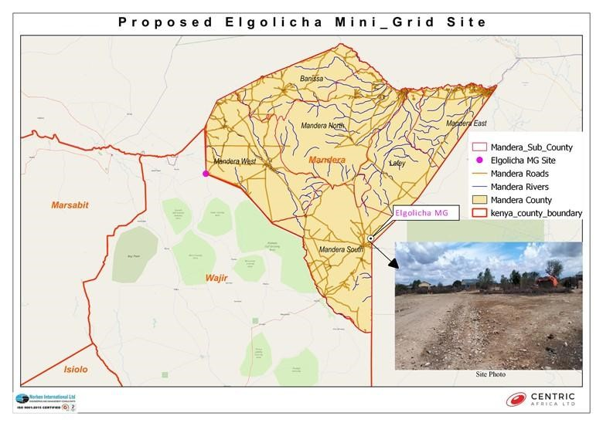
Figure 2: Proposed site for the Elgolicha Solar Minigrid.

2.3 Project Site Setting
The proposed Elgolicha mini grid is in Mandera South Constituency, Mandera County. Mandera County projects fall under Lot 3 of cluster 3 consideration area as part of the larger country support program which has a total of 113 mini-grids. Geographically, Elgolicha site falls on coordinates Latitude 2⁰ 80’ 8.573”N and Longitude 40⁰ 94’ 97.36”E.

The site is currently used as the grazing field by members of the community and characterized by acacia trees, shrubs, and withered grasslands. The site is near human settlements with the nearest household being approximately 100meters and adjacent the public village dispensary and primary school.

Other land uses in the neighbourhood include an urban setting, playing grounds, worship (mosque), school, social and cultural gatherings among others. The proposed mini grid will have very minimal negative impact to other existing land uses since it will attract the installation of solar panel that will use the sunshine rays to produce electricity.

Following comprehensive consultation during the preparation of the National Electrification Strategy with the County Governments, NGOS, CBOs and local communities, the government identified possible sites within 14 counties that would benefit from solar mini grids. Consequently, NRECA a consulting firm was tasked to undertake a feasibility study and map out the possible project site in Mandera County and Elgolicha is one of the areas that was identified.

Land in Elgolicha is in the centre of the village next to the dispensary and opposite primary school and is unregistered communally owned land. The portion of land identified for the Mini grid by the community is part of the land that the community had set aside for public purposes i.e., land which the community had set aside for social service projects. The land is about 5.87 acres, and the projects are allocated as they come with nearby public infrastructures including the mosque and religious school known as madarasa. Consultations with the community indicated that the land is purely set for social services projects the mini grid was found to fall in this category and so it was allocated 5.87 acres. No objections were raised by the community regarding transferring land 2.3768 hectares for the mini-grid) to KPLC for management of the solar mini-grid.

The site is conveniently located and surrounded by homesteads with the nearest about 100metres and public facilities such as a dispensary, borehole and water tanks, and primary school. The community gets water from a borehole adjacent the site to the western edge of the village. The site is well accessed via an 12metres main Elwak-Elgolicha Road.

The site has sparse vegetation of acacia type, shrubs, and seasonal grass all around with the site utilized for grazing by few livestock kept within the village. The major land uses near and around the proposed project site include residential facilities, grazing area, public facilities (dispensary, borehole, a school within a radius of 1km) and main Elgolicha shopping Centre which is about 800metres from the project site. The area is sparsely populated. The shopping Centre is approximately 200meters from the proposed project site.

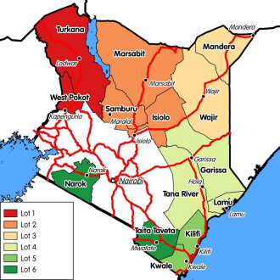
Grievances in the community are addressed through elders who are headed by one village elder in partnership local administration like chief and his assistant in the village. Grievances that cannot be solved by the elders are referred to the Subcounty administration in Elwak including the Assistant County Administrator and other elders through National Government conflict resolution mechanism.

Figure 3: Map showing the KOSAP counties Lot 3.

2.5 Description of the Proposed Solar Mini-grid
Based on an aerial survey done in 2019, Elgolicha has a potential customer base approximated at 160 residential users, and a 47KWp solar Mini grid to supply power to the community will be installed. The total length of LV distribution network will be 7 Km. The community members will pay a connection fee of KES. 1000 once they apply for electricity.

2.5.1 Nature of the Project
The proposed project will be having two components in one that is a Hybrid Mini-Grids (PV- and Diesel) and construction of Power line reticulation lines. The following sections are explanations for each of the components that will be implemented.

2.5.2 PV Hybrid Mini-Grid Sizing
The power system has been sized based on the energy parameters. These are:
- The proposed Residential & Non-Residential Users available
- The PV Capacity in kilo Watt peak.
- The storage battery Capacity
- The Inverter capacity in (kW).

The system will be modular, so that it can be upgraded easily to meet future demand needs. The proposed power plant will be configured as AC coupled due to the significant portion of daytime loads that can be fed directly from the solar PV generator without intermediate battery storage.
This will include:
- PV modules with PV inverters,
- Diesel Genset,
- Deep-cycle lead-acid electrochemical batteries with liquid electrolyte (largely used in off-grid applications thanks to its well proven technology at baseline costs compared with other types of batteries).

The proponent will be required to apply for a NEMA ESIA variation of the license, during the design changes over the project lifespan.

2.5.3 Architecture and Basic Design Specifications
The El Golicha Mini Grid project is a vital initiative aimed at providing reliable electricity to approximately 160 residential consumers. This electrification project will significantly improve the quality of life for the local residents and support economic development in the region. The proposed mini-grid installations will be built to comply with the International Electro technical Commission (IEC) standards. The technical details are as provided below;

  - Power Generation Sources

Solar Photovoltaic Panels: The project will harness the power of the sun through a 47kWp solar photovoltaic panel array. Solar energy, a clean and renewable source, will be the primary electricity generation method.

Battery Energy Storage System: A 152 kWh Battery Energy Storage System will store excess solar energy for use during nighttime or periods of low solar irradiation.

Diesel Generator: A 50 kVA diesel generator is integrated into the system as a backup power source to ensure a continuous supply of electricity even in unfavorable weather conditions or high demand periods.

Fuel Tank for Diesel Generator: A 2,000-liter fuel tank is provided to store diesel fuel for the generator, ensuring its continuous operation during extended periods of low solar or high demand.
  - Power Distribution Network
Low Voltage (LV) Network: A 7-kilometer low voltage power distribution network will be established to efficiently transmit electricity to the residential and nonresidential consumers. This network ensures a stable and reliable power supply while minimizing energy losses.

  - Project Metrics
Monthly Energy Demand: The project is designed to meet a monthly energy demand of 3,720 kWh.
Daily Energy Demand: The average daily energy demand is proposed at 124 kWh, ensuring a consistent power supply for consumers.
Peak Demand: The peak demand of the system is proposed at 16 kW, representing the maximum power requirement during any given moment.

Estimated Project Cost: The estimated cost of the Guba Mini Grid project is approximately USD 375,641. Please note that this cost may be subject to change as more detailed plans and implementation phases are developed
The Solar PV hybrid system is based on a centralized photovoltaic plant connected to a 3-phase 415V AC busbar line, where the multi-mode battery inverter and the diesel generator are also connected.

The plant is configured such that a significant portion of daytime loads is fed directly from the solar generator (grid-tie inverter) without intermediate battery storage usage. The solar PV power plant is also equipped with a Diesel Generator, which is normally used as reserve power. The diesel generator switches on automatically whenever the battery state of charge reaches a certain defined DOD (Depth of Discharge). The diesel generator comprises of 0 kVA unit in three-phase operation, and it’s equipped with automatic start-up function controlled by the battery inverter charger.

Residential | Nonresidential | Circuit(km) | Peak demand kW | PV capacity(DC-KW) | Battery Capacity kWh | Generator (kva) | Cost (USD
160 | 0 | 7 | 16 | 47 | 152 | 50 | 375,641

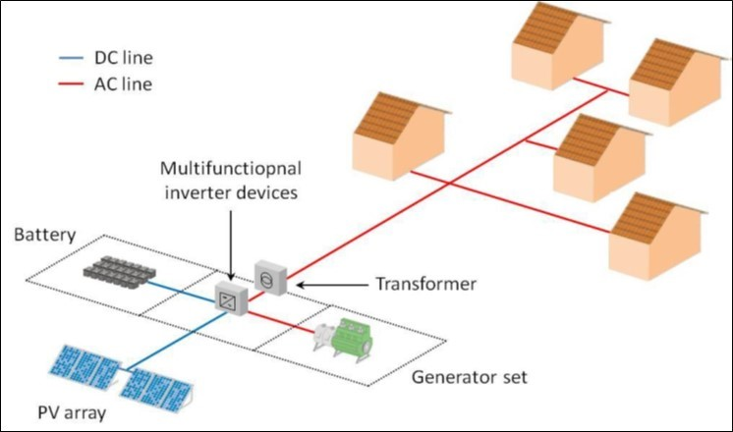

Figure 4: Illustration sketch of the proposed design of the proposed project.

2.5.4 The PV Generator
The PV generator consists of Silicon Crystalline Photovoltaic modules of capacity at STC of 250 Wp or more. The PV modules should comply with the norms IEC 61215 and IEC 61730. The outside junction box with the positive and negative terminals shall incorporate bypass diodes that have the function of preventing any possibility of the electrical circuit inside the module being broken due to the partial shading of a cell and shall be at least IP 65 and UV resistant.

The module support structure shall be ground-mounted on arid soil with a base made of concrete. The support shall have a tilt angle between 10° - 15° from the horizontal. No soil tests have been performed, at this stage of the proposed project design, but from the site inspection during the pre-feasibility study, ramming or screw foundations could be used. The support frame shall be of either lightweight aluminium or galvanized steel and it shall be easy for installation, maintenance, and disassembly at the end-of-life cycle. These materials will be possibly sourced locally or from abroad and shipped to Mombasa port and transported via road to the site town.

Cables used within the PV generator shall have a voltage rating of at least 1,2 VOC; have a temperature rating higher than 40°C above ambient temperature; they will be UV-resistant; water resistant and it is recommended that they be flexible (multithreaded) to allow for thermal/wind movement of modules. The PV inverter shall be of type current source grid-tied to convert DC to an AC Sinusoidal current. String inverters shall be installed indoors or outdoors with a cover and suitable for desert conditions with high ambient temperatures and dust.

PV and Battery Inverter Chargers
A 39-kW solar PV inverter will be used to convert direct current (DC) electricity generated by the solar panels into alternating current (AC) electricity suitable for consumer use.

A 27-kW battery inverter charger is incorporated to manage the energy flow to and from the battery storage system efficiently, optimizing the system's overall performance

2.5.5 Powerhouse
The Battery, Multi-mode inverter and all monitoring equipment will be installed indoors with adequate air ventilation accordingly to the manufacturer’s recommendations. Thus, a powerhouse or a containerized solution, considering the equipment manufacturer’s recommendations shall be installed. All electrical boards and LV protections will also be installed indoors. The batteries will be installed in the powerhouse in a separate room, specifically for their use and meeting the electrical safety requirements according to its voltage class.

2.5.6 Multi-mode Inverter
The multi-mode inverter (or inverter set) for this application is a 20 kW (nominal) bidirectional sinusoidal inverter. It can operate in autonomous mode as well as grid-tied mode. The efficiency curve shall be always above 80% in all cases, adjusting it at the load demand curve (base load, partial load or maximum load).

A priority function of the Multi-Mode Inverter is to adjust the instantaneous power consumed from the source according to the battery voltage. The operation of the solar priority function shall be done with an automatic adjustment algorithm of the input limit current. The input limit current is decreased, if there is enough energy available at the DC side, from the initial value.

2.5.7 Battery
The battery considered is lead-acid, deep discharge type with a permissible repeated deep discharge without damage. Automotive or starting type batteries are not acceptable. It shall be of the open “vented” OpzS type with recombination caps and transparent enclosure for easy inspection of electrolyte level.
OpzS stands for:
O = Ortsfest (stationary)
Pz = PanZerplatte (tubular plate)
S = Flüssig (flooded).

Other batteries can be considered:
- OpzV type, “gel” lead-acid batteries are “maintenance less” but the unit weight is higher and the lifetime is sensitive to high temperatures.
- Li-ion batteries, have longer lifetime, are lighter and smaller. But they have a higher investment cost and are not adapted to high air temperature so that an additional active cooling system is needed.
The batteries must be manufactured according DIN 40736-1: “Stationary batteries with tubular positive plates. Capacities, measurements and weights”. The battery array will have 12 batteries.

2.5.7.1 Battery Rating
The battery nominal voltage does not need to be established at this stage and different technology providers may offer different solutions on this issue. Nevertheless, it must be noted that the voltage class, either ELV or LV, will determine the electrical isolation and accessibility requirements of the battery room. The battery shall have at least the rated capacity of 2.16V at the C10 discharge rate according to DIN 43539-9.

2.5.7.2 Battery Performance
The battery shall have a self-discharge when new of less than 5% per month (at 25ºC and fully charged) of its rated capacity and shall have a Coulombic efficiency of at least 85% and energy conversion efficiency of at least 85% when new and charged to more than 50% of capacity. The battery cycle life for discharge/charge regular cycles down to 80% DOD shall be more than 1500 cycles (According to IEC 896-1).

2.5.7.3 Lifetime
The design lifetime of the batteries shall be of at least 8 years without losing more than 10% of the rated C10 capacity. When the batteries get damaged, they will be stored separately at the site and then transported to Nairobi for proper disposal.

2.5.7.4 Battery Cabling and Protections
The battery connection point shall be as close as possible to the Multi-mode Inverter. Cables used to connect the battery shall have a temperature rating higher than 20 °C above ambient temperature. It is recommended that they be flexible (multithreaded) to allow for easy installation and maintenance. Fuses in cables that connect components to the battery shall be rated for D.C. use, be installed separately as close as possible to the battery terminals and rated to interrupt high fault currents from the battery. A neutralization kit will be provided at the site to manage any battery acid spills that may occur.

2.5.8 Diesel Genset
The Diesel Generator Set shall have a capacity of 100 kVA (50 kW) with an output of 400 V /230 V @ 50 Hz and 1500 r.p.m. The rated consumption will follow a 0.25 L/h/kW curve at stand-by power. It should include a highly corrosion resistant enclosure, control panel and monitoring, fuel tank and circuit breaker protections. The Diesel Genset shall be suitable for indoor or outdoor installation and shall perform accordingly with Multi-mode Inverter and the mentioned architecture model. The Diesel Genset shall be working in a fully automatic manner with the above stated components. The diesel gensets will have base mounted fuel tanks that will be factory tested for leaks. There will also be an external reserve fuel tank with a capacity of not less than 500 litres. The proponent, through the operating entity will have regular inspection by the manufacturer. The noise rating for the generator set will be 75dBA @ 1 meter at 75% load under free field conditions. The generator sets will have a high-quality noise absorbent and fire-retardant grade acoustic insulation material complying to IS 8183.

2.5.9 Substation
The mini-grid site will have a 190 kVA transformer that will allow stepping up of the voltage before it is connected to the distribution line.

2.5.10 Distribution Line and Energy Meters
The electricity distribution from the generation plant to the end consumers will be done by means of a distribution line formed by low voltage (LV) line at 415V for three phase and 240V for single phase. All lines shall be over-head mounted on concrete poles or eco poles. The project implementing agency and KPLC will seek way leaves for the LV lines which will run along road reserves and boundaries within the supply area.

2.6 Land Tenure
The proposed works will be carried out on a 2.3768 hectares proposed unregistered community land which the community identified for setting up the project. Stakeholder engagement with the community on this matter has been conducted. The proposed site land falls on a land owned by the Elgolicha community. The sub-project site will be acquired by NLC compulsorily and affected communities compensated in-kind through their community project of choice.

2.7 Compensation Details
Compensation for the land acquired for the proposed project will be in kind. NLC will acquire the 2.3768 hectares land in Elgolicha compulsorily, The MOE will pay compensation in kind through implementation of projects in water, education and health sectors. Elgolicha community requested for drilling of community boreholes within the village.

2.8 Site Ownership
The proposed works will be carried out on 2.3768 hectares proposed site which the community identified for setting up the project. Stakeholder engagement with the community on this matter has been conducted.

2.9 Access to the Site
It is proposed that the Elgolicha Solar Mini-grid will have one access road, which will be designed according to KPLC’s standards, taking into account the Ministry of Road’s requirements. The Solar Mini-grid will be accessed from the Elwak-Elgolicha road. The 12metre road in the village is a well maintained murram road, and the proposed site touches the said road. This is advantageous because no new road will be required. However, a proper access to the site and drainage will be constructed to safely access the Mini -grid site and to avoid flooding.

2.10 Fencing and Security
The proposed site is within Elgolicha village. The site is in an area that is basically open and in close proximity to residentials and public facilities. This calls for proper security measures to be put in place to protect both human and domestic animals from accessing the Solar Mini-grid site. Therefore, the Mini-grid will have a chain link fence to keep off the electrical installation away from access by unauthorized persons or animals. A gate will be constructed at the entrance to the site which will be locked at all times. The Mini-grid will be lit at night, and a photocell will be used to automatically switch on the lights at a set time each evening. The Mini-grid will also be guarded at all times by two security guards during the day and two guards at night.

2.11 Fire Safety
There is potential of fire on the site and this will be avoided by the provision of fire protection and firefighting equipment including fire extinguishers, signage, danger plates and name plates. The fire equipment will be placed where they are visible and easy to reach.

2.12 Vegetation Undergrowth
Concrete will be used on surfaces where it is required leaving the rest of the areas covered with vegetation. Vegetation undergrowth will be managed by regular slashing and cleaning up of the site compound.

2.13 Project Activities
The final design and construction of the Solar Mini-grid will be undertaken by a contractor selected through a competitive bidding process. Construction will be supervised by KPLC to ensure works are undertaken in accordance with specifications. This is to ensure quality work is achieved.
It is anticipated that the proposed site will undergo alteration during construction to install the Solar Mini-grid and associated structures. Some of the activities envisaged in this project include site clearance and levelling, civil works and construction of utilities and structures for the facilities, installation and connection of the power plant as described in the section below.

Safety protocol, requirements and precautions and established National and International Environmental protection regulations/ standards as well as all management plans proposed under this ESIA report for this project, shall guide the contractor and project operator during the project cycle. Modest construction procedures will be followed to reduce noise and vibration levels and the production of dust and any form of pollution that may affect the neighbouring community within the project area.

2.14 Construction Procedures
All construction activities including ground preparation, earth moving, materials delivery, building, walling, roofing and the installation of amenities (power, water, communication equipment, etc.), fittings (doors, windows, safety provisions, etc.) will be carried out by competent personnel obtained through respectable contractors to ensure consistent high standard of finish and providing superb value for money.

2.14.1 Construction Activities Outline
Construction activities will involve the following:
- The contractor shall perform site investigations in good time to ensure appropriate designs and construction is done on a sound engineering basis.
- Site preparation (ground-breaking, clearance of vegetation, preparation of a site office and stores, fencing to avoid intrusion),
- Disposal of any soil that could is not required, excavations/earth moving, filling and foundation laying,
- Procurement of construction materials and delivery of the same to the site,
- Storage and utilization of materials,
- Civil, mechanical, and electrical works,
- Building works, trampling and removal of construction wastes,
- Construction of fuel storage tank
- Installing of containerized generators
- Piping of fuel lines
- Cabling
- Installation of the Mini-grid
- Completion of the plant
- Post construction clean–up, restoration and landscaping of site
- Load testing
- Remedying of defects after functional tests
- Solid waste collection and commissioning of the plant.

During construction, the contractor shall observe safety and shall erect warning signs to warn on any potential hazards, ensure proper and efficient use of Personal Protective equipment (PPE) for all on site and observe safe work procedures.

2.14.1.1 Soil Excavation
Soil will be excavated to pave way for the construction of the Solar Mini-grid. Soil excavation process shall be done with utmost care to ensure that the excavated soil is not improperly heaped or not carried away by any surface flows to any nearby surface waters causing siltation. The excavated soil will be used to backfill, and any remainder shall be disposed appropriately in accordance with the environmental management plan. Company safety and environmental policy and other established local environmental protection regulations/standards shall guide the contractor. This will include appropriate safety wear at all times and the contractor will appoint a safety officer on site during all construction activities.

2.14.1.2 Construction Supervision and Safety
Throughout the construction phase, supervision shall be carried out by the KPLC to ensure:
- Workers use personal protective equipment (such as hand gloves, helmets, safety shoes earmuffs, overalls and dust coats) at all times as is appropriate
- Motorized equipment is checked to ensure that they are in good working condition, safe to use and produce minimal noise levels and reduced smoke emission.
- Provision of first aid kit and firefighting equipment (portable cylinders) and placement at strategic positions for access
- Proper disposal of waste material and toilet facilities are provided for construction workers
- Emergency response procedures are in place and all workers are aware of them like in case of fire.
- Any work involving deep excavations, elevated heights and lifting heavy loads, poses a number of risks to personnel. The contractor shall develop a worksite plan before commencement of each of the construction. This will ensure that personnel are equipped with the correct protective clothing and equipment and are ready to work safely while also safeguarding the environment.
- Workers shall be provided ablutions facilities and changing rooms.

2.15 Mini-grid Components
The following components are planned to be constructed and operated on site. The same will need to undergo regular maintenance during the operation phase.
- Technician Room
- Battery Room
- Generator Room
- PV Array/Panels
- Distribution network
- Guard house.

2.16 Operation Phase Activities
The Solar Mini-grid will be operated and maintained by the contractor for the first seven years and then handed over to KPLC engineers and operators. During operation phase of the project, no unauthorized person shall access the Solar Mini-grid site. This is in line with company policy to ensure safety of staff and the public. Routine maintenance is to be done under supervision by authorized staff.

2.16.1 Construction Contractor
The construction contractor is responsible for building the physical infrastructure required for the mini-grid project. In this case, the infrastructure includes the installation of solar panels, battery storage systems, a diesel generator, inverters, and the low voltage power distribution network.
Their specific responsibilities will include site preparation, installation of solar panels, setting up the battery storage system, configuring the diesel generator, and laying down the distribution network.
The construction contractor will be responsible for ensuring that the components are installed correctly and meet the required standards for safety and performance. They may also manage the workforce, logistics, and project timeline to ensure that construction proceeds smoothly and is completed within the specified timeframe.

2.16.2 Operation and Maintenance (O&M) Contractor
The O&M contractor will be responsible for the ongoing operation and maintenance of the mini-grid system once it is operational. The construction contractor will also double up as the O&M contractor
In this project, their responsibilities include monitoring the performance of the solar panels, battery storage system, and the diesel generator to ensure the continuous and reliable supply of electricity to the consumers. The O&M contractor must carry out regular maintenance tasks, such as cleaning and servicing solar panels, inspecting and maintaining the battery energy storage system, and ensuring the diesel generator is in good working condition for backup power needs. They are responsible for addressing any technical issues or faults that may arise, as well as responding to consumer complaints and inquiries related to the electricity supply. The O&M contractor plays a crucial role in maximizing the system's efficiency and longevity by ensuring all components operate optimally.
The contractor will be required to have their own Environment, Health, and Safety (EHS) policy and an EHS officer on site. In the context of the mini-grid project, it will outline the contractor's dedication to upholding safety standards, minimizing environmental impact, and adhering to legal requirements. The presence of an EHS officer on site will be equally essential. Their role will be to oversee and manage all EHS concerns directly at the project location

Throughout the project life, the KPLC shall adhere to all requirements of National Environmental Management Authority (NEMA) licensing conditionalities and any other applicable legislation regarding environmental and socio – economic impacts.

2.17 Project’s Decommissioning Activities
Kenya Power shall submit a decommissioning plan to NEMA in good time prior to decommissioning. The decommissioning plan should include a restoration plan.
At the decommissioning/demolition phase, the following activities will take place.
- Removal of Solar Mini-grid panels and Diesel Generator and their associated switching equipment’s
- Removal of electrical fittings, bus bars and steel poles/structures
- Demolish and carefully handle components that contain oil and fuels like the Diesel generators
- Ensure proper handling of the demolished materials and have an authorized and guided transportation and disposal away from human settlement, water bodies and wildlife conservation area in line with NEMA requirements for safe disposal
- Demolish and remove all the concrete works.

The host environment should be rehabilitated and restored to its former state through:
- Approved and appropriate landscaping methodology.
- Planting of vegetation.
- Removal of any soils that may have been impacted by oils or fuels for offsite (away from the project area) remediation.

2.18 Construction Materials, Equipment and services
All materials that will be used in construction of this project shall be of high quality in line with the Kenya Bureau of Standards. Sufficient materials and equipment shall be purchased and stored on site to avoid wastage. Most of the materials are locally available and the contractor should source from within the project area.

2.18.1 Input Materials and Equipment & Machinery
Works and construction activities are expected to use quality construction materials and procedures to ensure quality work, occupational and public safety and environmental protection. The following inputs and equipment will be required for construction:

Table 5: Inputs and Equipment required for construction
Lorries | Plumbing equipment | Concrete mixers | Welding machines, wheelbarrows | Paints, solvents, whitewash, etc.,
Electrical equipment | Excavators | Lightning arrestors and Steel structure members | Timber (e.g., doors and frames, fixed furniture, etc.) | Labour force (of both skilled and unskilled workers)
Generator Sets | Bus bars, Switch gears, Circuit breakers |  | Water | Sand
Solar panels | Conductors | Poles | Meters | Fuels (Diesel)
Hardcore | Building stones | Glass | Raw construction materials (Sand, cement, natural building stone blocks, hard core, gravel, concrete among others)

2.18.2 Use of Services and Resources

2.18.2.1 Water
Water is key in the construction of this project. Water will be required for potable use and in the construction of the foundations for the control room, guard house and any other works. The contractor will source water from elsewhere rather than the community dam because water may not be enough for the community for use during construction and operation.

2.18.2.2 Labour
The size and the composition of the workforce will be at the discretion of the contractor(s). The contractors will adhere to the Employment Act of 2007 in the recruitment and management of the employees. It is recommended that the contractor seeks unskilled labour from the surrounding areas.

2.18.2.3 Sewerage
A negligible sewerage flow is anticipated for the duration of the construction period. On site, use will be made of toilets that will be serviced periodically. For operations, a similarly negligible amount of sewerage will be generated. The area is not served by a sewer system and the KPLC will make use of septic tanks to dispose waste during operation period.

2.18.2.4 Roads
Existing roads will be utilized as far as possible during the construction and operational periods. No new road will be constructed because there is an existing road to the Solar Mini-grid. The flow of traffic to the site during the construction period will increase and management of traffic will be paramount.

During operations there will be virtually very low traffic considering because once operational the Solar Mini-grid will require minimal maintenance.

2.18.2.5 Electricity
Electricity will be essential for the proposed project both during construction and operation. The contractor will have to have a portable generator during construction for fabrication and welding where necessary but Kenya Power will provide electricity for operations from its constructed Solar Mini-grid electrical network in the area since the area will be well served with power after competition of the Solar Mini-grid.

The project KPLC should ensure that all material sourcing does not trigger any environmental or social impacts. All hazardous materials should be handled according to the NEMA regulations on hazardous waste. All new unidentified impacts should be mitigated and managed in a responsible manner throughout the project cycle by the contractor and the project operator.

2.19 Products, By-Products and Waste
The sections below provide an overview of the products, by-products and wastes to be generated by the project. Most of these will be generated during the construction phase of the project while some will be generated during the operation and decommissioning phases.

2.19.1 Construction Phase
The final product after construction phase is a modern Solar Mini-grid and its associated structures.

2.19.1.1 By-products
During the construction phase of the project no by-products is envisaged.

2.19.1.2 Waste
During construction the proposed project is anticipated to generate different waste which shall include:

2.19.1.3 Domestic Waste from the Construction Area
The workers will not be supplied with any forms of foodstuffs. They are expected to buy or carry their own food. Plastic bags and containers which the workers will use to carry their food are expected to increase within the site. Other forms of waste include sanitary waste and therefore the provision of sanitary facilities will need to be considered both for the site construction workers and any other person coming to site.

2.19.1.4 Site Construction Waste
The project will generate waste from the site construction activities which includes:
- Excavated soils and vegetation.
- Construction equipment and maintenance wastes.
- Dust and fumes.
- Scrap metals.
- Packaging materials, etc.
- Metal cuttings generated from the construction activities
- Any excess construction materials brought to the project site by the contractor which can be reused later.

2.19.1.4.1 Dust
The construction activities that will occur particularly during the site excavation process will generate dust and other particulates particularly during dry weather conditions that will be released into the atmosphere.

2.19.1.4.2 Smoke Emissions
The site machinery, equipment and trucks brought in by the contractor are expected to generate smoke emissions when in operation during the construction activities. The concentration of emissions will depend on the maintenance levels of the equipment, machinery and trucks used by the contractor.

2.19.2 Operation Phase

2.19.2.1 Products
The primary product of the proposed project during the operational phase will be electricity generated from Solar Mini-grid and distributed.

2.19.2.1 By-products
The by-product anticipated to be generated during operational phase is used oil.

2.19.2.2 Waste
The wastes that will be generated will include;

2.19.2.3 Domestic Waste
Some of the domestic waste to be generated at the facility include wastepaper and empty cans. Other waste will include sanitary facilities effluent which will directed to septic tank.

2.19.2.4 Process Waste
Some of the waste anticipated from the process will include used/ waste oil from stand by generator which will require to be managed well by ensuring containment of any spillage and incineration oily rags used during maintenance of generators. Solid waste will include faulty or obsolete batteries and solar panels, conductor and scrap metals during replacement which takes several years before being replaced.

2.19.3 Decommissioning Phase

2.19.3.1 Products and By-products
During the decommissioning phase it is expected that there will be no product. However, the by-products during decommissioning phase will include:
- Metal generated from the decommissioning of Solar Mini-grid and associated infrastructure; and
- Foundation materials which can be donated to individuals for reuse.

2.19.3.2 Waste
During the decommissioning phase of the proposed project, several waste products are expected to be generated. These shall include:
- Remains of concrete from demolition of Mini-grid foundation
- Dusts and fumes.
- Scrap metals.
- Solar Panels.
- Batteries.
- Generator.

2.19.3.3 Dust
The activities that will occur particularly during the demolition process will generate a considerable amount of dust and other particulates that will be released into the atmosphere.

2.19.3.4 Smoke Emissions
The demolition machinery, equipment and trucks used are expected to generate smoke emissions. The concentration of emissions will depend on the maintenance levels of the equipment, machinery and trucks used by the contractor.

2.20 Safety of the Facility
As is with other projects, the proposed project is prone to both natural and man-made disasters. However, it is difficult to prevent the occurrence of natural disasters, but the consequences could be reduced by engineering measures. Man-made disasters on the other are preventable. The following safety concerns will be addressed in the proposed project.

2.21 Natural Disasters
In order to reduce the impacts of any potential natural disaster, the proposed project will be designed according to acceptable standards and code and shall be able to reasonably withstand any impacts which may arise as a result of the worst credible seismic event.

2.21.1 Malicious Damage or Theft
The proposed project could be prone to malicious damage such as terrorist attack or theft. To prevent the occurrence of such events, the following measures will be taken:
- Regular monitoring and inspection of the project and its associated infrastructure.
- 24-hour guard of the premises/office block.

2.22 Hazard Risk Assessment
An emergency response procedure will be prepared by the KPLC and be communicated to the contractor. As a minimum requirement, the emergency management plan will cover the following aspects:
- Safety regulations
- Scope of the safety emergency plan
- Notification of local authorities
- Details of the proposed project
- Aim of the safety emergency plan
- Objectives of the study emergency plan and evacuation procedures
- Emergency arrangements, procedures and plans
- Roles and responsibilities in the event of an emergency
- The role of local communities
- Regular testing of the safety emergency plan
- The risk assessment will include as a minimum:
    - A general process of the project being investigated
    - A description of the potential major incidents associated with that type of installation and the consequences of such incidents
    - An estimation of the probability of a major incident
    - A copy of the site emergency plan
    - An estimation of the damages in the case of an explosion or fire
    - An estimation of the effects of toxic gas releases.
    - The potential effect of an incident on the project or part thereof or an adjacent project or part thereof.
    - The potential effect of a major incident on any other installations, members of the public and residential areas.
    - Meteorological tendencies
    - The suitability of existing emergency procedures for the risks identified.
    - Any requirements laid down in the OSHA 2007 and EMCA 1999.
    - Recommendations regarding any organizational measures.

CHAPTER THREE

3.0 ANALYSIS OF PROJECT ALTERNATIVES

3.1 Consideration of Project Alternatives
In this chapter, various alternatives available to the project are discussed. The alternatives are as follows; “no-go/do nothing” alternative, alternative construction materials and technology, the alternative Mini-grid site and alternative sources of energy identified during the ESIA process.

The identification and examination of alternatives is fundamental to environmental assessment. It provides decision-makers with information that enables them to properly consider optimal solutions to development proposals. Alternatives illustrate and contrast the environmental implications and consequences of different options available to achieve the same end. In this way, both the KPLC and the authorities who must consider granting the authorization, are put in a position where all involved are able to make informed choices or decisions.

This section analyses the project alternatives in terms of site, technology, and waste management options.

3.2 Relocation Option
Relocation option to different sites is an option available before the project implementation. At present the project KPLC does not have alternative sites in the general direction of the proposed sites. This means that the project proponent has to look for the alternative lands. Looking for the lands to accommodate the scale and size of the proposed project and completing official transaction may take a long time although there is no guarantee that the land would be available.

This project is to improve electrification and accessibility to an already established market center. Several alternatives were considered to improve other areas, but this one was selected because it meets the electrification needs of the area.

In consideration of the above concerns and assessment of the current proposed sites, relocation of the projects is not a viable option.

3.3 Zero or No Project Alternative
The No Project option in respect to the proposed project implies that the status quo is maintained. This option is the most suitable alternative from an extreme environmental perspective as it ensures non-interference with the existing conditions. This option will, however, involve several losses both to Elgolicha village and the community as a whole. The target beneficiaries will stay without electricity and the government objectives of bring electricity in order to open up the area and provide better public services will not be realized. The No Project Option is the least preferred from the socio-economic and partly environmental perspective due to the following factors:

- The socio-economic status of target communities the local economy would remain unchanged.
- Generation of employment opportunities through expansion of business activities that would have been spurred by availability of electric power will not occur.
- Opening up the area for investors will not occur.
- Health benefits that come with electricity will not be realized.
- The targeted consumers will forgo the desired electricity supply in the area.
- The country won’t meet its energy requirement.
- The objectives of the government’s efforts towards achieving Vision 2030 will not be realized.
From the analysis above, it becomes apparent that the no project alternative means no project to the local people and the Government of Kenya, and the benefits outlined above and other indirect benefits that would accrue from construction of the proposed project.

It is thereby concluded that the ‘do-nothing’ option is not a good option economically and should therefore be discouraged and rejected. It is therefore imperative for KPLC to establish a new solar mini grid in the area and supply the community with clean energy.

3.4 Alternative Sources of Energy

3.4.1 Thermal Power Generation
Thermal power through installation of Diesel Gen Sets is an option which can be considered to provide power to Elgolicha. This would need more than 500litres of Industrial Diesel Oil (IDO) is burnt daily to generate targeted 50kWp of electricity at Elgolicha. Thermal generation can also be fueled using alternative fuels such as natural gas, bio diesel, industrial kerosene, heavy vehicle fuel, coal, and unleaded petrol. Thermal power generation has serious negative environmental impacts including generation hence the need for the KPLC to install the proposed solar power plant.

Hydro Electric Power – HEP
This would mean exploring the possibility of extending the existing national grid to Elgolicha since there are no hydro facilities within the region to facilitate HEP generation. The proposed project is quite far from the national grid hence this is a costly venture and may take time before the resident’s power need is facilitated.

3.4.3 Other Sources of Energy
Wood fuel is the main source of Energy contributing to 80% of energy requirements in Africa which holds the truth Elgolicha as well. Over reliance on wood has led to deforestation, desertification, global warming, and climatic change among other socio – economic demerits. The Government of Kenya should look into the possibility of using nuclear energy to generate electricity. This is a long-term consideration and also has several deleterious effects to the environment and human health. Nuclear Waste disposal will also create a huge environmental challenge.

Based on this discussion the proposed solar Mini grid presents the most appropriate option of electrifying/ bringing power to Elgolicha in terms of technology, cost, and environmental considerations.

3.5 Analysis of Alternative Construction Materials and Technology
The proposed solar Mini grid will be constructed using modern, locally, and internationally accepted materials to achieve public health, safety, security, and environmental aesthetic requirements. Equipment that guarantees efficient use of locally available materials will be encouraged to ensure reliability in supply with minimum power loss and good design to allow efficient distribution of power in the area.

The support structures in the Solar Mini-grid can be wooden or steel. Because of its durability and strength, steel is the best choice, and all support structures will be steel. Perimeter fence can be a reinforced wire mesh fixed to support structures that can be wooden, concrete, or steel. Alternatively, a stone perimeter wall can be constructed, and this is the option of choice since it is more durable, offer better protection and requires less maintenance.

The design of the solar mini-grid will be easy to install and dismantle with minimum labour requirements and maintenance costs will be minimal. The process material that are input for the proposed project such as generator diesel fuel and oil and water for cooling the generator and for cleaning purposes are critical elements. There is no alternative for generator oil and water for standby generator cooling and for mini-grid facilities cleaning water. So, the task was to assess alternative water and Diesel generator oils and fuel sources for the project.

3.6 Solid Waste Management Alternatives
A lot of solid wastes will be generated from the proposed project. An integrated solid waste management system is recommendable. First, the KPLC will give priority to reduction at source of the materials. This option will demand a solid waste management awareness program in the management and the staff. Recycling and reuse options of the waste will be the second alternative in priority. This will call for a source separation program to be put in place. The third priority in the hierarchy of options is combustion of the waste that is not recyclable. Finally, the KPLC will need to establish partnership with NEMA approved waste handlers for regular waste removal and disposal in an environmentally friendly manner. In this regard, a NEMA registered solid waste handler would have to be engaged. This is the most practical and feasible option for solid waste management.

3.7 Alternative Solar Mini-grid Site
In determining the most appropriate site for the establishment of the mini grid, several options were explored. Mini grid Sites under KOSAP were selected based on a number of factors as detailed below.
- Geophysical Factors-Proximity to Hills-Shade effect, Soil erosion, Drainage of the area, Flooding etc.
- Land identified is free from any dispute on ownership or any other encumbrances,
- Proximity to public utilities-Schools, Dispensaries, Places of worship and community settlements.
- No squatters, encroachers, or other claims to the land.
- The Size of the Mini grid to be constructed and the optimal coverage of a Mini grid in terms of the number of people to be reached.
- The Land identified should be on spaces set aside for public use within the community centres.
The land was identified by the beneficiary communities and confirmed by technical staff to be suitable for the sub-project and free from any environmental or health risks. The impacts on the Community will be marginal and will not result in displacement of households or cause loss of household’s incomes and livelihood.
The site identified was considered against the criteria highlighted above and was found suitable for Mini grid construction.

CHAPTER FOUR

4.0 BASELINE SETTINGS- ENVIRONMENT, ECOLOGY AND SOCIAL

4.1 INTRODUCTION
This chapter describes the existing bio-physical and socio-economic context of the proposed project area which acts as the basis for the identification and assessment of the potential environmental and social impacts of the proposed project. It provides both the project specific information of the project’s area of influence as well as the regional baseline information derived from secondary information.

4.2 Environment Baseline

4.2.1 Project Location
The project site is located in Elgolicha, Mandera South sub-county, within Mandera County. The coordinates for the site are Latitude 2⁰ 80’ 8.573” N and Longitude 40⁰ 94’ 97.36” E. It is proposed that the mini grid will be constructed on approximately 2.3768 hectares of land, which will be acquired from the local community specifically for the project. The soil in the area primarily consists of limestone, with a mixture of sandy and loamy soils.

The project site is situated approximately 6kilometers east of Elwak town and less than 5 kilometers away from the Kenya-Somalia border. Currently, the site is used as a grazing field by members of the community and is characterized by acacia trees, shrubs, and withered grasslands. It is in close proximity to human settlements, with the nearest household located approximately 100 meters away. Additionally, it is adjacent to the public village dispensary and primary school.

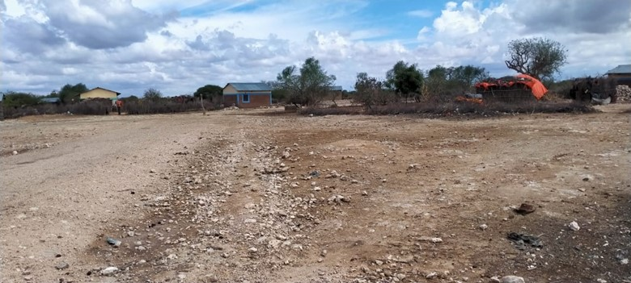
Plate 1: Proposed Project Site

4.2.2 Geology and Soil
The area has been bevelled by five pen plains of which the lowest, the end-Tertiary surface, comprises the largest proportion of the area, from which rise the central hill masses upon which remnants of the other peneplains are preserved. The rocks in the area consist of limestones, sandstones and siltstones of Middle Jurassic to Cretaceous Age and tertiary to recent claystone’s, kunkur, gypsum and residual (red, gray and black) soils. Subsequent to the deposition of the Mesozoic sediments the area has been gently tilted and folded. The sediments are now dipping generally to the northwest.

Soils range from limestones to red sandy soils to the western side of the village along the dry riverbed or lagha and loamy sand soils. The soils are characterized by poor drainage, cracks and high rate of expansion making farming less productive. Most hills are covered by shallow and stony soils unsuitable for crop farming. Generally, soils are of low fertility and prone to erosion due to tendency to form surface capping. Soils are variable in depth and have stony surfaces. There are small pockets of black cotton soils (vertisols) in the County along the border with Ethiopia along Daua River. The soil fertility ranges from low to moderate with low organic matter content.

4.2.3 Topography
Elgolicha is a featureless plain and lies 401meters above sea level and along Latitude 2⁰ 80’ 8.573”N and Longitude 40⁰ 94’ 97.36”E. The village is low lying, characterized by sparse vegetation with thorny shrubs. The area is covered by bushes, shrubs, boulders and invasive Prosopis juliflora ‘mathenge’ coverage. The flat plains make drainage very poor, causing floods during heavy rain downpours. There are no lakes, swamps or dams but there is an earth pan and permanent water wells.

4.2.4 Hydrogeology and Drainage
In Elgolicha, the notable hydrological features are the permanent deep-water wells, boreholes, and water pans. However, the water is hard water making it not portable water. Most of the flowing water resources and wells are sub-terranean though drainage is in North Easterly directional flow eastwards to Somalia. During the rainy season, there are several seasonal swamps/temporary wetlands. These swamps and drainage serve as dry season grazing zones at the same time allow some cultivation for extended periods of time. During the rainy season water collects in the earth dams forming water points for the locals and their livestock. Percolation of water in the limestones flood plains and subsequent low evaporation rates provides water for the local communities during much part of the year.

4.2.5 Ground Water Development
The ground water resources were majorly identified during the site assessment by means of observation and selected data hydrological model of the area. Elgolicha similar to Elwak has permanent water wells though the water quality is hard water. Nonetheless, the well waters have served the community for both domestic, livestock and agricultural uses. Community has utilized the water for subsistence farming.

4.2.6 Ecological Conditions
The area’s ecological conditions are influenced by the soil type, altitude, vegetation, rainfall pattern and human activities. As is the rest of the county, Elgolicha is a semi-arid area falling in the ecological zone V-VI. The rainfall pattern is bi-modals with annual rainfall ranging between 190mm and 277mm and is usually characterized by poor distribution especially the long rains. The rainfall is usually erratic and short making it unfavourable for vegetation and crop growth.

The main economic activity practiced in the project area is livestock keeping and seasonal small-scale farming. The area has drought tolerant flora tree species with the vegetation in the County generally being Acacia and Commiphora species which are used for fuel wood, carving, livestock fodder and in charcoal production. The vegetation density is estimated to be 300-500 bushes per hectare. However, this varies from locality to locality based on the individual land holders where significant degradation has been done by livestock grazing and farming in particular along Daua River. The estimated bush coverage is between 30% - 50% of the area. Predominant bush species are Acacia and Commiphora types including; Acacia gerrardii, Acacia Tortilis, Terminalia Brownii among others.

The Fauna found within the area includes a mix of both predatory and herbivorous animals found within the area. This includes; Hyena, Lions, Warthogs, Cheetahs, Antelopes, Dikdik, Baboons among others. No detailed wildlife including birdlife count and diversity assessment was conducted. Density of game is low with concentration along the seasonal dry riverbed’s bushes with few or minimal in open grassland. Wildlife hunting has been significant over the years with proliferation of small arms in the area from across the Somalia border decimating the wildlife in the area.

4.2.7 Climatic Conditions
The county experiences an annual average relative humidity of 70 percent. The county receives an average of 255 mm precipitation annually. The higher areas of Elgolicha receive higher rainfall of between 300mm and therefore dry most part of the year. The average temperature is 32°C. There are two rainy seasons’ i.e., short, and long rains. The short rains are expected between October to December and the long rains from March to May each year.

4.3 Socio-Economic Environment

4.3.1 Community Profile
Elgolicha village is in Elwak North ward, Mandera South subcounty in Mandera County. It is located 6km East of Elwak town and 5km to the Kenya -Somalia border. The top community development priorities are 1st water, 2nd medical laboratory at the local dispensary and 3rd education in that order. The village has been in existence for 40 years. Houses in the community are thatched with a fair number having masonry walls and roofed iron sheets. The community support mechanism includes Hunger safety net, emergency relief food/feed (for livestock and humans). The main clans are the Garre clan. Islam is the dominant religion. Below is a summary of the demographic profile of Elgolicha.

Table 6:Demographic profile of Elgolicha
Attribute | Magnitude/Number
Approx. population | 2000
Households | 200
Gender. | Male – 48%  Female – 52%
Ave. No. per household | 8 per household
Indigenous | Indigenous- 100%
Vulnerable classes | Elderly, PLWDs, orphans, divorcees
Dominant ethnic group | Garre
Primary religion | Islam
Other groups | zero
Employment (formal/Informal) | Formal – Less than 1% (teachers, medical officers, security personnel)  Informal – 99%

4.3.2 Socio-Economic Status of Study Area

4.3.2.1 Demographic Profile
Elgolicha has a population of approximately 2000 and with about 200 households with an average of 7.2 people. The gender ratio is currently estimated to be about 48% male and 52% female.

4.3.2.2 Educational Infrastructure
The village has only one primary school - Elgolicha Primary which is located within the village. Elgolicha primary has a total of 508 students: 307 boys and 201 girls with 8No.teachers. The girl child education among the community is evidently less favoured as shown by the low enrolment numbers. However, this trend of poor girl child enrolment in schools both at primary and secondary level is not unique to the village but rather the whole of Mandera County which has one of the lowest literacy levels and in particular for women.

4.3.2.3 Occupation and Livelihood Profile
The Elgolicha community are mainly pastoralists moving with livestock in search of pasture and water. Major livestock kept are camels, cattle, sheep, goats, and local chickens. The community relies on livestock products for food at the household level and for income generation. Formal employment is <1 %. Other sources of income in the society include sale of wood fuel/charcoal and firewood, building materials, retail shops and eateries. Due to the aridity of the county, food production (crop growing) is limited and contributes little to food security.

4.3.2.4 Vulnerable Individuals and Households Groups
According to the World Bank Document-Vulnerability: A View from Different disciplines by Jeffry Alwang and Paul B. Siegel, a vulnerable group is a population that has some specific characteristics that make it at higher risk of falling into poverty than the others.
The categories of vulnerable individuals and households’ groups as identified by the community at the project area are, the poor female headed households and persons living with disabilities (PLWD). At the time of assessment, the female headed households were about 10 and 4 PLWD.
The vulnerable households can hardly access the basic needs and most of them rely really on well-wishers within the community. The project should consider such households for electricity connection. Most of them cannot afford the one thousand shillings’ connection fees

4.3.2.5 Gender Based Vulnerability
The society in the project area is characterized by a patriarchal family structure. Women continue to be rooted in traditional norms of social behaviour which include minimal participation in household or economic decision making, lesser economic freedom and limited opportunity to socialize with other females in the village. During the Focus Group Discussion with women, it was reported that men have more control over household resources such as land, assets and equipment. In a typical household, the head of the household is the eldest male member, while the decision-making authority is the man. In addition to this, men are responsible for ensuring the financial security of the family. The women on the other hand are responsible for household activities such as fetching water, cooking, cleaning, and taking care of the children. Female literacy was reported to be low among women over the age of 18 and higher among the younger girls.

4.3.2.5 Gender Based Violence
Based on the Focus Group Discussion with women at Elgolicha, the only form of GBV common in the area is early marriages for the young girls. Other forms of GBV including the intimate partner violence and sexual exploitation and abuse are not common. The forms of GBV that may arise during project implementation include Sexual Harassment and Sexual Exploitation and Abuse. A SEA/SH Prevention and Response Action Plan needs to be prepared and implemented in all the phases of the project.

4.3.2.6 Land Use
Land ownership in the community is mainly communal. The land is used for homesteads and other infrastructures set up and mainly for livestock grazing, water wells construction among other common use facilities. Common interest infrastructure land use is allocated by the community as donation and this information is community to the ward administrators who are county government representatives as trustee of community lands. Such common use includes schools, energy infrastructure, water, hospitals, communication infrastructure etc.

An A-RAP applies where affected persons are not physically displaced, and less than 10% of their productive assets are lost, or fewer than 200 people are displaced. In the case of KOSAP sub-projects, there is no physical displacement of affected persons, and the foreseen impacts on livelihoods such as grazing occasioned by mini-grid construction, wayleaves acquisition, and implementation of community projects are considered minor. A-RAPs will be implemented for sub-project sites on registered and unregistered community land/group ranches.

4.3.2.7 Social and Physical Infrastructure
Water: The only sources of water in the village are boreholes, permanent wells and water pans. Water from the borehole and shallow wells are however salty and require treatment. During the drought seasons water tankering is undertaken to supplement the community needs for drinking water in particular.
Sanitation: Open defecation (OP) is widely practiced in the village. There are however few private toilets in the school, some homesteads and Mosques. Waste management is poor both for solid and gray water with latrines the main sanitary waste disposal system which has potential to contaminate the groundwater.
Road Network: Roads connectivity within the area is also poor and not regularly maintained. The main forms of transport within the area are Motor bikes, taxis and Matatus while donkeys and camels also provide alternative modes of transport. The village is located 6km East of Elwak. The center also has a road link to Buruhache town across the border in Somalia.
Mobile Network Coverage: There is Network coverage within the village for both airtel and Safaricom due to the proximity to Elwak Town. Internet access is limited to mobile telephony data with no fiber optic cable within the town though Elwak town has access to fiber optic cable for provision of high-speed internet services.
Power/electricity: - the community is not connected to the main grid. The population uses mainly portable solar at the household for charging mobiles and lighting. Kerosene is also used for lighting homes. Firewood is the main source for lighting and cooking for most households.

4.3.2.8 Religious Institutions
Elgolicha community has got only Muslims that are served by one mosque. The number of Christians in the village is negligible since there are only a few Christians working as security officers within the village. The contractor is expected to put into consideration the time of worship and the place to have the prayers.

CHAPTER FIVE

5.0 RELEVANT LEGISLATIVE AND REGULATORY FRAMEWORKS

5.1 Introduction
The current legal provisions for natural resource management in Kenya are contained in over seventy sector-specific statutes. For a long time, the country lacked an umbrella legislative guide for harmonious and holistic environmental management. As such, resources were managed sectoral in accordance with the statutes that were in place.
As these statutes were contradictory at times, in 1999, the Government of Kenya enacted the Environmental Management and Co-ordination Act (EMCA) which is an umbrella legal framework under which the environment is being managed. Some amendments were made on the Act in 2015. EMCA establishes the institutional framework under which environmental management is to be coordinated. EMCA prevails over all other Sectoral laws relating to the environment in cases of conflict or contradictions. It also grants the public a locus standi in matters of the environment.

5.2 Environmental Policy Framework
The Kenya government formulated a national Environmental policy in 2013 whose goal is better quality of life for present and future generations through sustainable management and use of the environment and natural resources.
According to the said policy Kenya has a wide variety of ecosystems namely mountains, forests, arid and semi-arid areas (ASALs), freshwater, wetlands, coastal and marine all offering many opportunities for sustainable human, social and economic development. These ecosystems are natural capitals which provide important services such as regulatory services, provision services, cultural services and supporting services implying that he survival and socio-economic wellbeing of Kenyans is ultimately intertwined with the environment.
The policy comes in handy as it provides a framework to guide the country’s efforts in addressing the ever-growing environmental issues and challenges such as: Environmental governance, Loss of biodiversity, valuation of environmental and natural resources, rehabilitation and restoration of environmentally degraded areas, urbanization, waste management and pollution, climate change, energy, security and disaster management, public participation, environmental education and awareness, data and information, poverty, chemicals management
One of the principles of the policy which this project must adhere to is that the right to development should be exercised taking into consideration sustainability, resource efficiency and economic, social, and environmental needs.

5.3 Institutional, Regulatory and Legal Framework
The multi-faceted nature of the environment and the need to integrate environmental considerations in all development planning and activities calls for cooperation and consultation among responsible government agencies and stakeholders at all levels. At present there are several institutions and departments which deal with environmental issues in Kenya. Some of the key institutions include:

5.3.1 National Environment Management Authority (NEMA)
The objective and purpose for which NEMA was established is to exercise general supervision and co-ordinate over all matters relating to the environment and to be the principal instrument of the government in the implementation of all policies relating to the environment. However, NEMA’s mandate is designated to the following committees:

5.3.2 County Environment Committees
According to EMCA (Amendment), 2015, every governor shall, by notice in the Gazette, constitute a County Environment Committee (CEC) of the County. The County Environment Committees are responsible for the proper management of the environment, development of county strategic environmental action plan, every five years including implementation of the plans among others.

5.3.3 National Environmental Complaints Committee
The Committee performs the following functions:
- Investigate any allegations or complaints against any person or against the authority in relation to the condition of the environment in Kenya and on its own motion, any suspected case of environmental degradation and to make a report of its findings together with its recommendations thereon to the Council.
- Prepare and submit to the Council periodic reports of its activities which shall form part of the annual report on the state of the environment under section 9 (3) and
- To perform such other functions and excise such powers as may be assigned to it by the Council.

5.3.4 National Environment Action Plan Committee
This Committee is responsible for the development of a 5-year Environment Action Plan among other things. The National Environment Action Plan shall:
- Contain an analysis of the Natural Resources of Kenya with an indication as to any pattern of change in their distribution and quantity over time.
- Contain an analytical profile of the various uses and value of the natural resources incorporating considerations of intergenerational and intra-generational equity.
- Recommend appropriate legal and fiscal incentives that may be used to encourage the business community to incorporate environmental requirements into their planning and operational processes.
- Recommend methods for building national awareness through environmental education on the importance of sustainable use of the environment and natural resources for national development.
- Set out operational guidelines for the planning and management of the environment and natural resources.
- Identify actual or likely problems as may affect the natural resources and the broader environment context in which they exist.
- Identify and appraise trends in the development of urban and rural settlements, their impact on the environment, and strategies for the amelioration of their negative impacts.
- Propose guidelines for the integration of standards of environmental protection into development planning and management.
- Identify and recommend policy and legislative approaches for preventing, controlling, or mitigating specific as well as general diverse impacts on the environment.
- Prioritize areas of environmental research and outline methods of using such research findings.
- prejudice to the foregoing, be reviewed and modified from time to time to incorporate emerging knowledge and realities and.
- Be binding on all persons and all government departments, agencies, States Corporation, or other organ of government upon adoption by the national assembly.

5.3.5 National Environment Tribunal
This tribunal guides the handling of causes related to environmental offences in the Republic of Kenya.

5.3.6 National Environment Council (NEC)
EMCA 1999 No. 8 part III section 4 outlines the establishment of the National Environment Council (NEC). NEC is responsible for policy formulation and directions for purposes of EMCA; set national goals and objectives and determines policies and priorities for the protection of the environment and promote co-operation among public departments, local authorities, private sector, non-governmental organizations, and such other organizations engaged in environmental protection programmes.

The project proponent will adhere to any directive issued by the above institutions that are relevant to the project.

5.4 Relevant Statutes
The National laws and policies are as illustrated in table below;

Table 7:National Laws and policies
S.No. | Legislation/  Guidelines | Description of the Legislation/Guidelines | Relevance of the Legislation/Guidelines
 | POLICY
 | Vision 2030 | Kenya Vision 2030 is the current national blueprint for development from its inception in 2008 until the milestone year of 2030. This plan is the national long-term development policy that aims to transform Kenya into a newly industrialized, middle-income country by 2030. The Vision is comprised of three key pillars (economic, social, and political), two of which are projected to be positively affected by project implementation. | Under Vision 2030, Energy is identified as one of the key sectors that form the foundation for socio-political and economic growth. Promoting equal opportunities across the entire Kenyan territory and enhancing access to competitively priced, reliable, quality, safe and sustainable energy is essential to the achievement of this vision.
 | The Poverty Reduction Strategy Paper (PRSP) of 2001 | The PRSP has the twin objectives of poverty reduction and enhancing economic growth. The paper articulates Kenya ‘s commitment and approach to fighting poverty; with the basic rationale that the war against poverty cannot be won without the participation of the poor themselves. | The proposed project aims at provision and access of renewable electricity geared towards improved economic performance and thus will contribute to poverty alleviation in the project area.
 | National Environmental Action Plan (NEAP) of 1994 | The NEAP for Kenya was prepared in mid 1990s. It was a deliberate policy whose main effort is to integrate environmental considerations into the country ‘s economic and social development. The integration process was to be achieved through multi-sectoral approach to develop a comprehensive framework to ensure that environmental management and the conservation of natural resources forms an integral part of societal decision-making. | The NEMA does not approve a development project unless the impacts of the proposed project are evaluated and mitigation measures proposed for incorporation in the project ‘s development plan, which is in line with the requirements of the NEAP. The project will be reviewed by NEMA for approval before implementation.
 | Environmental and Development Policy (Session Paper No.6 1999) | As a follow-up to the foregoing, the goal of this policy is to harmonize environmental and developmental goals to ensure sustainability. The paper provides comprehensive guidelines and strategies for government action regarding environment and development. | The proponent:  - Is undertaking an Environmental Impact Assessment, Social Impact Assessment and Public participation as part of the planning and approval of infrastructural projects.  - Will ensure that periodic Environmental Audits are carried out for the project
 | The National Energy and Petroleum Policy 2015 | The overall objective of the energy and petroleum policy is to ensure affordable, competitive, sustainable, and reliable supply of energy to meet national and county development needs at least cost, while protecting and conserving the environment. This policy stipulates the transformation of the Rural Electrification Authority (REA) to Rural Electrification and Renewable Energy Corporation (REREC) to be the lead agency for development of renewable energy resources. | The policy is relevant to the project in the sense that the project will provide sustainable and reliable energy supply and measures will be put in place to protect and conserve the environment during its development. REREC will oversee the development of the mini-grid and maintenance.
 | The Gender and Development Policy (Sessional paper no.2 2019) | The overall goal of this policy is to achieve gender equality by creating a just society where women, men, boys, and girls have equal access to opportunities in the political, economic, cultural, and social spheres of life. | In the absence of appropriate measures, the project can exacerbate gender inequalities and sexual and gender-based violence. In adherence to this policy, measures will be put in place to:  - ensure gender inclusivity in decision making, employment opportunity and access to the energy generated from the Mini-Grid  - mitigate social risks including sexual and gender-based violence, and any form of discriminations
 | The HIV/ AIDS Policy 2009 | In summary, the policy aims at:  - Establishing and promoting programmes to ensure non-discrimination and non- stigmatization of the infected.  - Contributing to national efforts to minimize the spread and mitigate against the impact of HIV and AIDS.  - Ensuring adequate allocation of resources to HIV and AIDS interventions; | The proposed project is to be implemented in the rural setting at Elgolicha area. The area is not economically empowered hence few HIV/AIDS prevention resources are available. This policy shall provide a framework to both the project proponent and contractor to address issues related to HIV/AIDS during the entire project phase.
National Laws
 | The Constitution of Kenya, 2010 | The Constitution of Kenya promulgated in 2010 is the supreme law of the republic and binds all persons and all State organs at all levels of government. The Constitution provides the broad framework regulating all existence and development aspects of interest to the people of Kenya, and along which all national and sectoral legislative documents are drawn. | The proposed project complies with the Constitution by proposing a structure in its ESIA on how to deal with Social, Health, safety, and environmental issues for sustainable development.
 | Environmental Management and Coordination Act, 1999 (And the Amendments of 2015) | The EMCA is a framework environmental law in Kenya. This Act (assented to on January 14, 2000) provides a structured approach to environmental management in Kenya. With the EMCA coming into effect, the environmental provisions within the sectoral laws were not superseded; instead, the environmental provisions within those laws were reinforced to better manage Kenya’s ailing environment. | The proposed project will be undertaken in accordance with relevant sections of the EMCA, specifically Clauses 58 – 63. These sections of the Act are operationalized by subsidiary legislation promulgated under the Act and specifically Legal Notice (L.N.) 101: Environment (Impact Assessment and Audit) Regulations, 2003.
 | L.N. 101: EIA/EA Regulations, 2003 And 2016 Amendments | These regulations provide the framework for undertaking EIAs and EAs in Kenya by NEMA licensed Lead Experts and Firms of Experts. An EIA or EA Study in Kenya is to be undertaken by a firm duly licensed by the NEMA. The EIA/EA Regulations also provide information to project proponents on the requirements of either an EIA or EA as required by the EMCA. | The proposed project is subject to relevant provisions of these regulations and subsequently, the ESIA has been undertaken in accordance with the requirements.
 | L.N. 120: Water Quality Regulations, 2006 | This regulation provides for the sustainable management of water used for various purposes in Kenya. The regulation contains discharge limits for various environmental parameters into public sewers and the environment. | The contractor will be required to properly manage the effluent from construction activities in accordance with the above regulations prior to discharge into the environment.
 | L.N. 121: Waste Management Regulations, 2006 | Generally, it is a requirement under the regulations that a waste generator segregates waste (hazardous and non-hazardous) by type and then disposes them in an environmentally acceptable manner. | Waste to be disposed in accordance with these regulations.
 | L.N. 61: Noise and Excessive Vibration Control Regulations, 2009 | The general prohibition of these regulations states that no person shall make or cause to be made any loud, unreasonable, unnecessary, or unusual noise which annoys, disturbs, injures, or endangers the comfort, repose, health, or safety of others and the environment. | Rules 13 and 14 of the regulations define the permissible noise levels for construction sites. These noise limits will be applicable to the proposed project.
 | Environmental Management and Coordination, (Conservation of Biological Diversity) (BD) Regulations 2006 | These regulations are described in Legal Notice No. 160 of the Kenya Gazette Supplement No. 84, December 2006. These regulations apply to conservation of biodiversity which includes conservation of threatened species, inventory and monitoring of BD and protection of environmentally significant areas, access to genetic resources, benefit sharing and offences and penalties.  Additionally, this regulation provides for the local enforcement of the International Convention on Biological Diversity (CBD). | The proposed project will impact biodiversity through clearance of vegetation on the proposed site. This will be done in strict adherence to ESMMP, and revegetation of degraded site will be done as spelt out in the ESMMP
 | Environmental Management and Coordination, (Fossil Fuel Emission Control) Regulations 2006 | These regulations are described in Legal Notice No. 131 of the Kenya Gazette Supplement No. 74, October 2006. These regulations include internal combustion engine emission standards, emission inspections, the power of emission inspectors, fuel catalysts, licensing to treat fuel, cost of clearing pollution and partnership to control fossil fuel emissions. The proposed project will generate fuel emissions linked to the back-up generator. This will only happen when the sun rays are poor. | This legislation gives caution to proponent on proper handling and management of fuels. The KPLC will adhere to the ESMMP while handling and managing the fuels
 | Licenses and Permits Required Under The EMCA | The subsidiary legislations under the EMCA are partially monitored using permits and licenses. Subsequently all licenses and permits required during the construction phase shall be the responsibility of the individual contractors and their agents. During the operational phase, all permits, and licenses required to operate the project will be the responsibility of the proponent. | The following permits and licenses to be available for inspection during the construction and operational phases of the project:  - EIA License under Environmental Management and Coordination Act, 1999.  - Workplace Registration under Occupational Safety and Health Act, 2007.  - Construction Permit by the County Government; and  - Noise Permit under Legal Notice 61: The Environment Management and Coordination (Noise and Excessive Vibration Control) Regulations, 2009.
 | Occupational Health and Safety Act, 2007 | The Occupational Safety and Health Act (OSHA) was enacted to provide for the health, safety and welfare of persons employed in workplaces, and for matters incidental thereto and connected therewith. | The contractors will be required to fully comply with Legal Notice 40 titled: Building Operations and Works of Engineering Construction Rules, 1984 (BOWEC). Each contractor will develop and implement a formal construction health and safety plan.
 | L.N. 31: The Safety and Health Committee Rules, 2004 | These rules came into effect on April 28, 2004, and require that an Occupier formalize a S&H Committee if there is a minimum of 20 persons employed in the workplace. The size of the S&H Committee will depend on the number of workers employed at the place of work | The contractor will be required to constitute Health and Safety Committee to oversee safety and health at the construction site
 | L.N. 24: Medical Examination Rules, 2005 | These rules provide for Occupiers to mandatorily undertake pre-employment, periodic, and termination medical evaluations of workers whose occupations are stipulated in the Eighth Schedule to the OSHA and the First Schedule to this Rules. Workers that fall under the above two schedules are required to undergo medical evaluations by a registered medical health practitioner duly registered by the DOSHS. | The contractor should that the workers exposed to hazards and or accidents undergo requisite medical examinations as required by these rules
 | L.N. 25: Noise Prevention and Control Rules, 2005 | The rules set the permissible level for occupational noise in any workplace (which includes construction sites)  The Proponent is to ensure that.  - any equipment brought to the site for use shall be designed or have built-in noise reduction devices that do not exceed 90 dB(A).  - those employees that may be exposed to continuous noise levels of 85 dB(A) are medically examined as indicated in Regulation 16. If found unfit, the occupational hearing loss to the worker will be compensated as an occupational disease. | The contractor to ensure that equipment is serviced properly and/or use equipment that complies with the threshold noise values provided in the act. Alternatively, each contractor will be required to develop and implement a written hearing conservation programme during the construction phase.
 | L.N. 59: Fire Risk Reduction Rules, 2007 | Several sections of the rules apply to the proposed project as enumerated below.  - Regulation 16 requires Proponents to ensure that electrical equipment is installed in accordance with the respective hazardous area classification system. It is also a requirement that all electrical equipment is inspected every six months by a competent person and the Proponent is required to keep records of such inspections.  - Regulation 22 provides a description of the functions of a fire-fighting team.  - Regulation 23 requires Proponents to mandatorily undertake fire drills at least once a year.  - Regulation 34 requires Proponents to develop and implement a comprehensive written Fire Safety Policy  - Regulation 35 requires a Proponent to notify the nearest Occupational S&H area office of a fire incident within 24 hours of its occurrence and a written report sent to the Director of DOSHS within 7 days. | The proponent is expected to comply with the requirements of L.N. 59: Fire Risk Reduction Rules, 2007 by  - Carrying out, and record, a fire risk assessment identifying any possible dangers and risks.  - Reducing, or where possible remove, the risk of fire and take precautions to deal with the remaining risks.  - Developing an emergency plan should a fire occur which includes evacuation procedures etc.
 | The Energy Act, 2019 | The Energy Act of 2019 deals with all matters relating to all forms of energy including the generation, transmission, distribution, supply, and use of electrical energy as well as the legal basis for establishing the systems associated with these purposes. The Act also established the Energy and Petroleum Regulatory Authority (EPRA). | The proponent is in line with the Energy act regulations in the following ways.  - The proponent has identified an available site.  - Alignment of the Mini-Grid Project to County development plans.  - The Mini-Grid proponent has the technical and financial capability to conduct the project.  - The proponent has conducted the necessary engagement with the community.
 | Water Act, 2016 | Part 2 section one of the Act notes that every water resource is vested in and held by the national government in trust for the people of Kenya.  Section 143 (1) notes that; A person shall not, without authority conferred under this Act-  (a) Wilfully obstruct, interfere with, divert, or obstruct water from any watercourse or any water resource, or negligently allow any such obstruction, interference, diversion, or abstraction; or  (b) Throw, convey, cause, or permit to be thrown or conveyed, any rubbish, dirt, refuse, effluent, trade waste or other offensive matter or thing into or near to any water resource in such manner as to cause, or be likely to cause, pollution of the water resource. | All construction, operation and decommissioning phases will take caution to refrain from polluting any water resource and will endeavour to prevent pollution in line with the ESMMP.
 | The Energy (Solar Photovoltaic Systems) Regulations, 2012 | These regulations shall apply to a solar PV system manufacturer, importer, vendor, technician, contractor, system owner, a solar PV system installation and consumer devices. The Regulations prohibits any person from designing or installing any solar PV system unless he/she is licensed by EPRA. | - The Regulations regulates the design and installation of PV systems. The persons engaged in the designing and installation of the Mini-Grid shall be licensed by EPRA
 | The Public Health Act (Cap. 242) | The Act prohibits the proponents from engaging in activities that cause environmental nuisance or those that cause danger, discomfort or annoyance to inhabitants or is hazardous to human and environmental health and safety. | - The proponent will be in line with the regulations of this act and will ensure suppression of infectious diseases and maintain proper sanitation during all the phases of the project.
 | The Standards Act Cap 496 | The Act is meant to promote the standardization of the specification of commodities, and code of practice; to establish a Kenya Bureau of Standards, to define its functions and provide for its management and control. The KPLC will ensure that commodities and codes of practice utilized in the proposed project adhere to the provisions of this Act. | All materials and spares used to construct the project will comply with the standardized specifications and certification.
 | Penal Code Act (Cap.63) | Section 191 of the penal code states that if any person or institution that voluntarily corrupts or foils water for public springs or reservoirs, rendering it less fit for its ordinary use is guilty of an offence. Section 192 of the same Act says a person who makes or vitiates the atmosphere in any place to make it noxious to health of persons /institution, dwelling or business premises in the neighbourhood or those passing along public way, commits an offence. | The KPLC shall observe the guidelines as set out in the environmental management and monitoring plan laid out in this report as well as the recommendation provided for mitigation/minimization/avoidance of adverse impacts arising from the project activities.
 | The Land Act, 2012 | An Act of Parliament to give effect to Article 68 of the Constitution, to revise, consolidate and rationalize land laws; to provide for the sustainable administration and management of land and land- based resources, and for connected purposes.  Forms of Tenure. 5. (1) There shall be the following forms of land tenure- (a) freehold; (b) leasehold; (c) such forms of partial interest as may be defined under this Act and other law, including but not limited to easements; and (d) customary land rights, where consistent with the Constitution.  Methods of acquisition of title to land. 7. Title to land may be acquired through— (a) allocation; (b) land adjudication process; (c) compulsory acquisition; (d) prescription; (e) settlement programs; (f) transmissions; (g) transfers; (h) long term leases exceeding twenty-one years created out of private land; or (i) any other manner prescribed in an Act of Parliament.  Conversion of land. 9. (1) Any land may be converted from one category to another in accordance with the provisions of this Act or any other written law.  (d) Community land may be converted to either private or public land in accordance with the law relating to community land enacted pursuant to Article 63(5) of the Constitution. | Land in Elgolicha is community land whose tenure falls under customary land rights. KPLC will observe all the relevant provisions of the Act including conversion from community land to public land as will be deemed appropriate.
 | Community Land Act, 2016 | This Act is critical for the proposed project is within community land. Section 6(1) of the Act provides that ‘county governments shall hold in trust all unregistered community land on behalf of the communities for which it is held’. Furthermore, Section 6(2) maintains that ‘the respective county government shall hold in trust for a community any monies payable as compensation for compulsory acquisition of any unregistered community land’.  Section 30(1) states that ‘Every member of the community has a right to equal benefit from community land’. Section 26(1) provides that ‘a community may set aside part of the registered community land for public purposes and Sub-section (2) holds that ‘where land is set aside for public purposes under Sub-section (1), the (Land) Commission shall gazette such parcel of land as public land’. These provisions offer a window for the proposed project to acquire land for project works legally for communities as necessary and to convert the same into public land. This is useful for the project as once done powerful groups will not have opportunity to exclude them on account of their socio - economic statuses. In any event, Section 35 holds that, ‘subject to any other law, natural resources found in community land shall be used and managed-  (a) Sustainably and productively.  (b) For the benefit of the whole community including future generations.  (c) With transparency and accountability; and  (d) On the basis of equitable sharing of accruing benefits.  The concept of community land has been defined broadly enough to include VMGs. Women, children, old people, and future generations have been thought of as beneficiaries and thus their rights secured in this Act | - The proposed project site falls on unregistered community land. The community has since offered the land in kind for project use. The establishment of the mini grid will convert communal land to industrial use for long term. Further, based on community need assessment the proponent will undertake in kind development project to support the community water needs.
 | Land Registration Act, 2012 | Section 27 (2) provides that a transfer without valuable consideration shall have the same effect as a transfer for valuable consideration when registered. | Once the KOSAP PIU finalizes stakeholder engagements in all the identified counties, the transfer process shall be commenced to ensure that the land rights are secured. This gives the project the required land security to allow project implementation, which is in compliance with this legal requirement.
 | Land value amendment Act 2019 | It aims at standardizing the value of land in Kenya for the primary purpose of enhancing efficiency and expediting the compulsory land acquisition process for public projects.  It introduces Section 107A into the Land Act, which provides the criteria for the valuation of freehold and community land that is the subject of compulsory acquisition. Community Land, like freehold land, shall be valued based on the criteria outlined in Section 107A and the Land Value Index which will be jointly developed by the national government and county government. Section 5 introduces a list of the forms in which compensation can be made. | Land in Elgolicha is community land. The 2.3768 hectares allocated by the community for the proposed mini grid will be acquired for the project. The MOE will pay compensation in kind through implementation of projects in water, education, and health sectors. The community will choose the project for purposes of compensation
 | The Environment and Land Court Act 2011 | This is an Act of Parliament intended to give effect of article 162(2) b of the constitution; to establish a superior Court to hear and determine disputes relating to the environment and the use and occupation of, and title to, land and to make provision for its Jurisdiction functions and powers, and for connected purposes. The principal objective of this Act is to enable the Court to facilitate the just and expeditious, proportionate, and accessible resolution of disputes governed by this Act. | The project will have a grievance redress mechanism with a committee. The work of the committee will be to receive and respond to all the grievances raised. As explained in chapter five of this report, an aggrieved party will turn to the legal system after exhausting the GRM levels of resolution set. In the event any disputes on land and environment are not resolved through the project GRM, this court will provide a forum for timely resolution of such grievances.
 | The Physical and Land Use Planning Act, 2019 | This Act of Parliament makes provision for the planning, use, regulation, and development of land and for connected purposes. | The proposed site is not in contravention of any Zoning regulations. The project site is within unregistered community land; necessary county approvals will be sought by the proponent e.g., Project design approval and change of use. The approvals shall be issued by the Physical planner in the department of Lands, Housing and Urban Development – Mandera County.
 | The Employment Act No 11 of 2007 | This Act is important since it provides for employer – employee relationship that is important for the activities that would promote management of the environment within the energy sector. | With the Contractor and the Project Proponent being primary employers during the construction and operational phases of the Project, respectively, they are bound by this law to abide to its stipulations on employee management and relations
 | The Work Injury Benefit Act, 2007 | This is an Act of Parliament to provide for compensation to employees for work related injuries and diseases contracted in the course of their employment | The Proponent and Contractor will maintain an insurance policy cover for its employees, record of accident, carryout proper accident investigations; organize for pre-employment and regular medical examinations for staff.
 | Air Quality Regulations (2014) | Regulation 3 stipulates that the objective of these Regulations is to provide for the prevention, control, and abatement of air pollution to ensure clean and healthy ambient air. | The Proponent and contractor will implement mitigation during construction to ensure neighbouring properties are not impacted by nuisance dust
31 | The Traffic Act Chapter 295 Laws of Kenya | This Act consolidates the law relating to traffic on all public roads. Key sections include registration and licensing of vehicles; driving licenses; driving and other offences relating to the use of vehicles on roads; regulation of traffic; accidents; offences by drivers other than motor vehicles and other road users.  Many types of equipment and materials shall be transported through the roads to the proposed site. Their registration and licensing will be required to follow the stipulated road regulations.  The Act also prohibits encroachment on and damage to roads including land reserved for roads. | The project will observe the provisions of the Act including management of traffic of construction vehicles as guided by the ESMMP
32 | National Museums and Heritage Act, 2006 | The Act seeks to consolidate the law relating to national museums and heritage; to provide for the establishment, control, management and development of national museums and the identification, protection, conservation, and transmission of the cultural and natural heritage of Kenya; to repeal the Antiquities and Monuments Act and the National Museums Act. | During implementation of the project, the Act will be followed in the event of case of chance find of cultural heritage on the proposed site
33 | The Prevention, Protection and Assistance to Internally Displaced Persons and Affected Communities Act, 2012 | This an Act of Parliament that provides for the prevention, protection, and provision of assistance to internally displaced persons and affected communities and give effect to the Great Lakes Protocol on the Protection and Assistance to Internally Displaced Persons, and the United Nations Guiding Principles on Internal Displacement and for connected purposes. | According to this Act, displacement in projects should be avoided to the extent possible and implementation of KOSAP sub-projects will adhere to this requirement.
34 | County Government Act, 2012 | This Act makes provisions for county governments’ powers, functions, and responsibilities to deliver services and for connected purposes. Part VIII of the act on Citizen Participation (87) (b) emphasizes on the right of citizens to participate to any development projects prior to their implementation.  This Act gives guideline on planning in the County and especially the partnership in development between the National Government and other investors | In complying with this requirement, the ESIA team held consultations on the project with the County Government of Mandera namely the Governor, County Executive Committee members for Environment, Energy and Public service and Administration. Additionally, the County government through the CEC Public service administration and the Chiefs office mobilized the communities for the consultation forums
35 | The Sexual Offenses Act 2006 | This is a comprehensive law that criminalizes a wide range of behaviours including rape, sexual assault, defilement, compelled or induced indecent acts with child imbeciles or adults, gang rape, child pornography, child trafficking, child sex tourism, child prostitution, exploitation of prostitution, incest by male and female persons, sexual harassment, deliberate transmission of HIV or other life threatening sexually transmitted disease, stupefying with sexual intent, forced sexual acts for cultural or religious reasons among others. The Act also has orders for medical treatment for victims including free HIV prophylaxis, emergency pregnancy pill and counselling. The Act provides stiff penalties in which most of the crimes attract minimum of ten years imprisonment which can be enhanced to life imprisonment. | Implementation of a project creates changes in a community in which it is implemented and is has potential can cause shifts in power dynamics between community members and within households. For instance, male jealousy is a key driver of Gender Based Violence (GBV) which can be triggered by labour influx on a project when workers are believed to be interacting with community women. Hence, abusive behaviour can occur not only between project-related staff and those living in and around the project site, but also within the homes of those affected by the project.
36 | The Children Act, 2012 | Part 2 of the Act denotes the rights of the children, and their welfare shall be protected from child labour and armed conflict i.e. Every child shall be protected from economic exploitation and any work that is likely to be hazardous or to interfere with the child’s education, or to be harmful to the child’s health or physical, mental, spiritual, moral, or social development.  The Act also notes that a shall be protected from sexual exploitation and use in prostitution, inducement, or coercion to engage in any sexual activity, and exposure to obscene materials. | Sensitization to the community on the need to ensure the protection of children has been done and will continue throughout the project cycle. In addition, the contractor will sensitize workers against abuse and exploitation of children.
37 | Persons with Disability Act, Chapter 133 | This Act provides for the protection of the rights of people with disabilities ensuring they are not marginalized and that they enjoy all the necessities of life without discrimination. The Act guarantees that (1) No person shall deny a person with a disability access to opportunities for suitable employment. (2) A qualified employee with a disability shall be subject to the same terms and conditions of employment and the same compensation, privileges, benefits, fringe benefits, incentives, or allowances as qualified able-bodied employees. (3) An employee with a disability shall be entitled to exemption from tax on all income accruing from his employment. | The Act will be adhered to in order to ensure that persons with disability are included in all decision making that affects their lives. This will be monitored to make sure they are not excluded from project benefits and exposed to negative impact from the project that could adversely affect them.

5.5 World Bank Environment and Social Safeguards Policies
The objective of the World Bank’s environmental and social safeguard policies is to prevent and mitigate undue harm to people and their environment in the development process. These policies provide guidelines for the bank and borrower staffs in the identification, preparation, and implementation of programs and projects. Safeguard policies have often provided a platform for the participation of stakeholders in project design and have been an important instrument for building ownership among local population.

The Safeguard Policies aims at improving decision making, to ensure that project options under consideration are sound and sustainable, and that potentially affected people have been properly consulted.

Table 8: World Bank Environmental Social Safeguards Standards
S.No. | Safeguard Policy | Objective | Applicability
 | Environment Assessment (Operational Policy, OP/BP 4.01) | The objective of this policy is to ensure that Bank-financed projects are environmentally sound and sustainable, and that decision-making is improved through appropriate analysis of actions and of their likely environmental impacts. This policy is considered to be the umbrella policy for the Bank’s environmental ‘safeguard policies. | The policy is applicable to this project because there are environmental and social concerns associated with the construction and operation of the proposed project. In response, the KPLC has commissioned and Environmental impact assessment in order to identify and address the potential impacts to a level that is acceptable.
 | Natural Habitats (Operational Policy, OP/BP 4.04) | This policy recognizes that the conservation of natural habitats is essential to safeguard their unique biodiversity and to maintain environmental services and products for human society and for long-term sustainable development. The Bank therefore supports the protection, management, and restoration of natural habitats in its project financing, as well as policy dialogue and economic and sector work. The Bank supports, and expects borrowers to apply, a precautionary approach to natural resource management to ensure opportunities for environmentally sustainable development. Natural habitats are land and water areas where most of the original native plant and animal species are still present. Natural habitats comprise many types of terrestrial, freshwater, coastal, and marine ecosystems. They include areas lightly modified by human activities but retaining their ecological functions and most native species. | The proposed project will not significantly affect natural habitats due to its area of coverage. Additionally, caution will be taken to ensure minimum disruptions to habitats as guided by the ESMMP.
 | Indigenous Peoples (Operational Policy 4.10) | The objective of this policy is to (i) ensure that the development process fosters full respect for the dignity, human rights, and cultural uniqueness of indigenous peoples; (ii) ensure that adverse effects during the development process are avoided, or if not feasible, ensure that these are minimized, mitigated or compensated; and (iii) ensure that indigenous peoples receive culturally appropriate, gender and inter-generationally inclusive social and economic benefits. | The policy is applicable because the inhabitants of Elgolicha who are the Garre are classified as a marginalized group in Kenya. The Garre are the main inhabitants of Elgolicha and the sole beneficiaries of the proposed solar mini-grid project. Further the proponent will continue to engage the beneficiaries in a culturally appropriate way and allow for decision making in a free, prior, and informed consent manner throughout the phases of the project.
 | Involuntary Resettlement (Operational Policy, OP/BP 4.12) | The objective of this policy is to (i) avoid or minimize involuntary resettlement where feasible, exploring all viable alternative project designs; (ii) assist displaced persons in improving their former living standards, income earning capacity, and production levels, or at least in restoring them; (iii) encourage community participation in planning and implementing resettlement; and (iv) provide assistance to affected people regardless of the legality of land tenure. | The policy is applicable for the entire project because there is land acquisition for the Mini-grid, Wayleaves, contractor facilities and worker’s camps.

5.6 Environmental and Social Management Framework (ESMF) for KOSAP
An Environmental & Social Management Framework (ESMF) for KOSAP was prepared by the Environment & Social Unit, Safety, Health & Environment (SHE) Department of Kenya Power in liaison with REA (now REREC) and MoEP now (MOE). The purpose of the Environmental and Social Management Framework (ESMF) was to provide a procedure for environmental and social assessment of the proposed REA, KPLC and MoEP subprojects.

The framework was prepared because the geographic coverage for KOSAP was generally known but the exact locations for the sub projects had not been identified. The ESMF provides guidelines for MoEP, KPLC & REREC in determining the appropriate level of environmental and social assessment required for the sub-projects and in preparing the necessary environmental and social mitigation measures for these sub-projects.

This ESIA report for Elgolicha Project Site is guided by this KOSAP ESMF.

5.7 Resettlement Policy Framework (RPF) for KOSAP
A resettlement policy framework report was prepared following the Kenyan laws and World Bank policy (O.P 4.12) on involuntary resettlement. The RPF states that K-OSAP component 1 (Mini-grids for Community Facilities, Enterprises, and Households) which involves installation of mini-grids will require land acquisition.
The Framework seeks to avoid, manage, and/or mitigate potential risks arising out of damage to assets, disruption to work, temporary negative impacts on livelihoods and/or in the unlikely case of displacement. The RPF proposes guidelines to develop a Resettlement Action Plan and propose an implementation framework for RAP to mitigate such effects. The RPF states that involuntary resettlement and land acquisition will be avoided where feasible, or minimized or compensated where it cannot be eliminated. Where involuntary resettlement and land acquisition are unavoidable, resettlement and compensation activities will be conceived and executed as sustainable development programs, providing resources to give PAPs the opportunity to share project benefits.

The Ministry of Energy has partnered with the community who are the owners of the land and the County government of Mandera in identifying land for the proposed project. The sub-project site will be acquired compulsorily by NLC, and in-kind compensation in form of priority community projects provided to affected communities. The A-RAP will stipulate procedures and actions for acquiring land and compensating affected communities. The A-RAP will also document the land acquisition consultations undertaken with affected communities.

5.8 Vulnerable and marginalized Groups Framework (VMGF) for KOSAP
As noted above the KOSAP project trigged O.P 4.10 policy on Indigenous People and therefore a Vulnerable and Marginalized Groups Framework (VMGF) was prepared for use by the Ministry of Energy (MOE) and the implementing agencies KPLC and REREC and other stakeholders. The framework was prepared then because was known that IPs are present in all the 14 target project counties. However, at that stage of project preparation, the exact sub-project sites were not yet identified and the exact impacts of the project on VMGs were not yet completely known. The VMGF describes the policy requirements and planning procedures that during the preparation and implementation of components especially those identified as occurring in areas where VMGs are present.

The purpose of the VMGF is to guide management of issues related to Vulnerable and Marginalised Groups (VMGs) during the development and operation of proposed sub projects and to ensure effective mitigation of potentially adverse impacts while enhancing sharing of benefits.

In regard to the Solar Mini-grid in Elgolicha, the main inhabitants of Elgolicha - the Garre community- are classified as VMGs in Kenya. The ESIA did not identify any adverse impact on the Garre community therefore, a Vulnerable and Marginalized Group Plan (VMGP) will not be required however, elements of the VMGP such as inclusion of Garre in the stakeholder engagement process as well as representation on the locational grievance redress committee will be incorporated in the ESMP, to ensure that the Garre access culturally appropriate project benefits and opportunities, in a gender sensitive and intergenerationally inclusive manner.

5.9 Comparison between the World Bank and Kenyan Laws to this Project
A comparison between the WB policies and the Kenyan law is presented in this section. The objective is to find out any gaps and propose a recommendation.
Table 9: Comparison between the WB safeguard policies and the Kenya legislation
World Bank safeguard Policies | Kenyan laws | Comparison | Recommendation
O.P 4.01 requires screening to determine level of environmental and social assessment to be done.  An ESIA is prepared before project implementation | EMCA requires screening of project to determine level of environmental and social assessment to be done.  An ESIA is required once determination is done | Similar both require screening | Screening has been done and the project is established as medium risk which requires and ESIA
ESIA is needed once determination had been established and should be prepared identifying all environmental and social impacts and mitigation measures proposed to address the impacts | ESIA is needed once determination had been established and should be prepared identifying all environmental and social impacts and mitigation measures proposed to address the impacts | Similar-both require ESIA depending on the project impacts | ESIA is prepared in line with EMCA /EIA regulations and makes reference to WB safeguard policies
O.P 4.12 Land Acquisition and Involuntary resettlement should be avoided wherever possible or minimized and exploring all alternatives | The Government and any other organization shall prevent internal displacement linked to development projects to the extent possible by exploring other alternatives. | Similar- displacement in projects should be avoided to the extent possible by exploring alternatives. | WB policy is more elaborate than the Kenyan Law.
O.P 4.10 on indigenous people seeks to promote the inclusion of these group in development project and especially through consultation to ensure they also share in the project benefits and ensure negative impacts do not disproportionately fall on them.  The policy requires these groups to be consulted separately to enhance their participation | The COK 20.10 article 56 provides for the right of marginalized communities and the importance of their input in decision making that regards them.  National Gender and Equality Act and the Children’s Act and Persons with disability Act seeks to promote the inclusion of these persons in all issues as they are often overlooked and left out.  Emphasis is also on consulting with them | Similar-both seek to promote inclusion of these group so that they do can share the projects benefits and ensure that negative impacts of the project do not fall on them disproportionately.  WB needs a social assessment to be conducted | WB policy more elaborate and the two are being used to compliment
Project affected persons should be meaningfully consulted and be given opportunities to participate in planning and implementing of projects and especially where there is resettlement | EMCA requires that the project owner seeks the views of the people who are affected and explain the project information to them and especially the impacts f project and also obtain their opinions or comments | Both are similar | Consultation has been done and will be progressed in line with the two WB policy and Kenya legislation

CHAPTER SIX

6.0 STAKEHOLDER ENGAGEMENT

6.1 Introduction
Timely stakeholder analysis and engagement is key as it provides opportunities for stakeholders to make significant contribution to the project design and implementation which results in enhanced project acceptance among other benefits. Stakeholders in this project are individuals or groups who will be affected or are likely to be affected by the project (project affected parties) and those that have interest in the project (interested parties).

6.2 Legal requirement for Stakeholder Engagement
The overall objective and the spirit of the Kenya constitution is to involve citizens in project formulation and implementation at the local level. This is enshrined in our constitution in Article 35 which provides that ‘every citizen has the right of access to information held by the state; and information held by another person and required for the exercise or protection of any right or fundamental freedom’.

Further public participation is an essential and legislative requirement for environmental authorization. The ESIA team undertook the stakeholder consultation (SC) for the proposed project in accordance with the requirements for as stipulated in the EMCA, 1999 and its 2015 amendments and ESIA/EA Regulations 2003. The main purpose of public participation is to provide project information to stakeholders and allow them the opportunity to provide input and comment on the project, including issues and alternatives that are to be investigated, thereby facilitating informed decision-making.

Therefore, public participation was a key component of the ESIA of the proposed solar Mini-grid in Elgolicha. Project information was shared with different stakeholders mainly government officers and also community/project affected persons/beneficiaries. The positive and negative views of the stakeholders on the project were sought. The exercise was conducted through a public meeting/baraza, key informant interviews. In addition, gender and intergenerational dimensions of the community members were considered and three separate focus group discussions sessions were held with the men, women and the youth.

6.3 Objectives of Public Participation
- To assess the level of stakeholder interest and support for the project
- To enable stakeholder’s views to be considered in project design and implementation
- To establish and maintain constructive relationships and means for effective and inclusive engagement with project affected parties on issues that could affect them
- To ensure appropriate project information on environmental and social risks and impacts is disclosed to stakeholders in a timely and accessible matter

The purpose of stakeholder engagement/participation is to identify stakeholders and to allow such parties the opportunity to provide input and comment on the project, including issues and alternatives that are to be investigated, thereby facilitating informed decision-making. Stakeholder participation involves both disseminating information about the project as well as gathering primary data from stakeholders regarding the project. Therefore, data collection was a key component of the EIA of the proposed project. The first source of information was literature review of project documents, site visit coupled with observations and discussion with the project engineers and other project officers. Further information and views on the project were also sought from other government officers at the county and from the target community.

Part of the key project information that was shared with the stakeholders to enable them to understand the project included positive and negative impacts of the project including potential opportunities. The information specifically focused on; the objective, nature and scale of the project, potential risks and impacts of the project on local communities, mitigation measures to the negative impacts, need for future consultations and means of raising and addressing impacts.

6.4 Stakeholders Identification and Consultation
Stakeholders are classified in the following two categories.
- Primary Stakeholders- Stakeholders who have a direct impact on or are directly impacted by the project.
- Secondary Stakeholders- Stakeholders who have an indirect impact or are indirectly impacted by the project.

The stakeholders were identified, and consultations conducted as summarised in
Table below;

Table 10: Stakeholders Consulted
Stakeholders |  | Consultation Tool
Primary stakeholders | Project Affected Persons i.e., Residents of Elgolicha | Public Meeting  - 2 public meetings were held in Elgolicha Sub-location on 27/02/2020 and 28/11/2021.  - The first meeting was held with attendance of 50 people while the second one had 42 people in attendance (Appendix 1- Attendance list & minutes).  Focus Group Discussions (FGD)  - For the first consultations the FGDs were conducted with the men, women, youth while the second consultation was with the men, women, youth and VMGs.  Key Informant Interviews (KII)  - During the second round of consultations, the KII for Elgolicha Primary school was conducted through a one-on-one interview.  - The chief was also interviewed on the Community Profile of Elgolicha.
Secondary stakeholders | Interested Parties i.e. County Government of Mandera | Meeting  During the first consultation a meeting was held with the county officials

6.5 Summary of Community Consultation Meeting Leading to Land Identification and GRC Constitution- (screening level)
Project: Proposed Elgolicha Solar Mini-grid
Venue of meeting; Elgolicha market in Elgolicha village, Elgolicha location, Mandera west Sub County of Mandera County
Date: 5/03/2020

Opening prayer by Sheikh while translations into the local language was done by Siyad and the chief. The area chief called the meeting to order at 12.05 p.m. The chief welcomed the project team and also the community members and thanked all for attending the meeting. The minutes and list of attendance have been appended in this report (Appendix 1).
Wilfred from KPLC described the proposed project i.e solar energy mini-grid and the reason for the choice of solar energy was because the area is far away from the national grid and the fact that the area is well endower with solar energy. He explained that the government’s target is to achieve universal access to electricity by 2022 using various sources and solar energy is one of the identified methods because it is clean green energy. He further explained that the solar energy mini grid will be put up and low voltage lines will also be constructed to enable connection to beneficiaries.
He informed the community that the KOSAP is being jointly implemented by the Ministry of Energy, the Kenya Power and Lighting Company (KPLC) and the Rural Electrification and Renewable Energy Corporation (REREC) in partnership with the word bank as a development partner, County Government and the Communities being the major beneficiaries.

He further noted that the agenda of the visit was to undertake
- Undertake an environmental and social screening of the proposed sites to check suitability in terms of environmental, technical, social and health requirements.
- Undertake community engagement to sensitize the community on the project.
- Explain the land requirements for the project and sensitize the community on their rights in regard to land so that they can make an informed decision.
- Need to set up Grievance Redress Mechanism for the project.
- Guide the community in electing Grievance Redress Mechanism committee members and sensitize the members of their work during project implementation

The environmentalist (Wilfred and Edwin) explained the benefits and negative impacts and their proposed mitigation measures of the project.

6.5.1 Land for the Project
The proposed works will be carried out on a 5.87 -acre proposed unregistered community land which the community identified for setting up the project. Stakeholder engagement with the community on this matter has been conducted. The proposed site land falls on a land owned by the Elgolicha community. The sub-project site will be acquired by NLC compulsorily and affected communities compensated in-kind through their community project of choice.

6.5.2 key feedback received during stakeholder consultation process
A Consultative Public Participation (CPPs) session is conducted to provide project information and facts to the local community and other stakeholders especially local government administrators thus giving them a platform to enable them to express their appreciation, concerns and fears as well as contribute ideas and opinions towards the project sustainability.
A detailed CPP and community engagement for Elgolicha Solar Mini Grid was held at Elgolicha village on 28th November 2021 chaired by the area chief.
During the consultative forum, there were remarks from various key personnel including the following.

6.5.3 Area Chief’s Remarks
The Chief of the Area invited Sheik Omar Abdullah to open the Baraza with a word of prayer. He then briefly informed the gathering about the project and how the team visited the area in the past during the screening stage. He then welcomed the members and urged them to fully participate in the discussions.
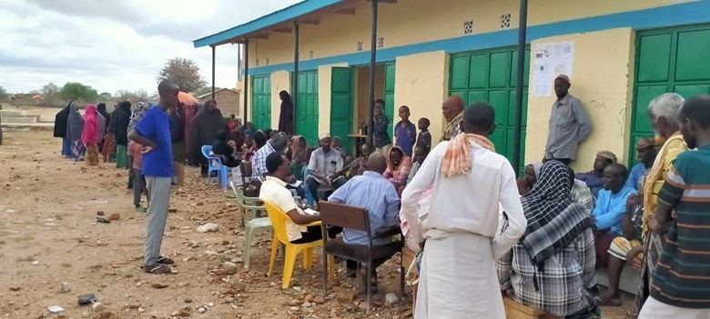

Plate 2: Elgolicha community participating in the ESIA consultation exercise.

6.5.4 Consultant’s Remarks
The Consultant, Mr. Mohamed Bubicha elaborated on the possible socio-economic impacts of the project to the residents of Elgolicha and requested the participants to give information for documentation. The consultant with assistance from the Area Chief guided as the translator Focused Group Discussions.

6.5.5 Positive Comments about the Project from the Participants
Some of the positive impacts that were identified by the participants includes;
- Learning will improve due to availability of lighting at all times of the day with the project implementation.
- Business opportunities will improve since farmers will be able to cool their milk, welding business, trading in boutiques, food eateries and small business-like limestone processing will rise in the area.
- Employment opportunities will increase for the youth due to increase in business opportunities.
- Security will improve due to availability of lighting.
- Medical services will improve due to availability of refrigeration services.
- The electricity will assist in pumping of water from the boreholes.
- Potential for small scale irrigation farming in the community with affordable electricity.

6.5.6 The Potential Projects negative impacts
Some of the positive impacts that were identified by the participants include;
- Accidents: some of the members raised concerns of possible accidents from electrocution especially the children as well as possible accidents from falling of the electric poles. The community suggested extra care during construction, protection of appliances and reinforcement of electric poles to mitigate these accidents.
- Employment Disputes: There was a concern over the possibility of disputes arising between the local community with people of different cultures in the construction sites. The community suggested that proponents should consider employing local construction workers.
- Dust Generation: The participants expressed concern over the possibility of generation of large amounts of dust within the project site and surrounding areas because of demolition, excavation works and transportation of building materials.
- The proponent will ensure that dust levels at the site are minimized through sprinkling water in areas being excavated and along the tracks used by the transport trucks within the site. Additional mitigation measures presented in this report will be fully implemented to minimize the impacts of dust generation.
- Environmental Aesthetics It was seen that the aesthetics of the area would be affected negatively during construction. It was suggested that the proponent should ensure landscaping is conducted after construction.
- Environmental Aesthetics: Some neighbours will be affected by too much noise and exhaust fumes from the site.
- Other Concerns registered are;
- Mr Issack Maalim is concerned about the delay in project implementation having taken more than a year since the screening meeting.
- Mr Mohamed Yussuf wanted to know whether the extra project will be implemented with the solar project.
- Mr Adan Ibrahim requested for consideration of the locals in the job opportunities that will come with the project both during construction and operational phases.

6.5.8 Consultant’s Response
The consultant, while addressing the community’s issues raised, gave the following response.

- The ESIA team assured that the current visit is the final one and it will be followed by implementation.
- The community was guided in the process of engaging with the contractor through the village project oversight committee to ensure inclusion and consideration for local laborers during construction and operational phases.
- The community were also guided to engage qualified electricians to undertake wiring of the houses to minimize potential electrical incidents after the project is commissioned.
- Community was also informed of training on general electrical safety that will be undertaken as part of the implementation by Kenya Power prior commissioning of the infrastructure.

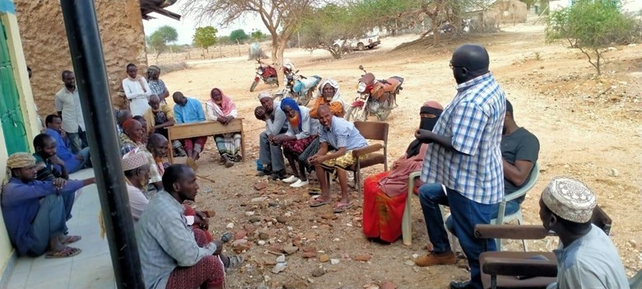

Plate 3: KPLC representative Samuel Abaya addressing Public Baraza in Elgolicha

6.5.9 Consent
The Community members present unanimously endorsed the Project Proposal as was the case during the screening phase where the site was marked for the project.

6.6 Community Presentation

6.6.1 Adult to youth Representation
During the stakeholder’s consultation adults were more represented than the youth.

6.6.2 Gender Representation
Gender representation of the area is 48% male and 52% women. This is similar to the wider national population census of 2019.

6.6.3 Heads of Households
Male genders are the household heads during the stakeholder consultation. This is largely influenced by the community beliefs where men have exclusive responsibility for provision for their households. Nonetheless, the community has women headed households mainly widows, divorcees, elderly women among others.

6.7 Focused Group Discussions Analysis
The in-depth interviews were used as a tool for stakeholder identification and mobilization as well as collection of baseline data to enable identification of the likely project impacts. In addition, it provided an opportunity to the participants to raise their fears and concerns as well as make recommendations as pertains to the project.
During the discussions, information was gathered about different roles, livelihood, health issues, challenges, perception of quality of life, education options for children, health care and project perception.
The consultative meeting had a wide representation as follows:
Table 11: The consultative meeting representation
Category | Male | Female | Total
Youth | 7 | 6 | 13
Adult | 14 | 20 | 34
TOTAL | 21 | 26 | 47
The target groups of the FGD were Males, Females, Health sector, Education sector as well as and the Youths.

6.7.1 Female Stakeholders’ Consultation and Participation
The participants were N=26 between 21-84 years of age. 3No Elderly respondents who were physically challenged from old age were present during the baraza. The respondent indicated that the community has female headed households (widows and divorcees).

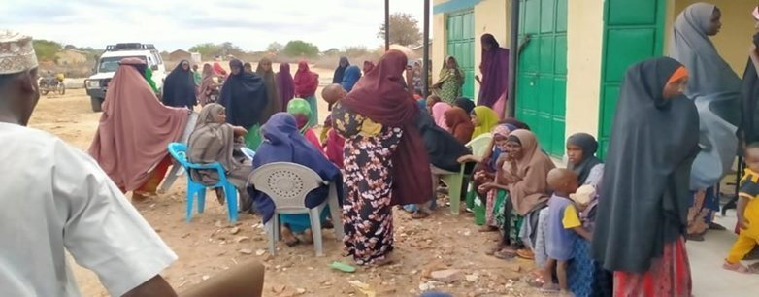

Plate 4: Female FDG participants during the stakeholders meeting at Elgolicha.

- Project Perception
The participants had knowledge of the solar project since the village was visited in the past during the screening phase and project description was done. According to the respondents the project will provide lighting for school going students, will be used for pumping water and create employment during the construction and operational phases.

- Role of Female
- Building houses, fetching firewood and water.
- Cooking and other house chores
- Women and men have no equal opportunities in the community however, Women control household equipment while male control livestock and other major assets.
- Women feel safe in the community and the level of crime is low. Conflict (inter clan clashes) is experienced
- The challenges encountered by women include inadequate water, lack of proper sanitation, high levels of illiteracy.
- Women receive information about local issues and development or news from their husbands and the local chief.
- Women are currently involved in decision making, a role that was exclusively for men in the past.

- Institutions/Community Development
- Women are involved in decision making at the household level not at the community level.
- Female are involved in doing business
- The main community development priorities/needs include.
  - Water
  - laboratory
  - education/ school library

- Economy /Income Generation
- Women earn income from operating small-scale eateries, clothes, selling livestock and livestock products. Some are involved in selling firewood.
- At the household level, women contribute less income than men
- To have greater economic opportunities, women suggested they should be capacity built and be involved in businesses
- The women have no access to any bank/credit/saving accounts in Elgolicha. However, they use mobile telephone money services.

- Land Use
- Land is mainly used for grazing.
- The livestock (goats and sheep, cattle camels, and donkeys) are reared for both subsistence, transportation and income generation.
- Community is largely nomadic and moves with their livestock in search of water and pasture during the dry seasons. However, sedentary lifestyle is mainly being adopted with severe climate disrupting pastoral sustainability.
- Women collect natural resources like firewood for both domestic use and commercial purposes.
- Occasionally, conflict is experienced in the community over boundary/land ownership claims with the neighbouring Garre community.
- Some Women in the FGD indicated that sometimes they experience gender-based violence (GBV) at household level. To eliminate GBV the women suggested creation of awareness on reducing GBV among community members.

- Education, Literacy, and Training
- Women noted that they have access to education but majorly affected by challenges like inadequate teaching facilities and teachers and cultural practices where women are not prioritized for education as compared to boychild.
- Girls access basic education at the Elgolicha primary school
- A few women can read and write in the community, especially the above young adults age bracket.

- Health care for Women in Elgolicha
- The women access health care from Elgolicha health center, though the main health problems/challenges facing women include inadequate medicine, healthcare education and sanitation. Health care services are not sufficient and do not meet the needs of the community.
- Environmental issues affecting health in the community are mainly air pollution because of the main road that passes through the village leading to respiratory concerns. However, the general air quality is pristine.
- Diseases affecting women include urinary tract infection, URTI and malnutrition due to high levels of poverty.
- The women have no access to family planning.
- There are some people leaving with disabilities and lack specialized home care due to lack of adequate facilities.
- Women majorly prefer using hospitals than traditional methods.

- Access to Water
- The community is served by dams, water wells and boreholes both in the village and Elwak.
- The water is mainly used for domestic use, sanitation, and livestock watering.
- The village also accesses water from a water pan. The dam water is turbid with dust particles and suspension. Shallow wells water is mainly salty.
- During the dry season water is not sufficient for both domestic and livestock needs, thus the community requires help through national or county government water tracking exercises.

- Sanitation and Hygiene
- The main type of toilets in the village are pit latrines. Open defecation was also reported by the FGDs. There are no public toilets except those in public institutions.

- Hygiene and Waste Management
- Women in Elgolicha access sanitary facilities and or products e.g., sanitary towels. However, due to low income most of them cannot afford it.
- Household waste is burnt in heaps or dumped in compost pits as there is no proper waste disposal infrastructure in Mandera County.

- Access to Energy
- Sources of energy and their uses in Elgolicha village include;
- For lighting use of kerosene lanterns and torches using batteries. Some have portable solar panels.
- Cooking -wood fuel/charcoal.
- Charging mobile-a few uses portable solar.
- The village has limited sources of power as the main challenge.

- Transport and Communication
- The main forms of transport are motorcycles, vehicles, donkey carts and camels.
- The village is served by an earth road that is impassable during wet seasons.
- The area is not connected to any service provider as means of communication.

- Cultural Heritage
- The area has no cultural heritage/historical sites.

6.7.2 Male Stakeholders’ Consultation and Participation
The male participants were N=14 of middle age to elderly during the FGD. The male participants are the main household heads though a few households headed by women were noted in particular widows, divorcees etc. The following were the responses provided by the participants.

- Project Perception
- As per the study, male participants were aware of the proposed project. According to the male respondents the project would boost the small traders/businesses especially those dealing with cold drinks, food kiosks and milk. They also indicated that the electricity generated by solar shall be used for lighting homes for school going children to carry out their school preparation work. Other benefits include phone charging, security within the village.
- The male respondents were concerned with the speed of implementation of the project.

- Role of Men
- According to the respondents’ male practice, rain fed farming and livestock keeping.
- Men in Elgolicha have more opportunities compared to females.
- In the community the men control livestock, land and assets with women controlling household items mainly.
- Poverty due to climate change that has decimated livestock is the main challenge men face in Elgolicha and farming that is no longer viable.
- Male feel safe in the community. However, fear of conflict from neighboring Somalia and inter clan clashes have been a concern over the years, in particular during rainy seasons attributed to control over resources such as pasture and water.
- Men receive information through radio, telephone and by word of mouth from the area chief.

- Institutions/community development
- The top three community development as per the male FGD include:
- Water.
- Health facility improvement.
- Economic empowerment through access to credit facilities.

- Economy /Income Generation
- The main sources of income in Elgolicha include;
- Livestock and livestock products.
- Petty trading in firewood, cold drinks, boutiques etc.
- Overall, men contribute more income to the household compared to females.
- To improve the community economy men suggested that they should be offered economic empowerment.
- Mobile phones are used as banks. However, there are no major credit facilities, the community rely primarily on savings through M-Pesa, KCB and Equity.

- Land Use
- Land in Elgolicha is mainly communal and is used mainly for grazing livestock.
- Men keep livestock both as subsistence and income-generating activities. Livestock reared include cattle, camels, sheep, goats, donkeys as well as local chicken.
- Community members are nomadic- moving with livestock in search of water and pasture especially during the dry seasons.
- The community members also grow crops like maize and sorghum during rainy season.
- The men are also involved in collection of natural resources like firewood.
- According to the FGD, no conflicts are experienced within the communities.

- Education, Literacy, and Training
- The village has only one primary school. Boys in the community can read and write.
- Elgolicha Primary school is about 2km from the village centre and provides access to formal basic education.
- Most of the male population generally complete their studies up to grade 8 and Form four level as compared to the girlchild.
- The factors preventing men from accessing further education include lack of school fees due to high levels of poverty, responsibilities like livestock rearing and finally security which caused inadequacy of teachers.
- Largely men in the village can read and write below the age bracket of 40years.

- Healthcare Service
- The men access health care from Elgolicha dispensary. However, complicated cases are referred to Elwak, Mandera or Nairobi counties.
- The dominant health issues among men include arthritis, pneumonia and blood pressure.
- The PLWDs are present among the male population and are mostly managed at home and only taken to a health facility in case of any complications.

- Access to Water
- shallow wells provide water for the community to use for drinking, cooking, washing and bathing.
- Water from the wells and borehole is used for domestic, irrigation and for livestock.
- Women and children are involved in fetching water for the community members.
- The men are responsible for searching for water to be provided to the livestock while women collect water for both livestock for domestic use.

- Sanitation and Hygiene
- The main type of toilets are pit latrines.
- Men indicated that open defecation is commonly practiced as an alternative where access to latrines is impossible.
- Hygiene and Waste Management
- Handwashing and general cleaning are done by use of basins and jerry cans.
- The community mostly uses private pit latrines and a few uses bush.

- Access to Energy
- Sources of energy for Elgolicha village include;
- For lighting, they use kerosene lamps.
- For warming they use firewood
- Cooking -firewood
- Charging mobile-private solar
- Cooling –none
- The village has limited sources of power since the solar power which they mostly rely on is privately owned and access to maintenance is limited and the systems are of low standards.
- The men suggested that the project will be of great importance to the community.

- Transport and Communication
- The main form of transport is motorcycle, PSV vehicles, donkey carts and camel
- The village is served by an murram road (6km from Elwak)
- The area is served with Safaricom service providers as the dominant means of communication.

- Religious Heritage
- Mosques are the main religious sites within the Elgolicha community.
- The main festivals undertaken by men include religious festivities e.g.,Eid Ul Adha & Hajj, weddings and rituals during good harvest.

6.7.3 Youth Stakeholders’ Consultation and Participation
The youth participants were N=20 in number. The following opinions were provided by the youth participants during the FDG.

- Project Perception
- The youth revealed that they were aware and understood the importance of the project to the community.
- The respondents suggested that the project will create job opportunities, improve business, improve education sector and security of the village.
- They however noted that negative impact as likely injuries through electric incidents such as fires and property damages and suggested awareness raising among the residents for safe handling of the electrical systems.

- Role of the Youth
- The youth said that they are involved in community matters and their voices are well heard.
- Key priorities among the youth include job opportunities and an improved health sector.
- Youth are involved in decision making in the community as the single largest grouping.

- Institutions/Community Development
- The community has a Youth Group whose function is to address general wellbeing of the community and youth.
- There are no development or aid programmes for youth within the community.

- Economy /Income Generation/Employment
- Ten (10%) of the respondents are self-employed while about (1%) have full-time salary jobs.
- The income-generating activities predominant among youth in Elgolicha include casual work like construction, fetching and selling of firewood, trading in livestock especially goats, transportation business by use of motorbikes and through selling of Miraa (khat).
- Other skills that enable them gain employment include teaching, mechanics and carpentry.

- Education, Literacy, and Training
- 80% of youth have completed secondary school among the respondents sampled during the engagement.
- About (50%) have completed some form of vocational/college.
- The major skills among the youth include masonry experts.

- Employment
- 1 percent of youth in the community have full-time salaried jobs with eighty percent of youth are self-employed with the main job being masonry.

- Recreation
- Most youth are involved in sports during their free time though a significant number of about 40 percent are also engaged in use of chewing khat as a pastime due to lack of gainful employment.

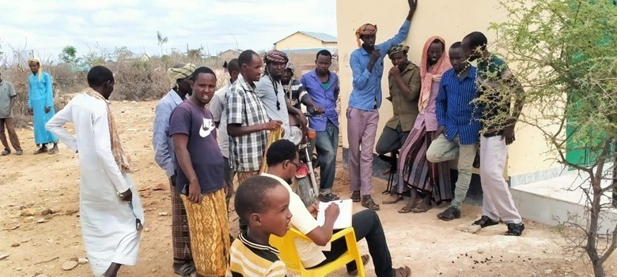

Plate 5: Youth FDG at Elgolicha

6.7.4 Vulnerable and Marginalized Group (VMG)
Garre are the main ethnic group and are said to inhabit the village. Vulnerable and marginalized groupings are mainly persons with disabilities, divorcees, windows etc. These groupings due to cultural biases are mainly segregated and hidden away in particular mentally challenged persons. However, widows and divorcees though not outrightly discriminated against their access to public resources is disadvantaged as traditionally men are stake all households claim in public resource sharing.

- Project Perception.
The Vulnerable and Marginalized Group (VMG) revealed that they were aware of the project and confirmed that they understand the project well.

- Baseline on VMG.
The following are groups of people that are considered Vulnerable and equally marginalized;
- The orphans
- The divorcees
- The widows
- The elderly and
- People living with disabilities.

- In Elgolicha, the widows and orphans are considered the most vulnerable group since they lack someone to fend for them and fight for their share of public resources in the village.
- Approximately 5 percent of households are considered vulnerable within the village.
- The main source of livelihood for the group is casual labourers and livestock produces sales and such.
- The public social amenities provided in the locality are; schools, dispensary and water point and they all serve the residents equally VMGs included.
- The community occasionally receives relief food (twice annually) and VMGs are mostly considered during distribution.
- The major challenge faced by VMG is poverty and it is addressed by charity.
- FAO is an organization that has a program in the area that supports the VMGs. The programme they undertake include; capacity building of VMGs, construction of pit latrines etc.

- Project Impact.
- There were many public projects that were implemented in the area like schools, boreholes and water pans. The VMGs were well involved in the implementation of the public projects.
- The project will benefit the VMGs by increasing accessibility to water, improvement in the health sector and education sector.
- The benefits can be maximized by considering free education and financial support for the VMGs.
- The tops 3 development priorities among the VMGs are;
    - Standard health facility to those with medical conditions
    - Economic Empowerment through access to credit.
    - Education.

6.7.5 Education Stakeholders’ Consultation and Participation (KI)
The village has Elgolicha Primary school with a student population of 508 students: 307 boys and 201girls. This enrolment data shows boys' education is preferred among the community with 60 percent. Thus, boys are giving more preference by the households with transition to secondary and college even worse for the girlchild.

  - Project Perception
- Project would have a positive impact on the school through access to electricity that will provide light especially in the evening study by students. Learning will also be digitized.
- He suggested that any possible negative impact of the solar project can be mitigated through regular maintenance checks and proper installation. The community should be capacity built on repair and maintenance.

  - Infrastructure/Resources
- Elgolicha primary School currently has 8No. teachers
- The challenges facing the school include lack of administration block and electricity, negative attitude towards education by the community as well as inadequate teachers.
- The school receives minimal support from the national government.
- The average walking distance of students to school is 0.5km.
- Students are sometimes provided with meals.
- Teachers receive their salaries from TSC, County government and PTA.

  - The School Performance
- The school’s performance in national examinations is very poor, similar to all schools in the county. This is partly attributed to lack of teachers among other resources such as libraries, and adequate classrooms.
- The performance of boys is generally better than girls as per national exams results analysis.

6.7.6 Health Stakeholders’ Consultation and Participation
The following were responses from the health work (a nurse) during the KII.

- The Project Perception
- The key informant had knowledge of the project.
- The project is seen to have a positive impact on Elgolicha Dispensary through access to electricity, availability of refrigeration services for storage of vaccines and other medicines requiring cold chains at the facility, improvement of communication that require electricity.
- The project will also help in a laboratory set up with adequate electricity to operate the various equipment.

- Facility Profile
- Elgolicha Dispensary currently operates on a 24hrs basis and provides Out-patient, in-patient, immunization, lab services and maternity services.
- It serves the local community and the surroundings of informal villages within a radius of 27 km. Services provided include Out-patient, nutrition services, immunization, maternity and family planning.

- Infrastructure/Resources
- The dispensary is currently understaffed and only has 1No staff.
- The Nurse indicated that the infrastructure at the institution is in good condition.
- The facility has inadequate equipment; there are no beds, or any emergency vehicles.
- The average walking distance of the community to the dispensary is approximately 27km.
- There are outreach and educational services currently provided in relation to health which include immunization and nutrition services.
- The Nurse indicated that there are several gaps in the health care system in the village that include inadequate funds to run the facility and inadequate staffing.

- General Health Concerns
- The main health issues predominant among the children in El Golicha are pneumonia, diarrhea and malnutrition.
- The main health issues predominant among the women in Elgolicha are anaemia, malnutrition and respiratory tract infection.
- The main health issues predominant among the men in Elgolicha are anemia, URTI, UTI
- Malnutrition was the most prevalent among VMG due to food insecurity while Sexual health issues are the least common among the community of Elgolicha.
- Maternal and infant mortality rates is high
- Minimal Mental health issues were reported; there are less than 10 known cases.
- There are no cases of GBV or health issues arising from the quality of the environment which have been handled by the dispensary.
- The most vulnerable groups within the community are single mothers, women and VMG due to poverty.
- Life expectancy is 60 years. Maternal and infant mortality rates are high.

6.8 Disclosure of ESIA to the Stakeholders
The final ESIA report will be shared with the stakeholders by way of making it available to the target beneficiaries and other interested parties. The ESIA report will be shared through the county headquarters (a copy will be availed) or will be accessible through the CREO office and KPLC website. In addition, a copy of the ESIA should be availed by CREO to the chief’s office for access by the local community and other stakeholders.

The findings of the ESIA will be shared or disseminated to the target community in a culturally appropriate format such as using local language and through public meetings and focus group discussions.

6.9 Stakeholder Engagement and Grievance Management Post ESIA
During implementation of the project or construction phase, stakeholder engagement will be progressed to ensure the community and other stakeholders are kept abreast of the progress of the project. For the target community this will take the form of meetings and focus group discussions between local community and the contractor which will also act as forums for the community to ask questions or provide feedback. Therefore, the contractor will prepare a stakeholder engagement plan to guide on the engagements with various stakeholders guided by the Stakeholder Engagement Plan prepared during ESIA.

6.10 Objectives and Principles of Stakeholder Engagement
Stakeholder engagement is the basis for building strong, constructive, and responsive relationships that are essential for the successful management of a project's environmental and social impacts.

In order to ensure effective engagement and consultation of all stakeholders, the contractor and the proponent KPLC will apply the following principles.
- Ensure the affected persons are provided opportunities to express their views on project risks, impacts and mitigation measures, and response provided.
- Begin consultations early even before construction begins because there is a lapse of time between ESIA consultations and implementation time. Identification of environmental and social risks and impacts should continue an on-going basis as risks and impacts arise.
- Consultations should continue in a manner that is transparent, objective, meaningful and allow for ease in accessing information in a culturally appropriate local language(s) and format that is understandable to affected and interested persons.
- Consultations with affected persons and interested parties should avoid manipulation, interference, coercion, or intimidation.
- Consultations should also pay attention to the needs of VMGs, vulnerable individuals and households.
The contractor shall identify the stakeholders early and consider appropriate methods for engaging them. The stakeholder engagements will be reported to KPLC on monthly basis alongside the construction progress reports.

CHAPTER SEVEN

7.0 IMPACT ASSESSMENT AND MITIGATION MEASURES

7.1 Introduction
This section provides an assessment of potential environmental and social impacts from the proposed Projects as well as the proposed mitigation measures to avoid, reduce, remediate, or compensate for potential negative impacts and to enhance positive impacts. A description of the assessment methodology used to assess the significance of potential impacts, considering impact magnitude and sensitivity of receptors and resources affected, is provided below. To facilitate the reading of the ESIA, the same heading structure in terms of environmental indicators, receptors or resources affected by the project activities were considered as the ones used in the baseline and listed in section 4. All the mitigation measures identified in this chapter have been collated into the Environmental and Social Management Plan (‘ESMP’) matrix. This includes Occupational Health and Safety.

7.2 Impact Assessment Methodology
An impact is essentially any change to a resource or receptor brought about by the presence of the Project component or by the execution of a Project related activity. In general, the assessment of impacts will proceed through an iterative process considering four key elements:
- Prediction of potential impacts and their magnitude (i.e., the consequences of the development of the natural and social environment).
- Evaluation of the importance (or significance) of potential impacts taking the sensitivity of the environmental resources or human receptors into account.
- Development of mitigation measures to avoid, reduce or manage the potential impacts or enhancement measures to increase positive impacts; and
- Assessment of residual significant impacts after the application of mitigation and enhancement measures.
Where significant residual impacts remain, further options for mitigation may be considered and impacts re-assessed until they are as low as reasonably practicable for the Project and would be deemed to be within acceptable levels.

7.3 Defining Impact
Impacts will be defined in several ways, including:
- Nature of impact: positive or negative.
- Type of impact: direct, indirect, or cumulative.
- Duration of impact: temporary, short-term, national, international
- Scale of impact: onsite, local, regional, national, international.

7.4 Assessment of Significance
Criteria for assessing the significance of impacts will stem from the following key elements:
- Status of compliance with relevant Kenyan legislation, policies and plans and any relevant Kenyan or industry policies, standards, or guidelines, as well as international best practice standards and guidelines.
- The magnitude (including nature, scale, and duration) of the change to the natural or socioeconomic environment (e.g., an increase in coastal erosion, or an increase in employment opportunities), expressed, wherever practicable, in quantitative terms. The magnitude of all impacts is viewed from the perspective of those affected by considering the likely perceived importance as understood through stakeholder engagement.
- The nature and sensitivity of the impact receptor (physical, biological, or human). Where the receptor is physical, the assessment considers the quality, sensitivity to change and importance of the receptor. For a human receptor, the sensitivity of the household, community or wider societal group is considered along with their ability to adapt to and manage the effects of the impact; and
- The likelihood (probability) that the identified impact will occur. This is estimated based upon experience or evidence that such an outcome has previously occurred.
It is generally accepted that significance is a function of the magnitude of the impact and the likelihood of the impact occurring.
For this assessment, significance has been defined based on five levels described in table below.
Table 12: Categories of Significance
Category | Significance
Positive impacts | Positive impacts provide resources or receptors, most often people, with positive benefits. It is noted that concepts of equity need to be considered in assessing the overall positive nature of some impacts such as economic benefits, or opportunities for employment
Negligible impacts (or Insignificant impacts) | Negligible impacts (or Insignificant impacts) are where a resource or receptor (including people) will not be affected in any way by a particular activity, or the predicted effect is deemed to be ‘negligible’ or ‘imperceptible’ or is indistinguishable from natural background variations.
Minor | An impact of minor significance (‘Minor impact’) is one where an effect will be experienced, but the impact magnitude is sufficiently small (with or without mitigation) and well within accepted standards, and/or the receptor is of low sensitivity/value.
Moderate | An impact of moderate significance (‘Moderate impact’) is one within accepted limits and standards. Moderate impacts may cover a broad range, from a threshold below which the impact is minor, up to a level that might be just short of breaching a legal limit. Clearly, to design an activity so that its effects only just avoid breaking a law and/or cause a major impact is not best practice. The emphasis for moderate impacts is therefore on demonstrating that the impact has been reduced to a level that is ALARP (as-low-as-reasonably-possible). This does not necessarily mean that ‘Moderate’ impacts must be reduced to ‘Minor’ impacts, but that moderate impacts are being managed effectively and efficiently.
Major | An impact of major significance (‘Major impact’) is one where an accepted limit or standard may be exceeded, or large magnitude impacts occur to highly valued/sensitive resource/receptors. An aim of EIA is to get to a position where the Project does not have any major residual impacts, certainly not ones that would endure into the long-term or extend over a large area. However, for some aspects there may be major residual impacts after all practicable mitigation options have been exhausted (i.e., ALARP has been applied). It is then the function of regulators and stakeholders to weigh such negative factors against the positive ones in coming to a decision on the Project.

For environmental impacts the significance criteria used in this ESIA is shown in the table below.

Table 13: Overall Significance Criteria for Environmental Impacts
 |  | Sensitivity/vulnerability/importance of resource/receptor
 |  | Low | Medium | High
Magnitude of impact | Negligible | Negligible | Negligible | Negligible
 | Small | Negligible | Minor | Moderate
 | Medium | Minor | Moderate | Major
 | Large | Moderate | Major | Major

For the social impact assessment, the perceptions of stakeholders, expressed as opinions around certain issues, can be as important as actual impacts. Consequently, the concept of perception is explicitly brought into the evaluation of significance after an impact is evaluated. When an impact is of significant stakeholder concern, this may be causing to raise the significance rating. This prompts the formulation of more rigorous and appropriate mitigation measures which focus on the source of the impact and address stakeholder perceptions. The risk of not addressing stakeholder perceptions is that reputational damage could arise, resulting in the loss of a ‘social license to operate.

7.5 Magnitude of Impact
The impact assessment describes what will happen by predicting the magnitude of impacts and quantifying these to the extent practical. The term ‘magnitude’ covers all the dimensions of the predicted impact to the natural and social environment including:
- The nature of the change (what resource or receptor is affected and how).
- The spatial extent of the area impacted, or proportion of the population or community affected.
- Its temporal extent (i.e., duration, frequency, reversibility); and
- Where relevant (accidental or unplanned events), the probability of the impact occurring.
For social impacts, the magnitude considers the perspective of those affected by considering the likely perceived importance of the impact, the ability of people to manage and adapt to change and the extent to which a human receptor gains or loses access to, or control over, socio-economic resources resulting in a positive or negative effect on their well-being (a concept combining an individual’s health, prosperity, their quality of life, and their satisfaction).
Table below (under Likelihood) provides an account of the key features (definitions) of each of the impact significance classifications (from Not Significant to High); specifically linking them to the need for mitigation measures.

7.6 Sensitivity of Resources and Receptors
Sensitivities are defined as aspects of the natural or social environment which support and sustain people and nature. Once affected, their disruption could lead to a disturbance of the stability or the integrity of that environment. For ecological impacts, sensitivity can be assigned as low, medium, or high based on the conservation importance of habitats and species. For habitats, these are based on naturalness, extent, rarity, fragility, diversity, and importance as a community resource.
For socio-economic impacts, the degree of sensitivity of a receptor is defined as ‘a stakeholder’s (or groups of stakeholders’) resilience or capacity to cope with sudden changes or economic shocks. The sensitivity of a resource is based on its quality and value/importance, for example, by its local, regional, national, or international designation, its importance to the local or wider community, or its economic value.

7.7 Likelihood
Terms used to define likelihood of occurrence of an impact are explained in the table below.

Table 14: Explanation of Terms used for likelihood of Occurrence
An impact with a
High probability | Refers to a very likely impact | Refers to very frequent impacts
Medium probability | Refers to a likely impact | Refers to occasional impacts
Low probability | Refers to rare impacts | Refers to rare impacts
 | As far as one-time events (e.g., air emissions) or slowly developing effects are concerned (e.g., impacts on local lifestyle) | As far as possibly recurring impacts are concerned, such as accident or unplanned events (e.g., traffic accident, fire)

7.8 Definition of Mitigation Measures
Mitigation measures are developed to avoid, reduce, remedy, or compensate for significant potential negative impacts, and to create or enhance potential positive impacts, such as environmental and social benefits. In this context, the term “mitigation measures” includes operational controls as well as management actions. These measures are often established through industry standards and may include:
- Changes to the design of the project during the design process (e.g., changing the development approach).
- Engineering controls and other physical measures applied (e.g., wastewater treatment facilities).
- Operational plans and procedures (e.g., waste management plans); and
- The provision of like-for-like replacement, restoration, or compensation.
For potential impacts that are assessed to be of major significance, a change in design is sometimes required to avoid or reduce the significance. For potential impacts assessed to be of moderate significance, specific mitigation measures such as engineering controls are often sufficient to reduce these impacts to ALARP (‘as-low-as-reasonably-practicable’) levels. This approach considers the technical and financial feasibility of mitigation measures. Potential impacts assessed to be of minor significance are usually sufficiently managed through good industry practice, operational plans, and procedures.
In developing mitigation measures, the first focus is on measures that will prevent or minimize potential impacts through the design and management of the Project rather than on reinstatement and compensation measures.

7.9 Assessing Residual Impacts
Impact prediction considers any mitigation, control and operational management measures that are part of the project design and project plan. A residual impact is the impact that is predicted to remain once mitigation measures have been designed into the intended activity. Social, economic, and biophysical impacts are inherently and inextricably interconnected. Change in any of these domains will lead to changes in the other domains.

7.10 Positive Impacts During Construction Phase
This section enumerates and discusses the positive impacts associated with the proposed project during the construction phase of the project.

7.10.1 Creation of Employment Opportunities
Various employment opportunities will be available during construction. The opportunities will be both skilled and unskilled. Majority of the unskilled and semi-skilled jobs will be taken up by the local community. Employment of the locals will increase skill transfer from the contractors.
The approximate number of workers to be employed by the proposed project is not yet known, however, this will contribute to easing unemployment level in the area. There will be a trickledown effect to the economy at large resulting from new income revenues as well as services provided through this project.

The impact significance is low as it will employ few people over a short period

Enhancements
- Contractor should ensure that they prioritize the local community in allocating job opportunities.
- Contractor should ensure that job opportunities are not discriminatory
- Equal opportunities should be given to both men and women

7.10.2 Improving local economy Provision of Market for Supply of Building Materials
During this phase, the project will require supply of building materials most of which will be sourced locally at the nearest trading centre and its environs to the extent possible. Therefore, the project will provide a ready market for local enterprises with such materials and boost the local economy.

7.10.3 Boosting of Businesses
The businesses that will benefit during this phase are such as hotels, shops, artisan industries and food vending who will benefit directly from the construction, as people working there will need commodities from them. This will promote the informal sector in securing some temporary revenues and hence improved livelihoods.
One of the responsibilities of the beneficiaries of the proposed Solar Mini-grid is to undertake wiring of their premises before they are connected and payment of a connection fee of Ksh 1000. The MOE through its implementing agency KPLC should consider supporting at least 50 households that are very poor through installation of ready boards to offset the cost of wiring so that they can also access electricity.
The impact significance is low as it will buy few materials over a short period of time
- KPLC should ensure that their contractors/suppliers remit taxes and have a tax compliance certificate
- Prioritize local purchases over imports.
- Remit taxes on behalf of employees
- Contractor should prioritize local purchases over imports;
- Contractor should give preference to local labor which increases the local’s ability to spend

7.11 Positive Impacts during Operation Phase

7.11.1 Quality, Reliable Power Supply
There is no electricity in Elgolicha. This is a maiden project with an aim of supplying power through solar because the area is far away from the national power grid. Once operational, household and public institutions (dispensary, primary school) and shopping centers in the area will greatly benefit from the stable power supply.

The impact significance is high as it will provide power where it wasn’t for a long period

Enhancements
- KPLC should ensure that they have a functional customer support team and a field response team;
- KPLC should ensure that they communicate power outages early to consumers

7.11.2 Employment Creation
Employment opportunities will also be created during the operation phase of the project. Opportunities that will be created include unskilled, semi-skilled to skilled jobs. These will involve security personnel, and staff to operate and maintain the Mini-grid. Employment will increase skill transfers.
The impact significance is low as it will employ people to manage the substation

Enhancements
- KPLC should ensure that they prioritize the local community in allocating job opportunities.
- KPLC should ensure that job opportunities are not discriminatory
- Equal opportunities should be given to both men and women

7.11.3 Reduction of Pollution Associated with Thermal Power Generation, Kerosene and Wood Fuel Usage:
Residents in the area use different sources of energy. Electricity supply will imply that as many as are willing can apply for connection and get connected. This will result in reduced individuals and organizations using diesel generators, less reliance on kerosene, wood fuel and charcoal. This would mean less carbon dioxide is released to the environment and destruction of forests will be reduced hence decreasing greenhouse gasses.

The impact significance is high as it will provide cleaner energy over a long [period of time for many households

Enhancements
- KPLC should ensure that the power provided cost is competitive to discourage the locals from using unclean sources of power.
- KPLC should ensure that they communicate power outages early to consumers

7.11.4 Improvement of Local and National Economy
The mini-grid project will ensure supply of a stable power that will reduce damage to the electronics and this will result in promotion of businesses both in the formal and informal sectors. Availability of power will enable businessmen to scale up their businesses while making it possible to set up businesses such as salons, barber shops, photocopying machines, cyber cafes, welding, refrigeration of drinks among others. This will result in income improvements at the individual level and for the national economy. More customers will be connected and retail of reliable electricity by the power utility firm will attract increased tax revenues to the government.

The impact significance is low as it will buy few materials over a long period of time

Enhancements
- KPLC should ensure that their contractors/suppliers remit taxes and have a tax compliance certificate
- Prioritize local purchases over imports.
- Remit taxes on behalf of employees

7.11.5 Education
Access to electricity at the household level and schools will create opportunities for children to be able to study even for longer hours. Additionally, children in households can also access education programs being aired through different radio and T.V. channels. Schools will be able to take advantage of information technology and communication that are becoming a way of life in the education sector and learning in general.’
The impact significance is high as it will provide power to schools over a long period for additional study time in the night and morning

Enhancements
- KPLC should consider having the transmission lines are closer to schools for them to benefit from the power supply;
- KPLC should consider partnering with the county government in providing street lighting to improve security for children and teachers leaving for school early or leaving late for home

7.11.6 Health Benefits of the Project
Solar energy for lighting is better than kerosene lamps that are in use currently. This is because kerosene lamps emit particles that cause air pollution. The health risks posed by this indoor air pollution mainly include acute lower respiratory infections. Additionally, insufficient illumination (low light) conditions can cause some degree of eye strain and reading in these conditions over long periods of time may have the potential to increase the development of near-sightedness in children and adults. The project will result in many families replacing kerosene lamps for lighting with electricity there-by reducing chances of the aforementioned disease incidences.

7.11.7 Improved Standard of Living
Availability of power will result in lifestyle changes through improved night lighting, pumping of water instead of manual pumping and refrigeration to maintain food safety and quality.

7.11.8 Security
The area will benefit from improved security since houses, businesses and public institutions will be well lit using electricity. This is as a result of more security flood lights bulbs which helps keep off opportunistic crimes including gender-based violence.

7.11.9 Communications
Access to electricity will lead to improved communication. This will be enabled by the fact that charging of mobile phones will be easier and cheaper. Access to mass media like radio and T.V will provide opportunity for the households to access a wide range of information which is useful for decision making.

7.12 Positive Impacts during Decommissioning Phase

7.12.1 Employment Opportunities
Once the project has served its purpose it will then be decommissioned. This will involve demolition and removal of the facility. During demolition, unskilled, semi-skilled and skilled employment opportunities will be available to the public.

7.12.2 Site Rehabilitation
After demolition of the proposed project, rehabilitation of the project site will be carried out to restore it to its original status or to a better state than it was. This will include replacement of topsoil and re-vegetation which will lead to restoration of the visual, vegetative and aesthetic state of the site.

7.13 Negative Impacts during Pre-construction Phase

7.13.1 Land Take
The identified site for the proposed Mini-grid is part of a 2.3768 hectares of land acquired from the Elgolicha community and compensation in kind offered. The assessment found that;
- No residential houses or businesses premises were on the piece of land
- No socio-economic activity was taking place on the land
- No physical relocation will take place.

7.13.2 Wayleaves
Supply of electricity will involve passing of low voltage (LV) lines to connect the customers to power. It is estimated that a total of 7km of LV circuit will be constructed mainly along the road reserve and along the boundaries to supply power.

The impact significance for this impact is assessed minor considering the community wilfully allocated the land for project construction.

Mitigation Measures
- Land for mini-grids will be acquired by NLC compulsorily and affected communities compensated in-kind.
- The contractor will sign and adhere to the agreement for use of community land for contractor facilities and worker’s camps, and restoration of the site after use.
- The construction activities will be restricted to within the allocated land and the immediate surroundings only.
- After construction work, any land taken for a temporary basis for storage of material will be restored to their original form.
- Consultations with the community during construction of the low voltage lines

7.14 Negative Impacts During Construction Phase
Despite the positive impacts identified, the project will also have negative impacts. However, adverse impacts are not anticipated due to its size and nature and most of the impacts will be experienced during the construction phase of the project. The negative impacts and their mitigation are discussed below.

7.14.1 Vegetation Clearance
The construction process of the proposed Mini-grid and other associated facilities and structures will involve clearing of the existing vegetation cover (mainly grass) and trees. The project site is located in an open area with minimal settlement around besides the dispensary and residential homes. Both the magnitude and sensitivity of this impact will be low. The impact will be direct, permanent and minor.
Mitigation Measures
- Clear only the necessary areas
- Ensure proper demarcation and delineation of the project area to be affected by construction works.
- Specify locations for vehicles and equipment, and areas of the site which should be kept free of traffic, equipment, and storage.
- Designate access routes and parking areas
- Re-vegetation including planting of trees around the plant/facility

7.14.2 Soil Erosion Impact
During clearing of the area to pave way for ground-breaking soil erosion may take place. This will be due to surface run off or blowing away by the wind if not properly managed. This is bound to happen because the soil will be loose. The area is gently sloped on the lower side and surface runoff can also result in soil erosion. The impact significance will be minor due to the nature of the works and the fact that construction activities will be confined in the small project area.
Mitigation Measures
- The contractor shall avoid ground-breaking during the seasons of high rainfall to avoid erosion.
- Monitoring of areas of exposed soil during rainy seasons to ensure that any incidents of erosion are quickly controlled.
- The contractor should ensure that construction related impacts like erosion and cut slope destabilizing should be addressed through landscaping and grassing, carting away and proper disposal of construction materials
- Use silt traps where necessary
- Cover soil stockpiles.
- Landscaping with grass on areas without electrical installation (lower areas)
- The contractor should ensure recovery of exposed soils with grass and other ground cover as soon as possible.
- The contractor should put up proper drainage to avoid unnecessary erosion and do compaction of spoil areas to avoid land instability in the form of soil subsidence, slip and mass movement.
- Areas compacted by vehicles during site preparation and construction should be scarified (ripped) by the contractor in order to allow penetration of plant roots and the re growth of the natural vegetation

7.14.3 Contamination of Soil from Fossil Fuels
The potential sources of soil contamination during the construction phase are oil /fuel leaks or spills from machinery used in site preparation and trucks used in transporting construction materials. Depending on the size and source of the spill, liquid and gaseous state, petroleum hydrocarbons may remain mobile for long periods of time, threatening to contaminate the soil. The significance of the impact to the soil will be minor due to the nature of the works and the fact that construction activities will be confined in the small project area.
Mitigation Measures
- Construction vehicles must be maintained in good state and proper servicing to ensure no oils are likely to leak
- Care must be exercised not to spill any fossil fuels
- Any contaminated soil shall be scooped and disposed-off appropriately.

7.14.4 Dust Emissions
Initial activities such as site clearing, excavation if done in dry weather conditions will result in dust pollution. Dust emission from construction machinery is regarded as a nuisance when it reduces visibility and is aesthetically displeasing. This is expected during construction works. Dust will be generated from construction earthworks, transportation activities and aggregate mixing.
The receptors were noted to be mainly residential and a health facility. The distances from a source that dust impacts can occur is highly site specific and will depend on the extent and nature of incorporated mitigation measures, prevailing wind conditions, rainfall and the presence of natural screening. Due to the variability of the weather, it is impossible to predict what the weather conditions will be when specific construction activities are being undertaken. Therefore, the assessment of construction dust impacts is typically qualitative.
Mitigation Measures
- The construction area should be fenced off to reduce dust to the public
- Sprinkle loose surface earth areas with water to keep dust levels down.
- Construction trucks moving materials to site, delivering sand and cement to the site should be covered to prevent material dust emissions into the surrounding areas;
- Masks should be provided to all personnel in areas prone to dust emissions during construction
- Stockpiles of excavated soil should be enclosed/covered/watered during dry or windy conditions to reduce dust emissions.
- Drivers of construction vehicles must be sensitized so that they limit their speeds so that dust levels are lowered.
- Trees can be planted around the plant provided they do not cast shadows to the solar panels to act as wind breakers and hence decrease dust pollution

7.14.5 Vehicle Exhaust Emissions
Exhaust emissions are likely to be generated by the construction vehicles and equipment. Motor vehicles that will be used to ferry construction materials would cause air quality impact by emitting pollutants through exhaust emissions. There are few Receptors (settlements) within 500 m of the project site and the impact magnitude will be medium and sensitivity medium hence the impact significance will be moderate.
Mitigation Measures
- Drivers of construction vehicles must be sensitized so that they do not leave vehicles idling so that exhaust emissions are lowered.
- Maintain all machinery and equipment in good working order to ensure minimum emissions of carbon monoxide, NO_{X}, SO_{X} and suspended particulate matter;

7.14.6 Pollution from Solid Waste Generation
It is expected that solid waste will be generated during the construction phase of the project. Solid waste is anticipated to be produced during site preparation, civil works, spoil from excavations and will include; mortar, wood, paper, waste paper wrappings, conductor off cuts, masonry chips and left-over food stuffs. Effects of mismanaged waste include:
- Public nuisance due to littering or smell in case of rotting
- Contamination of soils and water courses
- Creation of breeding grounds for vermin like rodents and cockroaches
The significance of this impact will be minor due to the nature of the works and the fact that construction activities will be confined in the small project area.
Mitigation Measures
- Ensure spoil from excavations is arranged according to the various soil layers. This soil can then be returned during landscaping and then rehabilitation, in the correct order which they were removed that is top soil last;
- Segregate waste and dispose of appropriately using a licensed waste handler
- Provide litter collection facilities such as bins and create awareness campaigns to segregate as early as possible, using the appropriate bins
- Contractor to put in place and comply with a site waste management plan
- The contractor should comply with the requirement of OSHA ACT 2007 and Building rules on storage of construction materials
- Use of durable, long-lasting materials that will not need to be replaced as often, thereby reducing the amount of waste generated over time
- Recovery of materials remains and return to stores
- Re-use of materials where possible
- Proper budgeting to avoid waste generation

7.14.7 Impacts on Water Resources and Water Quality
During construction, excavation activities will involve soil exposure which results in soil erosion due to wind and surface runoff due to rains. Seepage from spilled fuels and oils and leaking machinery can also negatively impact groundwater water which could lead to potential contamination. Generally, due to the localized area of impact, the overall significance of the related impacts on water quality is considered to be minor, provided the necessary mitigation/ management measures are implemented. The people in the Elgolicha area use an earth dam and shallow boreholes as the main source of water and care must be exercised to avoid any pollution to the water source.

Mitigation Measures
Measures shall be put in place to minimize erosion and sediment mobility, especially during construction. These measures include:
- Clear the necessary areas only.
- Appropriate remedial measures shall be implemented by the contractor in the event of erosion.
- Infrastructure shall be designed to ensure that contaminated run-off does not reach watercourses.
- In the event of an oil spill the procedures contained in the emergency response plan of the contractor will come into effect.
- No vehicle maintenance and service shall be done at project site but in approved garages or service stations to avoid any possible oil and fuel spills that could contaminate soils and possibly ground water quality.
- Ensure that potential sources of petro-chemical pollution are handled in such a way to reduce chances of spills and leaks.
- Construction activities to avoid any unchanneled flow of water at the site
- Storage areas that contain hazardous substances should be bundled with an approved impermeable liner and provision for a pit to be made in case of oil spill.
- The excavation and use of rubbish pits during construction should be strictly prohibited.
- A waste disposal area should be designated within the active construction area and this should be equipped with suitable containers i.e., skips or bins of sufficient capacity and designed to contain and prevent refuse from being blown by wind,
- Areas contaminated by spilled concrete and/or fuels and oils leaking from vehicles and machinery should be cleaned immediately.
- The contractor to source for alternative source of water for construction purposes to avoid potential conflict with the community

7.14.8 Noise and vibration
During construction activities noise pollution will occur and is bound to be a nuisance and a disturbance to neighbouring communities. This noise is from construction equipment, excavation works, concrete mixing and vehicles coming to site but will be temporary. From the prediction of the specialist study on ambient noise quality measurements, the traffic noise that will be emitted by traffic accessing the proposed project site during construction is expected to have an adverse impact on ambient noise. The level of traffic noise will increase depending on the traffic volume. General guideline indicates that an increase of 20% in traffic volume approximates to a noise level increase of around 1 dB, while a doubling of traffic volume results in a noise level increase of about 3 dB. It is, however, worth noting that the level of noise is attenuated with increase in distance from the source and thus the sites/objects in close proximity to the source will receive more noise in comparison to those at remote location. The impact significance has therefore been assessed minor. This is due to the fact that the impact magnitude is low and the receptor sensitivity is medium. The site is in very close proximity to a few residential houses nearby.

Mitigation Measures for Noise and Vibration
These proposed mitigation measures aim to ensure that noise generated during construction is kept to minimum and adheres to relevant noise standards. They include:
- Fencing off the construction site with iron sheet during construction
- Install portable barriers to shield compactors thereby reducing noise levels.
- Use of noise-suppression techniques to minimize the impact of construction noise at the project site.
- Use equipment designed with noise control elements.
- Coordinate with relevant agencies regarding all construction activities.
- Limit vehicles to minimum idling time and observe a common-sense approach to vehicle use, and encourage drivers to switch off vehicle engines whenever possible.
- Set and observe speed limits and avoid raving of engines
- The Contractor shall ensure that construction activities are limited to working hours (i.e., between 8am and 5pm daily) from Monday to Saturday, or as required in terms of legislation.
- Compliance with Noise and Vibration Regulations of 2009 is expected

7.14.9 Impacts from Hazardous Materials
Some hazardous materials will be used during the construction phase of the project. They include insulating oil, paints, solvents and oils. Spilled chemicals can contaminate soil as well as pollute water resources. Additionally, hazardous and flammable substances if improperly stored and handled on site become potential health hazards for construction workers and the public. The amount of hazardous waste generated will be minimal. The significance of the impact will be minor due to a low magnitude and medium sensitivity.

Mitigation Measures
- Maintenance of construction vehicles will not be done on site
- All hazardous products and waste should be labelled and handled properly to avoid contact with the ground
- Material handling to be done by trained and qualified staff
- The contractor site should have designated area (concrete bunded) for storing hazardous materials

7.14.10 Accidental Oil Spills or Leaks
There is a possibility of oil leaks from construction vehicles. The construction machines on the proposed site have moving parts which will require continuous oiling to minimize the usual corrosion or wear and tear. These processes may lead to oil spill to the ground. The impact significance will be minor due to the nature of the works and the fact that construction activities will be confined in the small project area.

Mitigation Measures
- In the event of accidental leaks, contaminated topsoil should be scooped and disposed of appropriately.
- It is proposed that the refuelling and maintenance of vehicles will not take place at the construction site.
- Contractor to create awareness for the employees on site on procedures of dealing with spills and leaks from oil for the construction machinery
- Vehicles and equipment must be serviced regularly and kept in good state to avoid leaks.
- In case of spillage the contractor should isolate the source of oil spill and contain the spillage using sandbags, sawdust, absorbent materials and/or other materials approved by materials.
- Proper training for the handling and use of fuels and hazardous material for construction workers.
- All chemicals should be stored within the bunded areas and clearly labelled detailing the nature and quantity of chemicals within individual containers.

7.14.11 Fire Hazards
During construction of the project, fire hazards are likely to occur especially when precaution measures are not taken to account. Smoking is one of the causes of fires and this can happen if cigarette butts are left carelessly. Additionally, keeping of fuels on site during construction can be a potential cause of fire. This impact is evaluated to be of moderate significance. All the construction activities will be confined at the project site hence high sensitivity and low magnitude.
Mitigation Measures
The following measures should be put in place to prevent fire hazards:
- Create awareness to the construction workers on potential fire hazards
- Provision of firefighting equipment (extinguishers) on site during construction.
- No smoking shall be done on construction site
- ‘No smoking’ signs shall be posted at the construction site
- A fire evacuation plan must be posted in various points of the construction site including procedures to take when a fire is reported.

7.14.12 Impacts of construction material sourcing (e.g., quarrying)
The construction of the project will utilize materials such as; stone, ballast, sand and hardcore. It is anticipated that they will be obtained from quarry and mining operations. Conscious or unwitting purchase of these materials from unlicensed operations indirectly supports, encourages and promotes environmental degradation at the illegal quarry sites and causes medium to long term negative impacts at source, including landslides. The significance of this impact will be moderate due to high sensitivity and low magnitude.

Mitigation Measures
- The contractor should source all building materials such as stone, sand, ballast and hard core from NEMA approved sites.
- Ensure accurate budgeting and estimation of actual construction materials to avoid wastage.
- Reuse of construction materials where possible.

7.14.13 Increased Water Demand
During the construction of the project there will be increased demand for water by the construction workers and the construction workers. Water will be mostly used in the construction works and for wetting surfaces or cleaning completed structures. It will also be used by the construction workers to wash themselves and even drink. Although the sensitivity of the receptor (surface water) in the project area is high owing to unavailability of feasible alternative source of water for the local community, the overall significance of impacts is assessed to be negligible due to negligible magnitude of the impact.
Mitigation Measures
- Prudent use of available water
- Consultations with the project local committee on use of water in the community to avoid conflicts with the community
- Contractor to make own arrangements to provide water for construction works different from the community dam to avoid any conflicts with the community.

7.14.14 Energy Consumption
The construction works will consume fossil fuels (mainly diesel) to run transport vehicles and construction machinery. Fossil energy is non-renewable and its excessive use may have serious environmental implications on its availability, price and sustainability. This impact will be negligible owing to the size of the project that will require very few trucks during the construction phase.

Mitigation Measures
Proper planning of transportation of materials will ensure that fossil fuels (diesel, petrol) are not consumed in excessive amounts. Complementary to these measures, the contractor shall monitor energy use during construction and set targets for reduction of energy use.
- Regular maintenance of vehicles to ensure efficient consumption of fuels.

7.14.15 Occupational Health and Safety Impacts
There are several activities involved during construction. These activities can pose potential health and safety risks to the workers. The activities include excavation, backfilling, civil works, pole erection, stringing of conductors. Risk of accidents and incidents are likely during construction activities. As already noted during construction, the safety and health of employees may be exposed to risk as a result of the use of tools and other machinery to construct the Mini-grid. Occupational safety and health risks include accidents, falls from heights, pricks by sharp objects etc. The impact on occupational health and safety during the construction phase is evaluated to be of moderate significance. All the construction activities will be confined at the project site hence high sensitivity and low magnitude.
Mitigation Measures
- The contractor should use skilled personnel for activities that demand that.
- Awareness creation/Tool box talks on safety to workers while at construction site and documentation kept
- Workers coming to the site should be knowledgeable on safety precautions to take
- Appropriate PPE (helmet, safety harness, gloves, safety shoes, masks, climbing irons among others)
- Proper housekeeping and maintain good hygiene
- Close supervision of workers
- Engagement of trained first aider on site
- Provide safe drinking water for workers
- Availability of equipped first aid box on site
- Risk assessment by contractor of the construction activities and implement mitigation measures appropriately
- Adherence to occupational Safety and Health Act 2007
- Establish Safety committees
- The contractor must acquire insurance for the workers-WIBA cover

7.14.16 Community Safety -Access to Site by General Public
If access to the Mini-grid site is not controlled then it can lead to people entering the site including animals. This can result to accidents. Impact significance is rated as moderate considering the high impact magnitude and low receptor sensitivity.
Mitigation Measures
- Proper barricading
- Awareness creation to community
- Hazard communication.
- Controlled access to the site by designated personnel
- Maintain records of any person who comes to site

7.14.17 Spread of HIV/AIDS and STIs
HIV and AIDS remains a major challenge in Kenya as well as in Mandera County. The epidemic continues to adversely impact all spheres of the County; economic, social and health sectors. With an estimated HIV prevalence of 5.7% (National HIV Estimates 2014) Mandera County is ranked as a medium-epidemic county. With 21,159 People Living with HIV (PLHIV) in the county, it is of concern that two thirds of this population are women and over 2,600 of them are children. These facts prompt us to audit our efforts towards elimination of mother-to-child HIV transmission (eMTCT) and other related programmes.
The project construction will improve the economic status of some of the people employed thus increasing the disposable income with the probability of indulgence in substance abuse and using the money to solicit for sex. Researchers have indicated that HIV prevalence rates are higher in areas where there is high disposable income as might be the case during construction of the project
Mitigation Measures include:
- Develop and implement HIV/AIDS Policy to promote awareness of HIV/AIDS and access to treatment.
- Employees, contractors and subcontractors will be required to follow, and will be trained in, the Worker Code of Conduct which includes context specific guidelines on worker-community interactions, worker-worker interactions and alcohol and drug use.
- Employees, contractors, and subcontractors will be trained and educated to improve awareness of transmission routes and methods of prevention of sexually transmitted infections, communicable diseases and vector borne diseases, notably malaria, prior to working on the Project site. Other diseases will be covered as appropriate.
- Provide access to free condoms at all worker sites and accommodation.
- Work with NGOs or the Ministry of Health to develop and implement a community sensitisation programme on HIV/AIDs and communicable diseases.
- Continue to implement a programme of stakeholder engagement including a grievance mechanism in communities in the Project Area.
- Monitor health trends during Project construction (and operations) in order to be aware of and respond appropriately to any negative health trends that may be linked to the Project and its workers.

7.14.18 Increase in competition for scarce resources and strain on public utilities
The influx of workers in the area is expected to lead to an increase in demand for public amenities such as hospitals, transport, schools, water resources etc. This could lead to a loss of access to these services by locals especially those who could be among the vulnerable categories. Due to an increase in demand, the cost of housing near the sites will disadvantage the locals.

7.14.19 Labour Influx and Related Impacts
The nature of the project will require technical skills that might not be available in this community. This might require movement of construction workers into the community. With an increase in population of the area the social set up may be affected resulting different negative social impacts such as competition for resources (such as housing), illicit behaviour, crime (including prostitution, theft and substance abuse) and spread of communicable diseases such as HIV/AIDS and STDs. However, it is expected that, except for the technically skilled personnel might be sourced from outside the community while the unskilled labour, most of the labour is expected to be sourced locally. It is therefore a possibility that the neighbouring communities might go out looking for opportunities in the project area thus creating competition. The significance of this impact is considered to be minor because the receptor sensitivity will be medium, and the impact magnitude is low.
Mitigation Measures
- Reduction of labour influx by tapping into the local workforce to the extent possible
- Recruitment of local workforce to the extent possible especially unskilled and semi-skilled jobs
- Consultations with and involvement of local community in project planning and other phases of the project
- Awareness-raising among local community and workers on the need to have a good /cordial working relation
- Sensitization/awareness to workers regarding engagement with the local community.
- Contactor shall make provision to provide resources needed by the workers if the need for such resources may result to competition e.g., water
- Establishment and operationalization of an effective Grievance Redress Mechanism accessible to community members
- The contractor and the project/community grievance redress committee work closely to address complaints raised on time.
- Gender considerations in employment opportunities
- Appropriate compensation for work done
- Respect for community values/culture
- Prompt payments as per the contractual agreements/terms

7.14.20 Child Labour
Implementation of the project will lead to increased opportunities for the host community to sell goods and services to the incoming workers. This can lead to child labour to produce and deliver these goods and services, which in turn can lead to school truancy. The impact significance is rated minor, based on low sensitivity of the receptor and medium magnitude of the impact.
Mitigation Measures
  - Awareness creation to the community that child labour is illegal and that children have a right to education.
  - Communication to the contractor that child labour is illegal and adherence to employment act is required.

7.14.21 Gender Based Violence- SEA and SH
Gender-based violence (GBV) is an umbrella term for any harmful act that is perpetrated against a person’s will and that is based on socially ascribed (i.e., gender) differences between males and females. It includes acts that inflict physical, sexual or mental harm or suffering, threats of such acts, coercion, and other deprivations of liberty. GBV in project may manifest in terms of sexual exploitation and abuse (SEA) and workplace sexual harassment (SH).

Sexual Exploitation and Abuse (SEA) is any actual or attempted abuse of a position of vulnerability, differential power, or trust, for sexual purposes, including but not limited to, profiting monetarily and socially from the sexual exploitation of another. Sexual abuse is further defined as “the actual or threatened physical intrusion of a sexual nature, whether by force or under unequal or coercive conditions.” Women, girls, boys and men can experience SEA.

Workplace sexual harassment (SH) includes unwanted sexual advances, request for sexual favors and sexual physical contact.

Sexual exploitation and abuse (SEA) of community members by project workers and sexual harassment (SH) among project workers are forms of GBV that are a potential risk and impacts to this proposed project. GBV has serious and far-reaching negative effects including physical injuries resulting in death or disfigurement, psychological trauma, infection with HIV/AIDS, unwanted pregnancies, social stigmatization and exclusion and economic deprivation among others. Consequently, it is incumbent that preventive measures be mooted to prevent occurrence of such cases.

There is no incident of gender-based violence in Elgolicha as identified during FGD with Men, women and youths. However, it cannot be ruled out during project implementation. Thus, the significance of this impact is considered to be Minor considering low sensitivity of the receptor and low magnitude of the impact.
Mitigation Measures
To manage GBV risks, the contractor will prepare a SEA/SH Prevention and Response Action Plan that will include a GRM that ensures confidentiality. The plan should have an Accountability and Response Framework. The plan will include the necessary measures for prevention and response. The contractor can make reference to the World Bank’s Good Practice Note for Addressing Gender-based Violence in Investment Project Financing involving Major Civil Works (Sept 2020) for further guidance.
It should be noted that the decision to report a GBV case lies with the survivor or the guardians if the survivor (in case of a minor) and such a decision must be respected. Therefore, the contractor or project will only refer the survivor or guardian to the established referral pathway, including the nearest police station with a gender desk for handling GBV cases. Also, should a survivor choose legal redress, the project will similarly facilitate him/her by referring him/her to the nearest established legal support facility that offers legal support to GBV survivors.

Key tasks will include:
- Community engagement to create awareness on GBV SEA/SH risk/ issues
- Creating awareness to workers on the need to refrain from GBV SEA/SH incidences
- Mandatory awareness creation for workers on required lawful conduct in the community and legal consequences for failure to comply with laws
- Mandatory signing and implementation of code of conduct for the workers
- Creation of partnership or liaison with specialized actors in GBV who can respond appropriately in case of any incidence (provide contacts to community)
- Ensure a survivor centered approach in responding to GBV SEA/SH incidences i.e., decision to report lies with the survivor or the guardian in case of a minor.
- Contractor to provide established referral pathway including police station with a gender desk for handling GBV SEA/SH cases and also free toll numbers/hotlines for reporting GBV
- The contractor will also facilitate any survivor who decides to take legal action by referring them to the nearest established legal support facility that offers legal support to GBV survivors.
- Ensure Confidential reporting and responding to GBV SEA/SH cases if reported;
- Encourage reporting of all GBV SEA/SH incidences to the chief or the grievance redress committee members or community elders; and
- Ensure all complaints on GBV SEA/SH or harassment are reported directly through CREO - county renewable energy officer.

7.14.22 Public Health Impacts
Construction works/activities will bring people together and new interactions between people are likely to happen. These interactions are likely to pose risks to the social fabric of the community. Such risks include public health related issues such as (COVID-19 infections and spread, HIV/AIDS, communicable and sexually transmitted diseases (STDs). The receptor sensitivity is medium and low magnitude, hence Minor significance.
Proposed Mitigation Measures
- Sensitize workers and the community on prevention and mitigation of HIV/AIDS and other sexually transmitted diseases, through staff training, awareness campaigns and community Barazas.
- Awareness creation and consultations with local communities prior and during construction on the dangers of these diseases
- Informing workers on local cultural values and health matters.
- Provision of condoms to workers
- Allowing migrant workers time to be with their families
- The contractor is impressed upon not to set a construction camp on site.
- The contractor will provide public education/information about HIV/AIDS transmission and prevention measures.
- Ensure equal treatment of workers
- Provide all appropriate COVID-19 preventive measures including campaign to maintain individual measures at the workplace.

7.14.23 Public Health Impacts Sanitary Waste
Currently at the site there is no sanitary waste system (toilet) except one that is being constructed for the dispensary. There is a need to dispose of sanitary waste in a manner that will not pose health hazards to the workers and the community. The receptor sensitivity is medium and low magnitude, hence Minor significance.
Mitigation Measures
- Construct/ install pit latrines for both genders clearly labelled

7.14.24 Forced Labour
During construction of the mini-grid the risk of forced labour is likely to occur and precaution is needed to safeguard the community from being subjected to forced labour. The impact significance is rated minor, based on low sensitivity of the receptor and medium magnitude of the impact.

Mitigation Measures
- Contractor must adhere to the employment Act which outlaws any form of forced labour
- Community to report any form of forced labour at the site
- Contractor to ensure that all workers have a national ID card or documentation to show they are adults (above 18 years).

7.14.25 Risks related to Inadequate Stakeholder Engagement
Lack of timely and adequate stakeholder engagement during construction is a recipe for dissatisfaction among stakeholders affected and can result in grievances which may turn to conflicts and delays in project construction. With the implementation of the mitigation measures the impact significance is minor.

Mitigation measures
- The contractor will design and implement a stakeholder engagement schedule to ensure various stakeholders are engaged at and informed about the project on a timely basis and respond to issues that the stakeholders may require.
- The contractor will also prepare and implement a grievance redress mechanism to deal with grievances. The grievance redress mechanism committee of this GRM should also include representatives from the community.

7.15 Negative impacts during Operation phase of the project
NOTE: According to the MOE the proposed project will be constructed by a third party (contractor) who will also operate and maintain the solar mini-grid for a period of seven years and then hand over the plant to Kenya Power who is the implementing agency of the plant on behalf of the MOE. Therefore, mitigation measures against negative impacts during the first seven years will be the responsibility of the contractor after which KPLC will take over.

7.15.1 Solid Waste Generation
The proposed Mini-grid is expected to generate some amounts of solid waste during its operation phase. The type of the solid waste generated during the operation of the project will consist of paper, drums, plastic, cables, meters, panels. Such wastes can be injurious to the environment. Some of these waste materials especially the plastic, cables, metals, polythene among others are not biodegradable hence may cause long-term injurious effects to the environment. The overall impact significance on land due to waste disposal during the O & M phase has been assessed as minor due to medium sensitivity and low magnitude.
Mitigation measures
The contractor will be responsible for efficient management of solid waste generated by the project during its operation. In this regard, the contractor;
- Will provide waste handling facilities such as labelled waste bins for temporarily holding solid waste generated at the site.
- He shall put in place an emphasis on prudent waste generation and will give priority to reduction at source. This option will demand a solid waste management awareness among the employees.
- Separation of hazardous waste from non-hazardous waste is required
- Use long-lasting materials that will not need to be replaced as often, thereby reducing the amount of waste generated.
- He will ensure that waste is disposed of regularly and appropriately.
- Waste should then be handled, collected, transported and disposed according to the Environmental Management and coordination (waste management) regulations of 2006.

7.15.2 Liquid Waste/Oils Generation
The solar Mini-grid will have a small diesel backup generator which will operate in the event that the solar energy is limited for example during rainy and cloudy seasons. From its operations there will be waste oil. There is also potential for oil spills and accidents during oil loading to the generator, storage and operations. These oil spills can pollute the soil and even ground water. The liquid waste to be generated is hazardous hence may cause long-term injurious effects to the environment. The overall impact significance on land due to liquid waste disposal has been assessed as minor due to medium sensitivity and low magnitude.
Proposed mitigation measures
- Proper storage of the oil is required to ensure no leakages/ spills to the ground
- Frequent inspection and maintenance of the generator to minimize leakages.
- No vehicles should be serviced or maintained at the Mini-grid area.
- The waste oil or used oil must be disposed-off using NEMA approved waste handlers
- Proper training for the handling and use of fuels for the operators of the Mini-grid.
- In the event of accidental leaks, contaminated topsoil should be scooped and disposed of in accordance to the law

7.15.3 Increased oil Consumption
The proposed Mini-grid shall consume fuel/oil in the process of backing up the solar energy required. The fuel is produced mainly through non-renewable resources, implying this will have adverse impacts on these non-renewable resources base and their sustainability. The impact will be of minor significance.
Mitigation Measures
To ensure efficient energy consumption during the operation phase of the project, the contractor installed an energy-efficient lighting system at the project site facilities. This will contribute immensely to energy saving during the operational phase of the project. In addition, the plant operators will be sensitized to ensure energy efficiently in their daily operations.

7.15.4 Increased Storm Water Flow
The panels, building roofs and pavements of the proposed Mini-grid will lead to increased volume and velocity of storm water or run-off flowing across the area covered by the solar panels during the operation phase. This will lead to increased amounts of storm water entering the drainage systems. The impact will be of minor significance.

Mitigation Measures
- Construct the drainage system in a way to follow natural drain of the water
- Concrete only the required area and leave the rest of the land with vegetation like grass
- Construct rain harvesting system on the control buildings/office and harness into storage tanks for use

7.15.5 Fire Outbreaks
Carelessness and negligence both at the solar mini-grid and by the beneficiaries of electricity may cause fires. With the mitigation measures in place the impact is evaluated to be of moderate significance due to high sensitivity and low magnitude.
Mitigation Measures
- The power plant must contain firefighting equipment (Portable fire extinguishers) of recommended standards and in key strategic points
- Detection/alarm systems that can detect fire should be considered and installed
- A fire risk assessment and evacuation plan should be prepared and posted at strategic points and should include procedures to take when a fire is reported.
- Workers especially operators of the plant must be trained on fire fighting and management
- ‘No smoking’ signs shall be posted within the Mini-grid area
- A fire Assembly point should be identified and marked

7.15.6 Visual Impacts
Once complete the Mini-grid will present visual impacts, both by its physical presence and by visual impacts of its associated structures. Visual intrusion caused by the Mini-grid may cause alteration to the natural scenery of the project area. Some people however, do not notice structures or do not find them objectionable from an aesthetic perspective. To some, the Mini-grid and its utilities may be viewed as part of the infrastructure necessary to enhance everyday lives and activities while to others it represents economic development. The project and its surrounding area are new for such a developmental project and will have visual impacts during the initial period of the Project and the same will disappear over a period of time. Based on the above, significance of visual impact on landscape during operation phase of the project has been assessed as minor due to low receptor sensitivity and impact magnitude being medium.
Mitigation Measures
- The visual negative impacts can be mitigated through putting up a fence round to keep off/screen the solar panels.
- Planting of short trees along the fence

7.15.7 Water Demand
During this period the demand for water will be lesser than that used in construction. However, some amounts of water will be needed in wiping of the panels and use at the solar plant facility. Therefore, caution needs to be exercised to ensure prudent use of water. The impact is assessed to be negligible due to the very low magnitude of the impact.
Mitigation Measures
- There is need to source for a sustainable water source for use
- Install water-conserving automatic taps
- Encourage water harvesting from rooftops and storage for cleaning purposes (washing the panels off dust)
- Any water leaks through damaged pipes and faulty taps should be fixed promptly.

7.15.8 Sanitary Waste
Although there are few people who will be running the Mini-grid during the operation phase, provision for disposal of sanitary waste must be put in place through septic tanks. The impact is assessed to be negligible due to the very low magnitude of the impact.
Mitigation Measures
The area is not served by a sewer system and sanitary waste will be drained through use of septic tanks.

7.15.9 Flooding
Flooding may occur and cause damage to the plant and other associated infrastructure but the risk of occurrence is low since the area is not known for regular flooding. The impact is assessed to be negligible due to the very low magnitude of the impact.

Mitigation measures
- Ensure drainage channels are free of any obstruction at all times i.e., not blocked
- Construct more channels and or expand existing ones
- Raise foundations of the solar panels and ensure a proper and firm concrete base
- Create flooding diversions and or spill ways to divert water from getting into the solar power facility

7.15.10 Workers Occupation Health and Safety
Working within the Mini-grid can pose potential health hazards and accidents to workers. Therefore, caution must be taken to ensure that the Mini-grid does not pose health and safety risks to workers. Because the maintenance activities will be conducted less frequently, the impact magnitude on occupational Safety and Health will be low. Considering that the accidents may result in injuries and death, the sensitivity is considered to be High. Therefore, the significance is Moderate.

Mitigation Measures
- Ensure only qualified staff are employed to work in the facility
- All workers operating the Mini-grid must be equipped with appropriate and adequate personal protective equipment (PPE) such as; safety footwear, helmet among others.
- Operators must be skilled on firefighting management
- Annual environmental audits should be done
- WIBA cover for staff is mandatory

7.15.11 Hazardous Waste
The amount of hazardous waste generated will be very low and possibly originate from maintenance works and would include; used up batteries, damaged panes, waste oil, and their containers, used rags and spent clean-up rags. This impact is assessed as minor due to medium sensitivity and low magnitude.
Mitigation Measures
- These waste wastes should not be mixed with other non-hazardous waste
- Operator to have a designated waste storage area for absolute lead-acid batteries awaiting disposal
- These wastes should be disposed by NEMA approved handlers

7.15.12 Noise and Vibration
Negligible noise and vibration will be produced during the operation phase of the project and would be from the backup generator.
Mitigation Measures
The generator room should be made sound proof to ensure no noise of a nuisance level will be produced. The contractor should also monitor noise levels by taking tests and putting in appropriate measures.

7.15.13 Electric and Magnetic Fields (EMFs)
Electric magnetic fields are only anticipated during the operation period, but these are negligible. The exposure to would be little EMFs is highly negligible because the EMFs produced by the electrical installation are low. Consequently, the study does not anticipate impacts of EMFs.

7.15.14 Shocks and Electrocutions to the Beneficiaries
Majority of the beneficiaries who will be customers and users of the power have not used electricity before. Failure to take appropriate precaution while interacting with electricity can result in electric shocks, fires and even electrocution/death. Impact significance is rated as moderate considering the high impact magnitude and low receptor sensitivity.
Mitigation Measures
The following precaution/preventive measures need to be observed in order to prevent risk of electric shocks, fires and electrocutions.
- Inspect the wiring of the houses before connecting power
- Safety awareness campaigns to the community before connection of power on safety precautions such as
  - Require community to engage a certified technician to do wiring in the premises
  - Use of quality materials while wiring
  - Refraining from individual illegal extensions of power lines to other houses
  - Observing safety measures while using electricity such as not touching sockets and switches with wet hands or wiping with wet cloths
  - Keeping off all electricity infrastructure e.g., not tying livestock on electric poles, no cutting earth wires that run along some electric poles, not interfering with sockets or switches
  - Reporting any electric wire/conductors if found fallen on the ground
  - Report any incident regarding electricity at the local office –staff in charge of operating the Mini-grid

7.15.15 Community safety -Access to the Facility by General Public
Once operational the facility/plant will need controlled access from the public to avoid any safety risks. The contractor will put the following measures to ensure the public will not access the site without permission. Impact significance is rated as moderate considering the high impact magnitude and low receptor sensitivity.

Mitigation Measures
- Fencing off the facility to keep of community members, children and livestock from entering into the facility
- Controlled access to the site only with prior approval
- Maintain records of any person who comes to site

7.15.16 Risks Related to Poor or Inadequate Stakeholder Engagement (Conflict)
During operation of the project there are grievances that may arise from community and other stakeholders related to poor or inadequate engagement of stakeholders and other need for information or challenges in using power by the community. Therefore, the contractor will design and implement a grievance redress mechanism to deal with grievances. The grievance redress mechanism committee should also include representatives from the community. With the implementation of the mitigation measures the impact significance is minor to negligible.

Mitigation measures
- Employ from the community to the extent possible
- Engage the community members and other stakeholders in a timely manner
- Work closely with the GRM committee members in solving the conflicts
- Solve all conflicts/grievances at the earliest time possible
- Ensure all grievances are logged and closed
- Monitoring the pattern of grievances to come up will long term measures

7.15.17 Gender Based Violence- SEA/ SH
Gender based violence risk is also possible during the operation phase although the labour force will be smaller. The impact is assessed as minor due to the low magnitude and medium receptor sensitivity. Therefore, measures must be put in place to address GBV risks.

Mitigation Measures
To manage GBV risks, the contractor will prepare a SEA/SH Prevention and Response Action Plan that will include a GRM that ensures confidentiality. The plan will include the necessary measures for prevention and response.

Key tasks will include
- Community engagement to create awareness on GBV risk/ issues
- Creating awareness to workers on the need to refrain from GBV incidences
- Mandatory awareness creation for workers on required lawful conduct in the community and legal consequences for failure to comply with laws
- Mandatory signing and implementation of code of conduct for the workers
- Creation of partnership or liaison with specialized actors in GBV who can respond appropriately in case of any incidence (provide contacts to community)
- Ensure a survivor centred approach in responding to GBV incidences i.e., decision to report lies with the survivor or the guardian in case of a minor.
- Contractor to provide established referral pathway including police station with a gender desk for handling GBV cases and also free toll numbers/hotlines for reporting GBV
- The contractor will also facilitate any survivor who decides to take legal action by referring them to the nearest established legal support facility that offers legal support to GBV survivors.
- Ensure Confidential reporting and responding to GBV cases if reported;
- Encourage reporting of all GBV incidences to the chief or the grievance redress committee members or community elders; and
- Ensure all complaints on GBV or harassment are reported directly through CREO - county renewable energy officer.

7.15.18 Public Health Impacts –HIV/AIDs
There is potential for HIV/AIDs risks during the operation phase. Therefore, the contractor needs to take measures to prevent the same. Based on the fact that the receptor sensitivity will be medium and the impact magnitude low, the impact significance will be Minor.
Mitigation Measures
- Sensitize workers and the community on prevention and mitigation of HIV/AIDS and other sexually transmitted diseases, through staff awareness and awareness campaigns for the community
- The contractor will provide public education/information about HIV/AIDS transmission and prevention measures.
- Provision of condoms to workers
- Allowing migrant workers time to be with their families

7.15.19 Public health Impacts -Covid 19 Disease
It is likely that the project will be implemented during the Covid 19 pandemic and so preventive measures must be put in place to prevent the disease from spreading. The receptor sensitivity will be medium and the impact magnitude low, therefore, the impact significance will be Minor.

Mitigation Measures
- Social distance must be observed
- Provision of hand wash facilities before access
- Provide thermal guards for temperature check and monitoring for workers and any other person coming to site
- Enforce wearing of masks
- Make provision for testing and treating especially of workers
- Display Ministry of Health guidelines on COVID 19 at strategic points and ensure adherence
- Create awareness on COVID 19 preventive measures
- Provision of contact numbers for the nearest health facility for testing and treatment
- Adhering to any other measures from the ministry of health which may be issued from time to time

7.15.20 Dust Emissions
During the operation phase not, much dust will be generated from the facility but wind and dust storms are potential impacts. This impact will be negligible because there will be no activities on site that will have the potential to generate dust.

Mitigation Measures
- Trees can be planted around the plant/facility provided they do not cast shadows to the solar panels to act as wind breakers and hence decrease dust pollution
- Ensure planting of grass around and within the facility compound

7.15.21 Vehicle Exhaust Emissions
Exhaust emissions are likely to be generated by the vehicles coming to the facility though on a low risk. Due to the low magnitude of the impact and the low sensitivity, the significance will be minor.
Mitigation Measures
- Drivers of the vehicles must be sensitized so that they do not leave vehicles idling so that exhaust emissions are lowered.
- Company vehicles should be well maintained

7.16 Negative Impacts During Decommissioning Phase
Preparation for decommissioning
The solar power plant may be decommissioned due to various reasons and there are impacts that will need to be mitigated. Once the KPLC makes the decision for decommissioning the following will be required;
- Prepare a Decommissioning Plan and submit it to NEMA and the County Governments of Mandera to obtain approval for implementation.
- Implement the decommissioning plan including backfilling, revegetation, disposal of waste material, recycling of recyclable material among others
Some of the negative impacts associated with the proposed project during its decommissioning phase include;

7.16.1 Noise and Vibration
The demolition works will lead to significant deterioration of the acoustic environment within the project site and the surrounding areas. This will be as a result of the noise from demolition works. The impact significance has been assessed minor due to the fact that the impact magnitude is low and the receptor sensitivity is medium.
Mitigation Measures
Significant impacts on the acoustic environment will be mitigated by the KPLC who will put in place several measures that will mitigate noise pollution. The following noise-suppression techniques will be employed to minimize the impact of temporary noise at the project site.
- Install portable barriers to shield compressors and other small stationary equipment where necessary.
- Use quiet equipment (i.e., equipment designed with noise control elements).
- Coordinate with relevant agencies in case the noise produced will require a license.
- Limit pickup trucks and other small equipment to a minimum idling time and observe a common-sense approach to vehicle use and encourage workers to shut off vehicle engines whenever possible.
- Demolish mainly during the day when most of the neighbours are out working.

7.16.2 Solid Waste Generation
Demolition of the Mini-grid and related infrastructure will result in generation of solid waste. The waste will contain the materials used in construction including concrete, metal, wood, glass, paints, adhesives, sealants and fasteners, conductors, poles, solar panels and batteries. Although demolition waste is generally considered as less harmful to the environment since they are composed of inert materials, there is growing evidence that large quantities of such waste may lead to release of certain hazardous chemicals into the environment. The impact will be of major significance due to high magnitude and medium receptor sensitivity. The batteries and panels need to be disposed of in a specific way, in accordance with the manufacturer’s guidelines and relevant regulations (both National and Mandera County Government regulations).
Mitigation Measures
- Demolition contractor to adhere to the various manufacturer’s guidelines and requirements regarding demolition and disposal
- Segregation of waste in order to separate hazardous waste from non-hazardous waste and other streams of waste
- Provision of facilities for proper handling and storage of demolition materials to reduce the amount of waste caused by damage or exposure to the elements
- Adequate collection and storage of waste on site
- Safe transportation to the disposal sites / designated area
- Hazardous waste must be disposed by NEMA approved waste handler

7.16.3 Dust Emissions
Some dust will be generated during demolition works. This will affect demolition staff as well as the neighbours. The impact will be of minor significance.
Mitigation Measures
High levels of dust concentration resulting from demolition or dismantling works will be minimized as follows:
- Watering all active demolition areas to kill dust.
- Cover all trucks hauling soil, sand and other loose materials or require all trucks to maintain at least two feet of freeboard.

7.16.4 HIV/AIDs Awareness and Prevention
Interactions during the decommissioning phase will be for a very limited time. The project will sensitize workers and the surrounding communities on prevention and mitigation of HIV/AIDS and other sexually transmitted diseases, through staff training and awareness campaigns/ to the community. This impact is assessed to be Minor due to the low magnitude and medium receptor sensitivity.

7.16.5 Social Protection
There will adequate mechanisms in place to protect local vulnerable population especially women and minors from risks associated with influx of workers (harassment, underage sex). This system will ensure having security on site provided by the contractor as well as sensitization and enforcement by the contractor. There will also be a code of conduct established for contractor employees and contract workers acknowledging a zero-tolerance policy towards child labour and child sexual exploitation. Additionally, the contractor will employ their skilled staff and apply unskilled construction labour from the local population as far as possible to minimize the influx of foreigners into the community.

7.16.6 Social Inclusion
Gender Mainstreaming
Projects usually affect women and men differently, and their roles are highly delineated. The project shall ensure that both men and women are equally consulted about the project and benefit from employment and other opportunities the project will present.
In addition, among communities, some groups are faced with barriers that prevent them from fully participating in political, economic, and social life. Disadvantage is often based on social identity, which may be derived from gender, age, economic status, ethnicity, disability, among other factors. These factors make some groups of people more vulnerable to project impacts than others alongside posing barriers to accessing project benefits. Thus, development projects affect people differently but vulnerable groups are more severely affected than those that are better off. In this project, some groups of the society that can be categorized as the vulnerable. These include the very poor, poor female headed households, poor children headed households, the poor elderly and the special needs persons (disabled). To ensure social inclusion and social sustainability, deliberate effort must be made to ensure the vulnerable take advantage of the project benefits as well as shielding them from adverse impacts of the project.

CHAPTER EIGHT

8.0 ENVIRONMENTAL AND SOCIAL MANAGEMENT PLAN (ESMP)

8.1 Introduction
Environmental and Social Management and Monitoring Plan (ESMMP) for development projects provides a logical framework within which identified negative environmental and socio–economic impacts can be mitigated and monitored. The ESMMP has been developed to be used as a tool to manage the environmental and social impacts that the activities of the proposed project will cause. The contractor before construction will make reference to this ESMMP and develop specific implementation plans. In addition, the ESMMP assigns responsibilities of actions to various actors and provides a timeframe within which mitigation measures and monitoring can be done.

The key objectives of the ESMMP are:
- To monitor the implementation of mitigation measures against potential adverse impacts of construction and operation phases of the project to ensure that they conform and comply with relevant environmental and social policies, guidelines and legislation
- To assess for emerging non-anticipated adverse environmental and social impacts and implement relevant mitigation measures to maintain them within acceptable levels
- To maintain best practice in environmental, social health and safety during project construction and operation

The ESMMP outlined below addresses the identified potential negative impacts and mitigation measures of the proposed Mini-grid during pre-construction, construction, operational and decommissioning phases, based on the chapter of Environmental Impacts and Mitigation Measures of the potential negative impacts.

8.2 Monitoring
Monitoring denotes a systematic process of collecting, analyzing and using information to track the progress of implementation of the ESMMP including coming up with measures to address any emerging issues. Monitoring of the ESMMP will involve recording information to track performance and recommendations to keep implementation of ESMMP on track. Reporting is a key component of the monitoring exercise.

The proposed ESMMP will be subjected to monitoring. Monitoring will have two elements: routine monitoring against standards or performance criteria; and periodic review or evaluation. Monitoring will often focus on the effectiveness and impact of the ESMMP as a whole.

During the construction phase, the Implementing agency (KPLC) shall monitor the contractor’s activities in order to verify that the management measures/procedures/specifications are implemented as contained in the ESMMP. Compliance will mean that the contractor is fulfilling their contractual obligation.
During the operation phase, KPLC will monitor the facility's operations to ensure compliance with management measures in the ESMMP and operation procedures. As part of this monitoring, the KPLC will undertake or statutory initial environmental audit as required by the ESIA/EA Regulations, 2003 and subsequent annual environmental audits.

8.2.1 Plan Monitoring
All of the management plans make provision for monitoring and evaluation. Special attention should be given to the monitoring arrangements relating to biophysical impacts, occupational health and safety, social risks, facility operational and emergency response.

During the construction phase of the project, the contractor’s Environmental Health and Safety Officer (EHSO) shall report on the implementation of the ESMMP i.e., all environmental, safety and health impacts as well as accidents and incidents to the implementing agency. The social specialist of the contractor will report on implementation of the social measures as spelt out in the ESMMP.

The reported impacts and incidents will be captured on a database to ascertain trends and track progress in the implementation of preventive and corrective actions, and benchmarking against other, similar operations.

During operation, the implementing agency – KPLC will monitor the health and safety of personnel and contractors, in compliance with legislative requirements. Emergency incidents should be reported to the relevant authorities. The reported impacts and incidents will be captured on a database to identify weakness in the emergency response plan and track progress in the implementation of preventative and corrective and benchmarking against other similar operations.

The Environmental and Social Management and Monitoring Plan (ESMMP) will provide the basis for monitoring of potential Environmental, social and health Impacts associated with the project. The ESMMP provides effective observation and documentation of monitorable parameters that will help in analyzing the effectiveness of the proposed mitigation measures with the advantages of improving operational efficiency, promoting competitive advantage, improving risk management, reducing liabilities and improving business performance. The ESMMP has been provided in Table 15 below.

8.3 Environmental and Social Monitoring by Contractors
KPLC will require that contractors monitor, keep records and report on the following environmental, health and social issues of the proposed project.
- Safety: hours worked, recordable incidents and corresponding root cause analysis (lost time incidents, medical treatment cases), first aid cases, high potential near misses, and remedial and preventive activities required (for example, revised job safety analysis, new or different equipment, skills training, and so forth).
- Environmental incidents and near misses: environmental incidents and high potential near misses and how they have been addressed, what is outstanding, and lessons learned.
- Major works: those undertaken and completed, progress against project schedule, and key work fronts (work areas).
- E&S requirements: noncompliance incidents with permits and national law (legal noncompliance), project commitments, or other E&S requirements.
- E&S inspections and audits: to include date, inspector or auditor name, and records reviewed, major findings, and actions recommended and implemented.
- Workers: number of workers, indication of origin (expatriate, local, nonlocal nationals), gender, age and skill level (unskilled, skilled, supervisory, professional, management).
- Training on E&S issues: including dates, number of trainees, and topics.
- Footprint management: details of any work outside boundaries or major off-site impacts caused by ongoing construction—to include date, location, impacts, and actions taken.
- External stakeholder engagement: highlights, including number of formal and informal meetings, and information disclosure and dissemination—to include a breakdown of women and men consulted and themes coming from various stakeholder groups, including vulnerable groups (e.g., disabled, elderly, children, etc.).
- Details of any security risks: details of risks the contractor may be exposed to while performing its work—the threats may come from third parties external to the project.
- Worker grievances: details including occurrence date, grievance, and date submitted; actions taken and dates; resolution (if any) and date; and follow-up yet to be taken—grievances listed should include those received since the preceding report and those that were unresolved at the time of that report.
- External stakeholder e.g., community grievances: grievance and date submitted, action(s) taken and date(s), resolution (if any) and date, and follow-up yet to be taken—grievances listed should include those received since the preceding report and those that were unresolved at the time of that report. Grievance data should be age and gender-disaggregated.
- Major changes to contractor’s environmental and social practices.
- Deficiency and performance management: actions taken in response to previous notices of deficiency or observations regarding E&S performance and/or plans for actions to be taken—these should continue to be reported until KPLC determines the issue is resolved satisfactorily.
A detailed Environmental and social management plan for pre-construction, construction and decommissioning phase is well illustrated in the table below.
Table 15: Environmental and Social Management Plan(ESMP)
Potential Impacts | Recommended Mitigation Measures | Project phase | Responsibility | Monitoring Indicator | Frequency | Estimated Cost (Ksh)
Local employment | -Prioritize hire of locals for all unskilled labour.  -Implement a local recruitment plan that is fair and transparent (including recruitment processes that ensure inclusivity of both men and women, vulnerable individuals, minority clans, ethnic groups and VMGs.  -Adhere to labour laws, and labour management practices (timely renumeration, equitable compensation for both genders for equal work etc.)  -Create awareness to workers and the community on worker and project grievance redress mechanisms. | Construction  Operations  Decommissioning | Contractor  Proponent | -Fair and transparent local recruitment plan in place.  -Recruitment processes (job adverts, interviews, selection etc.).  -Number of locals employed based on gender, vulnerability, ethnic group, clan etc.  -Type of employment (skilled, semi-skilled and unskilled).  -Grievances raised, those aggrieved, status of resolution. | Quarterly | Contractor’s cost
Local Sourcing | -Source materials from local businesses/communities, and where necessary give opportunities to businesses owned or operated by vulnerable individuals. | Construction  Decommissioning |  | -Number and types of businesses sourced from, businesses owned and operated by vulnerable individuals, types, and quantities of materials etc. | Quarterly | No additional cost
Land acquisition and compensation for land and assets on land | In line with the RPF provisions;  -Prepare and implement an Abbreviated Resettlement Action Plan (A-RAP) to guide land acquisition for the mini-grid, and wayleaves for power distribution. Further, the proponent will fast-track A-RAP preparation to ensure that land acquisition and contractor mobilization to the site is undertaken after the A-RAP is finalized, cleared, and disclosed.  -The contractor will implement and adhere to agreements for temporal use of land and restoration of land after use.  -Compensate affected communities in-kind (priority project) for the loss of land.  -The construction activities will be restricted to within the allocated land and the immediate surroundings only.  -After construction work, any land taken for a temporary basis for storage of material will be restored to their original form.  -Consultations with the community on the low voltage lines.  -The design of the distribution line will utilize the existing road reserves. However, any damage to structures, crops, trees, community facilities and other assets will be compensated in line with the RPF provisions. | Pre- Construction | Contractor- (contractors’ facilities, workers camps)  Proponent- (project land for generation assets) | -Land Acquisition and consultation report (consultation (minutes and lists of participants).  -Type and amount of compensation paid to affected persons.  - Priority community project implemented and handed over to affected communities.  -Signed agreements with communities on the use and restoration of their land. | Quarterly | Value of compensation in kind project will be equivalent to the value of land acquired as per NLC
Labour Influx and related impacts (SEA/SH, HIV/AIDs and other STIs) | -Tap into the local workforce to the extent possible to reduce labour influx.  -Recruit local workforce to the extent possible especially for unskilled and semi-skilled jobs.  -Consult with and involve local community in project planning and other phases of the project.  -Raise awareness among local community and workers on the need to have a good /cordial working relation  -Sensitize workers regarding engagement with local community.  -Make provision to provide resources needed by the workers if the need for such resources may result to competition e.g., water.  -Establish and operationalize an effective Grievance Redress Mechanism accessible to community members.  -The contractor and the project/community grievance redress committee to work closely address complains raised on time.  -Include gender considerations in employment opportunities.  -Provide appropriate compensation for work done.  -Respect for community values/culture.  -Prompt payment of workers as per the contractual agreements/terms. | Construction  Decommissioning | Proponent, Contractor | -Records of employees/updated employee register.  -Number of local community employees and external employees/ updated employee register. | Quarterly | 50,000.00
Child labour | -Employ workers who are 18 years and above, and with a valid national ID at the time of hire.  -Implement and monitor the employment register regularly. Compliance with the national labor laws and labour management practices.  -Put visible signage on site “No Jobs for children.”  -Do not allow children at the project site. | Construction  Decommissioning | Contractor, Proponent | -Updated employment register indicating locals employed, their ages, national identification numbers etc.  -Grievances raised, aggrieved persons and status on resolution etc. | Quarterly | 20,000.00
GBV- SEA and SH | -Prepare an SEA/SH Prevention and Response Action Plan, to manage the SEA/SH risks.  -The Action Plan to be proportionate to potential SEA/SH risks, and to include measures such as awareness creation for communities and workers; identification of referral services for survivors and a GRM that ensures confidential reporting of GBV cases.  -Implement a code of conduct signed by all those with physical presence on site. | Construction  Operations  Decommissioning | Contractor  Proponent | -Minutes of awareness creation sessions for the community and workers on GBV-SEA/SH.  -Code of conduct signed by all those with physical presence on site.  -GRM that ensures confidentiality of GBV cases in place.  Documented referral services for survivors.  -Grievances raised, aggrieved persons and status on resolution etc | Quarterly | 50,000.00
Forced Labour | -Adhere to the Employment Act which outlaws any form of forced labour.  -Report any form of forced labour at the site.  -Ensure that all workers have a national ID card or documentation to show they are adults (above 18 years). | Construction  Decommissioning | Contractor  Proponent | -Number of reported cases of forced labour. | Quarterly | 20,000.00
Risks related to Inadequate stakeholder engagement. | -Prepare a stakeholder engagement/consultation plan (SEP) that is proportionate to the subproject and the identified stakeholders.  -Timely and prior disclosure of project all project information, including project instruments, the full rights and entitlements of project affected persons, sub-project positive and negative impacts and opportunities, proposed subproject budget.  -In line with the SEP, undertake adequate consultations prior to construction and throughout the project cycle with all segments of the community and other relevant stakeholders.  -Prepare and implement a 2.3768 hectares redress mechanism to deal with grievances.  -The grievance redress committee to include representatives from the community.  -Sensitize stakeholders on SEP and GRM. | Construction  Operations  Decommissioning | Contractor | -Availability of and implementation of the Stakeholder Engagement Plan.  -# of stakeholder consultations held  -Record of stakeholder consultations held (minutes of meetings and list of participants).  -Information disclosed, to whom it was disclosed  (Men women, PWD, youth, vulnerable individuals, and households etc., methods and languages used in the disclosure (culturally appropriate and accessible), grievances raised and status on resolution etc.  -Concerns raised andactons raised. | Quarterly | 30,000.00
Exclusion of VMGs and vulnerable individuals and households | In line with the provisions of the ESMF, VMGF and Social Assessment ensure the following.  - Early identification and inclusion of VMGs and disadvantaged groups.  - Meaningful consultation to effectively participate in the project.  - Timely and prior disclosure of relevant project information to VMGs and disadvantaged groups.  - Adequate and ongoing consultations with VMGs and disadvantaged groups in line with the SEP.  - All concerns or grievances raised are fully resolved in a timely manner.  - Access to culturally appropriate project benefits and opportunities. | Pre-construction  Construction  Operations  Decommissioning | Contractor  Proponent | Minutes of consultative meetings with all community segments including VMGs and vulnerable individuals and households, grievances raised and status on resolution etc. | Quarterly | No additional cost
Inaccessibility of project benefits to VMGs and other vulnerable individuals due to affordability challenges | -Consult VMGs and Vulnerable individuals and households on charges for sub project services and put in place specific interventions to ensure the vulnerable equally access project benefits. | Operations | O&M contractor,  KPLC | -Interventions to enable those vulnerable access project benefits.  -Number of complaints raised by VMGs/vulnerable individuals regarding access to project services.  -GRM that is culturally appropriate and accessible.  Grievances raised and status on resolution etc. | Quarterly | No additional cost
Inadequate grievances management | -Constitute a Local Grievances Committee is in consultation with all community segments and incorporates the existing local dispute resolution mechanism.  -Implement a workers grievances mechanism.  -Awareness on the culturally appropriate and accessible GRM to all community segments  including VMGs, vulnerable individuals and households and CSOs  -All reported grievances are logged, dated, processed, resolved, and closed out in a timely manner.  -Proportionate representation of VMGs and vulnerable individuals in the local grievances committee.  -GRM provides for confidential reporting of particularly sensitive social aspects such as GBV, as well as anonymity. | Construction  Operations  Decommissioning | Contractor  Proponent | -Local Grievances Committee in place, composition of committee, awareness of community and workers on project and worker GRMs, updated GRM logs, types of grievances  -Availability of grievance redress process  -Number of grievances reported  -Number of grievances resolved in a timely manner  -Number of grievances escalated to national courts and the World Bank Grievances Redress Service and Inspection Panel. | Quarterly | No additional cost
Environmental Impacts
Vegetation clearance | - Clear only the necessary areas  - Ensure proper demarcation and delineation of the project area to be affected by construction works.  - Specify locations for vehicles and equipment, and areas of the site which should be kept free of traffic, equipment, and storage.  - Designate access routes and parking areas.  - Re-vegetation including planting of trees around the plant/facility | Construction | Contractor | -Number of trees cleared  -Planted trees | Once off | 50,000.00
Soil erosion | - Avoid ground-breaking during the seasons of high rainfall to avoid erosion.  - Monitoring of areas of exposed soil during rainy seasons to ensure that any incidents of erosion are quickly controlled.  - Construction related impacts like erosion and cut slope destabilizing should be addressed through landscaping and grassing, carting away and proper disposal of construction materials.  - Use silt traps where necessary.  - Cover soil stockpiles  - Landscaping with grass on areas without electrical installation (lower areas)  - Monitoring of areas of exposed soil during rainy seasons to ensure that any incidents of erosion are quickly controlled. | Construction | Contractor | Assess size of rills or Gulley’s forming from accelerated run off from compacted areas | Quarterly | Part of contractor’s fee
Contamination of soil from fossil fuels | - Ensure wastewater generated is discharged or drained into approved drainage facilities.  - Construction vehicles must be maintained in good state and proper servicing to ensure no oils are likely to leak.  - Care must be exercised not to spill any fossil fuels.  - Any contaminated soil shall be scooped and disposed-off appropriately.  - No servicing vehicles on site | Construction | Contractor | Records of any leakages from construction equipment/ vehicles. | Quarterly | 50,000.00
Dust emissions | - The construction area should be fenced off to reduce dust to the public.  - Suppress dust during dry periods by use of water sprays.  - Stockpiles of excavated soil should be enclosed/covered/watered during dry or windy conditions to reduce dust emissions.  - Burning of woody debris & construction waste to be prohibited  - Use of personnel protective equipment (PPE) -masks should be provided to all personnel in areas prone to dust emissions.  - Restrict speed on loose surface roads during dry or dusty conditions.  - Keep stockpiles and exposed soils compacted and re-vegetate as soon as possible.  - Construction trucks moving materials to site, delivering sand and cement to the site should be covered to prevent material dust emissions into the surrounding areas.  - Plant short trees to break speed of wind. | Construction | Contractor | -Visual Observation of dust  -Provision of PPEs especially masks | Daily | 100,000.00
Vehicle exhaust and emissions from Generator | - Drivers of construction vehicles must be sensitized so that they do not leave vehicles idling so that exhaust emissions are lowered.  - Maintain all machinery and equipment in good working order to ensure minimum emissions of carbon monoxide, NO_{X}, SO_{X} and suspended particulate matter.  - Maintain equipment in good running condition – no vehicles to be used that generate excessive black smoke.  - Use of diesel which is Sulphur- free to run the power producing generators to be encouraged.  - The stack chimney of the generators will be increased from its normal height of 3 meters to 6 meters. | Construction | Contractor | -Engine maintenance records  - inspection of stacks | Quarterly | 100,000.00
Solid waste generation | - Ensure spoil from excavations is arranged according to the various soil layers. This soil can then be returned during landscaping and then rehabilitation, in the correct order which they were removed that is topsoil last.  - Segregate waste  - Provide litter collection facilities such as bins.  - Contractor to put in place and comply with a site waste management plan.  - The contractor should comply with the requirement of OSHA ACT 2007 and Building rules on storage of construction materials.  - Use of durable, long-lasting materials that will not need to be replaced as often, thereby reducing the amount of waste generated over time.  - Recovery of materials remains and return to stores.  - Re-use of materials where possible  - Proper budgeting to avoid waste generation.  - Proper disposal of waste in line with solid waste regulation  - Construction wastes to be managed in accordance with construction standards in Kenya. | Construction | Contractor | Presence of well-maintained receptacles and centralized collection points | Quarterly | 100,000.00
Impacts on Water Resources and Water Quality | - Clear the necessary areas only.  - Appropriate remedial measures shall be implemented by the contractor in the event of erosion.  - Infrastructure shall be designed to ensure that contaminated run-off does not reach water source i.e., earth dam.  - Contractor to develop an oil-spill containment plan as part of the emergency response plan. In the event of an oil spill the procedures contained in the emergency response plan of the contractor will come into effect.  - No vehicle maintenance and service shall be done at project site.  - Ensure that potential sources of Petro-chemical pollution are handled in such a way to reduce chances of spills and leaks. | Construction | Contractor | -Oil spill containment plan.  -Provision of fuel/oil drip and spill trays | Quarterly | 150,000
Noise & vibration | - Construction activities to avoid any unchanneled flow of water at the site.  - Storage areas that contain hazardous substances should be bunded with an approved impermeable liner and provision for a pit to be made in case of oil spill.  - The excavation and use of rubbish pits during construction should be strictly prohibited.  - A waste disposal area should be designated within the active construction area, and this should be equipped with suitable containers i.e., skips or bins of sufficient capacity and designed to contain and prevent refuse from being blown by wind,  - Areas contaminated by spilled concrete and/or fuels and oils leaking from vehicles and machinery should be cleaned immediately | Construction | Contractor | Noise levels-Records of noise measurements done by contractor within the project area and at distances of 30m from the Solar mini-grid | Quarterly | 150,000.00
Impacts from Hazardous materials - | - Maintenance of construction vehicles will not be done on site.  - All hazardous products and waste should be labelled and handled properly to avoid contact with the ground.  - Dispose hazardous waste through a NEMA approved waste handler. | Construction | Contractor | Presence of well-maintained receptacles and centralized collection points | Quarterly | 100,000.00
Accidental Oil Spills or Leaks | - In the event of accidental leaks, contaminated topsoil should be scooped and disposed of appropriately.  - Refuelling and maintenance of vehicles will not take place at the construction site.  - Create awareness for the employees on site on procedures of dealing with spills and leaks.  - Vehicles and equipment must be serviced regularly and kept in good state to avoid leaks.  - In case of spillage the contractor should isolate the source of oil spill and contain the spillage using sandbags, sawdust, absorbent materials and/or other materials approved by materials.  - All chemicals should be stored within the bunded areas and clearly labelled detailing the nature and quantity of chemicals within individual containers. | Construction | Contractor | Records of all accidental spills and number of litters | Quarterly | 150,000.00
Fire Hazards | - Create awareness to the construction workers on potential fire hazards.  - Provision of firefighting equipment on site during construction.  - No smoking shall be done on construction site.  - ‘No smoking’ signs shall be posted at the construction site.  - A fire risk assessment and evacuation plan should be prepared and must be posted in various points of the construction site including procedures to take when a fire is reported.  - Designate an assembly point | Construction | Contractor | -Records of any Fire incidences  -Fire equipment and evacuation plan | Quarterly | 100,000.00
Impacts of construction material sourcing (e.g., quarrying) | - Source all building materials such as stone, sand, ballast, and hard core from NEMA approved sites.  - Ensure accurate budgeting and estimation of actual construction materials to avoid wastage.  - Reuse of construction materials where possible. | Construction | Contractor | Sources of raw materials (from local community) | Quarterly | Part of contractor’s cost
Increased water demand | - Prudent use of available water  - Consultations with the project local committee on use of water in the community to avoid conflicts with the community.  - Source and utilize a sustainable and reliable water supply for both construction and operation phase. | Construction | Contractor | Water usage records | Quarterly | Part of contractor’s cost
Energy Consumption | - Ensure responsible electricity use at the construction site through sensitization of staff to conserve electricity by switching off electrical equipment or appliances when they are not being used.  - Proper planning of transportation of materials will ensure that fossil fuels (diesel, petrol) are not consumed in excessive amounts.  - Complementary to these measures, they monitor energy use during construction and set targets for reduction of energy use. | Construction | Contractor | Energy consumption records | Quarterly | No additional cost
Occupational Health and safety Impacts | - Use skilled personnel for activities which demand skills/technical tasks.  - Awareness creation/Toolbox talks on safety to workers while at construction site.  - Workers coming to the site should be knowledgeable on safety precautions to take.  - Appropriate PPE (helmet, safety harness, boots, masks, climbing irons)  - Proper general house keeping  - Close supervision of workers  - Risk assessment by contractor of the construction activities and implement mitigation measures appropriately.  - Adherence to occupational Safety and Health Act 2007  - Availability of equipped first aid box on site.  - Provide safe drinking water for workers.  - Engagement of trained first aider on site  - Ensure the WIBA cover is taken for the staff.  - Establish safety committees | Construction | Contractor | Records of any near misses, incident, and accidents.  Records of corrective actions implemented if there was an accident. | Quarterly | 1,000,000.00
Community safety –access | - Proper barricading  - Hazard communication.  - Controlled access to the site by designated personnel  - Maintain records of any person who comes to site. | Construction | Contractor | Presence of a controlled access and records of every person accessing the site | Daily | 20,000.00
Public Health Impacts | - Sensitize workers and the community on prevention and mitigation of HIV/AIDS and other sexually transmitted diseases, through staff training, awareness campaigns and community Barazas.  - Awareness creation and consultations with local communities prior and during construction on the dangers of these diseases  - Informing workers on local cultural values and health matters.  - Provision of condoms to workers  - Allowing migrant workers time to be with their families  - The contractor is impressed upon not to set a construction camp on site.  - The contractor will provide public education/information about HIV/AIDS transmission and prevention measures.  - Ensure equal treatment of workers.  - Provide all appropriate COVID-19 preventive measures including campaign to maintain individual measures at the workplace. | Construction | Contractor | Number of awareness creation sessions conducted.  -Availability of and distribution of condoms | Quarterly | 20,000.00
Sanitary waste | - Construct/ install pit latrines for both genders clearly labelled. | Construction | Contractor | Presence of separate and clean washrooms for both the gents and ladies | Quarterly | 300,000.00
Solid Waste Generation | - Provide waste handling facilities such as labelled waste bins.  - Emphasis on prudent waste generation and give priority to reduction at source.  - Solid waste management awareness to operators  - Operator to contract a NEMA licensed waste handler to collect and dispose solid waste. | Operation | O&M contractor,  KPLC | Presence of well-maintained receptacles and centralized collection points | Quarterly | 50,000.00
Liquid Waste/Oils Generation | - Proper storage of the oil is required to ensure no leakages.  - Frequent inspection and maintenance of the generator to minimize leakages.  - No vehicles should be serviced or maintained at the Mini-grid area.  - The waste oil or used oil must be disposed-off appropriately.  - Proper training for the handling and use of fuels for the operators of the Mini grid.  - In the event of accidental leaks, contaminated topsoil should be scooped and disposed of appropriately. | Operation | O&M contractor,  KPLC | -Engine maintenance records  -Oil spill containment plan | Quarterly | 200,000.00
Increased oil Consumption | - Efficient energy consumption  - Install an energy-efficient lighting system | Operation | O&M contractor,  KPLC | Energy consumption records | Quarterly | No additional cost
Increased storm water flow | - Construct the drainage system in a way to follow natural drain of the water.  - Concrete only the required area and leave the rest of the land with vegetation like grass.  - Construct rainwater harvesting system on the control buildings/office and harness into storage tanks for use. | Operation | O&M contractor,  KPLC | Provision of a drainage system and a rainwater harvesting system | Quarterly inspections | 200,000.00
Fire Outbreaks | - The power plant must contain firefighting equipment (Portable fire extinguishers) of recommended standards and in key strategic points.  - Detection/alarm systems that can detect fire should be and installed.  - A fire evacuation plan should be prepared and posted at strategic points and should include procedures to take when a fire is reported.  - Workers especially operators of the plant must be trained on fire management.  - ‘No smoking’ signs shall be posted within the Mini grid area.  - A fire Assembly point should be identified and marked. | Operation | O&M contractor,  KPLC | -Provision of serviced fire equipment, evacuation plan and safety signages  -Records of fire safety training | Quarterly | 50,000.00
Visual Impacts | - Fence round the solar Mini grid to keep off/screen the solar panels. | Operation | O&M contractor,  KPLC | Presence of a perimeter fence | Quarterly inspections | No additional cost
Water demand | - Ensure prudent use of water.  - Install water-conserving automatic taps.  - Any water leaks through damaged pipes and faulty taps should be fixed promptly. | Operation | O&M contractor,  KPLC | Water usage records | Quarterly | 20,000.00
Sanitary waste | - Provide sanitary waste facilities for both genders clearly marked.  - Disposal of waste through septic tanks | Operation | O&M contractor,  KPLC | Presence of separate and clean washrooms for both the gents and ladies | Quarterly | No additional cost
Flooding | - Ensure drainage channels are free of any obstruction at all times i.e., not blocked.  - Construct more channels and or expand existing ones.  - Raise foundations of the solar panels and ensure a proper and from concrete base.  - Create flooding diversions and or spill ways to divert water from getting into the solar power facility. | Operation | O&M contractor,  KPLC | -Provision of drainage system  -Raised foundations for the structures | Quarterly | 100,000.00
Occupation health and Safety | - Ensure only qualified staff are employed to work in the facility.  - All workers operating the Mini grid must be equipped with appropriate and adequate person protective equipment (PPE) such as safety footwear, helmet among others.  - Operators must be skilled on firefighting management.  - Annual environmental audits should be done.  - WIBA cover for staff is mandatory. | Operation | O&M contractor,  KPLC | -Provision of PPEs and WIBA cover  -Environmental audit reports | Quarterly | 100,000.00
Hazardous waste-damaged panels | - Segregation from other waste streams  - Proper disposal through a NEMA approved/licensed handler. | Operation | O&M contractor,  KPLC | Presence of well-maintained receptacles and centralized collection | Quarterly | 200,000.00
Noise and Vibration | - Generator room should be soundproof to ensure no noise of a nuisance level will be produced.  - Monitor noise levels. | Operation | O&M contractor,  KPLC | Noise levels-Records of noise measurements done by contractor within the project area and at distances of 30m from the Solar mini-grid. | Quarterly | Part of contractor’s cost
Shocks and electrocutions | - Inspect the wiring of the houses before connecting power.  - Safety awareness campaigns to the community before connection of power on safety precautions such as:  - Require community to engage a certified technician to do wiring in the premises.  - Use of quality materials while wiring  - Refraining from individual illegal extensions of power lines to other houses  - Observing safety measures while using electricity such as not touching sockets and switches with wet hands or wiping with wet cloths  - Keeping off all electricity infrastructure e.g., not tying livestock on electric poles, no cutting earth wires that run along some electric poles, not interfering with sockets or switches.  - Reporting any electric wire/conductors if found fallen on the ground.  - Report any incident regarding electricity at the local office –staff in charge of operating the Mini-grid. | Operation | O&M contractor,  KPLC | -Records of awareness sessions conducted  -Incidences report | Quarterly | No additional cost
Community Safety- Access to site by general public | - Fencing off the facility to keep of community members, children, and livestock from entering into the facility.  - Controlled access to the site only with prior approval  - Maintain records of any person who comes to site | Operation | O&M contractor,  KPLC | Presence of a controlled access and records of every person accessing the site | Daily | Part of contractor’s cost
Risks related to poor or inadequate stakeholder engagement (Conflict) | - Employ from the community to the extent possible  - Engage the community members and other stakeholders in a timely manner.  - Work closely with the GRM committee members in solving the conflicts.  - Solve all conflicts/grievances at the earliest time possible  - Ensure all grievances are logged and closed.  - Monitoring the pattern of grievances to come up will long term measures. | Operation | O&M contractor,  KPLC | Grievance records | Quarterly | 20,000.00
Gender Based Violence –SEA and SH | To manage GBV risks, the contractor will prepare a SEA/SH Prevention and Response Action Plan that will include a GRM that ensures confidentiality. The plan will include the necessary measures for prevention and response and must ensure survivor-based approach | Operation | O&M contractor,  KPLC | -SEA/SH Prevention and Response Action Plan  -Grievance records | Quarterly | 20,000.00
Public Health Impacts –HIV/AIDs | - Sensitize workers and the community on prevention and mitigation of HIV/AIDS and other sexually transmitted diseases, through staff awareness and awareness campaigns for the community.  - Provision of condoms to workers.  - Allowing migrant workers time to be with their families. | Operation | O&M contractor,  KPLC | Number of awareness creation sessions conducted.  -Availability of and distribution of condoms. |  | 20,000.00
Public health Impacts -Covid 19 disease | - Social distance must be observed.  - Provision of hand wash facilities before access  - Temperature check and monitoring of the temperature of workers and any other person coming to site.  - Enforce wearing of masks.  - Make provision for testing and treating especially of workers.  - Provision of contact numbers for the nearest health facility for testing and treatment  - Adhering to any other measures from the ministry of health which may be issued from time to time. | Operation | O&M contractor,  KPLC | Availability of hand washing facilities  Utilization of hand washing facilities  Number of Covid-19 cases reported | Quarterly | 30,000.00
Dust Emission | - Trees can be planted around the plant/facility provided they do not cast shadows to the solar panels to act as wind breakers and hence decrease dust pollution.  - Ensure planting of grass around and within the facility compound. | Operation | O&M contractor,  KPLC | Visual inspection | Quarterly | 50,000.00
Vehicle Exhaust Emissions | - Drivers of the vehicles must be sensitized so that they do not leave vehicles idling so that exhaust emissions are lowered.  - Company vehicles should be well maintained. | Operation | O&M contractor,  KPLC | Engine maintenance records | Quarterly | No additional cost
Noise and Vibration | - Install portable barriers to shield compressors and other small stationary equipment where necessary.  - Use quiet equipment (i.e., equipment designed with noise control elements).  - Co-ordinate with relevant agencies in case the noise produced will require a license.  - Limit pickup trucks and other small equipment to a minimum idling time and observe a common-sense approach to vehicle use and encourage workers to shut off vehicle engines whenever possible.  - Demolish mainly during the day when most of the neighbours are out working. | Decommissioning | Contractor | Noise levels-Records of noise measurements done by contractor within the project area and at distances of 30m from the Solar mini-grid | Once off | 20,000.00
Solid Waste Generation | - Demolition contractor to adhere to the various manufacturer’s guidelines and requirements regarding demolition and disposal.  - Segregation of waste in order to separate hazardous waste from non-hazardous waste and other streams of waste.  - Provision of facilities for proper handling and storage of demolition materials to reduce the amount of waste caused by damage or exposure to the elements.  - Adequate collection and storage of waste on site  - Safe transportation to the disposal sites / designated area.  - Hazardous waste must be disposed by NEMA approved waste handler. | Decommissioning | Contractor | Presence of well-maintained receptacles and centralized collection points | Daily | 700,000.00
Dust Emissions | - Cover all trucks hauling soil, sand and other loose materials or require all trucks to maintain at least two feet of freeboard. | Decommissioning | Contractor | Visual inspection | Daily | 20,000.00
Public Health- HIV/AIDS | The project will sensitize workers and the surrounding communities on prevention and mitigation of HIV/AIDS and other sexually transmitted diseases, through staff training and awareness campaigns/ to the community. | Decommissioning | Contractor | Records of awareness creation sessions conducted.  -Availability of and distribution of condoms | Once off | 20,000.00
 | Total intervention Estimate (KShs) |  |  |  |  | 4,380,000

8.4 Approach to Environmental Impact Management
The proposed ESMMP will be the responsibility of the proponent/KPLC, and the contractor as outlined. This section presents the range of approaches that will be used to manage potential impacts of the proposed project.

8.5 Management Plan during Construction Phase
The contractor will prepare targeted management plans to deal with specific environmental and social aspects guided by the ESMMP and any other emerging issues on the ground. The contractor shall prepare these plans and have them approved by both the proponent and the Bank before they mobilize to the site:
- Construction management plan.
- Rehabilitation and site closure plan.
- Local recruitment plan.
- Workplace health and safety plan.
- Community safety plan.
- Emergency management and response plan.
- SEA/SH Prevention and Response plan.
- Stakeholder Engagement management plan.
- Grievance Redress mechanism.
- Labour influx management plan.

8.5.1 Construction Management Plan
The construction management plan for the proposed project shall include the following:
- Management of Fuels and other Hazardous Materials
- The Contractor shall comply with all applicable laws, regulations, permit and approval conditions and requirements relevant to the storage, use, and proper disposal of hazardous materials.
- Management of the Construction Site
- The contractor shall prevent littering and the random discard of any solid waste on or around the construction site.
- The contractor shall manage other solid and liquid waste.
- Fire Prevention and Management
- The Contractor shall take all necessary precautions to prevent fires caused either deliberately or accidentally during the construction process.
- The Contractor shall prepare a fire prevention and fire emergency plan as a part of the plans to be submitted to KPLC.
- Management of Air Quality
- The Contractor shall institute appropriate measures to minimize or avoid air quality impacts. This can be achieved through formulation of air quality management plans.
- Neighbouring Landowner and Occupier Relations
- The Contractor shall respect the property and rights of neighbouring landowners and occupiers at all times and shall treat all persons with deliberate courtesy.
- The contractor shall respect any special agreements between the KPLC and the neighbours e.g., the wayleaves agreements signed between Kenya power and landowners will need to be respected by the contractors.
- Complaints Register
The contractor shall establish and maintain a register for periodic review by the KPLC that logs all the complaints raised by the neighbours or the general public about construction activities. The register shall be regularly updated, and records maintained including the name of the complainant, his/her domicile and contact details, the nature of the complaint and any action taken to rectify the problem.

- Construction Control
The construction control for the proposed project shall cover the following:

8.5.2 Control of Access
The contractor shall ensure that the construction site is accessed by authorized persons only and up-to-date records kept.

- Control of material supply and burrow areas
- The contractor shall, as far as possible, source all material needed to construct the proposed project from the licensed quarries.
- In instances where materials are to be obtained from a new burrow area; the contractor shall comply with relevant legislation.
- The contractor shall prepare a method statement including plans, detailing the expected quantity of excavation, temporary and permanent drainage control, the final contouring of the burrow pit and the proposed method of rehabilitation.

8.5.3 Rehabilitation and Site Closure Plan
- After completion of construction activities, the contractor shall clear the site of construction materials and dispose wastes in appropriate disposal sites.
- The contractor shall remove all temporary works on the construction site and grow grass on areas that are not covered by the installations to control erosion.

8.5.4 Local Recruitment Plan
The contractor will prepare a local recruitment plan to guide on recruitment of locals. The plan shall pay attention or adhere to the Employment Act.
In designing the local recruitment plan contractor shall:
- Comply with the provisions of Employment Act, 2007
- Wherever possible, give priority to qualified local people when hiring employees.
The mitigation measure is:
- Prepare a local recruitment strategy that is fair and transparent to ensure all community segments - men, women, vulnerable individuals, minority clans, and VMGs who meet OP 4.10 criteria) - can access subproject benefits during construction and that prioritizes hire of locals for skilled, semi-skilled and unskilled labour.

8.5.5 Workplace Health and Safety Plan
The workplace health and safety plan to be implemented by the contractor and KPLC shall include the following key measures:
- The contractor shall comply with all relevant legislative requirements governing worker health and safety at the workplace (e.g., OSHA 2007 and its subsidiary legislations).
- The contractor shall prepare and implement measures to minimize diseases likely to be contracted by the construction workers as a result of the proposed project such as HIV &AIDs and other communicable diseases.
- The contractor shall have obligations of managing the safety of its employees by.
  - Provision of appropriate PPEs to employee
  - Training employees on competence
  - Employing competence and qualified staff
  - Provision of First Aid Kits onsite
  - Should have a trained first aider.
  - Document and create awareness on safe work procedures and work instruction.
- The contractor will manage accidents by having an emergency response plan which will include contacts for emergency service providers e.g., ambulances, fire brigade and nearest hospitals.
- Health and safety performance will be continuously monitored, and procedures reviewed with the aim of eliminating risk as far as reasonably practicable.

8.5.6 Community Health and Safety Plan
The community health and safety plan to be implemented by the contractor shall include:
- Adherence to OSHA 2007 Act and its subsidiary legislations to ensure that health and safety of immediate neighbours and the public is not threatened.
- The contractor ensures that construction work is undertaken in a manner not likely to pose risks to community health and safety.
- The contractor shall undertake an independent risk assessment prior to construction. The findings of this assessment will inform the development of a community safety plan and create awareness to the community on the same.

8.5.7 Emergency Preparedness Plan
The Contractor shall develop an emergency plan that will enable rapid and effective response to all types of environmental emergencies in accordance with recognized national and international standards.
The emergency plan shall include establishment of a network of communication between the Contractor and emergency services including police, ambulance services, and fire brigades among others.

8.5.8 SEA/SH Prevention and Response Action Plan
The contractor will prepare a SEA/SH Prevention and Response Action Plan that will include a GRM that ensures confidentiality. The plan should have an Accountability and Response Framework. The plan will include the necessary measures for prevention and response of GBV impacts.
The mitigation measures shall include:
- Ensure that local employment opportunities are equitably accessible to all segments of the community,
- Ensure equal pay for equal work.
- Prepare and implement GBV (SEA/SH management) plan that includes sensitisation of community members and subproject workers on the potential of the subproject giving rise to, exacerbating and/or mitigating SEA and SH, and the appropriate mitigation measures.
- Map all GBV service providers and document referral services for survivors and sensitize community members and subproject workers on the referral pathways.
- Prepare and implement a functional and accessible contractor GBV GRM for use by workers and community members (as appropriate).
- The GBV GRM should allow for anonymous incident reporting and should be GBV survivor centric.
- Sensitize community members and workers on contractor GRMs.
- Prepare and sensitize Code of Conduct (CoC) for SEA and SH, and their responsibilities for the same, to demystify the stigma associated with SEA and SH

8.5.9 Stakeholder Engagement Management Plan
A Stakeholder Engagement Plan is a formal approach to communicate with project stakeholders to achieve their support for the project. The plan prepared shall specify the frequency and type of communications, media, contact persons, and locations of communication events. The SEP is a useful tool for managing communications between the contractor and other stakeholders. The plan should meet the following objective of a SEP.
- To help improve project design and implementation.
- To inform third parties about changes that affect them.
- To take their views into account in the implementation of projects
- To identify adverse impacts and mechanisms to enhance project benefits.
- To identify risks from and to a project
- To increase project ownership and sustainability
- To comply with Bank policies that require consultations.
The plan shall put this measure in to consideration:
- In consultation with the identified stakeholders, prepare a stakeholder engagement plan (SEP) that is based on their locations (maps) and their information needs at the various subproject phases.

8.6 Grievance Redress Mechanism
One of the key roles of the Grievance Redress Committees, will be to address disputes led by the administrative chiefs. All PAPs will be informed how to register grievances or complaints, including specific concerns about land and environment. The PAPs will be informed about the dispute resolution process, specifically about how the disputes will be resolved in an impartial and timely manner.

The Land Acquisition Tribunal has the jurisdiction to hear and determine appeals from the decision of the NLC on the process of compulsory land acquisition of land. However, if a party is dissatisfied by the decision of the tribunal, they may appeal to the Environment and Land Court. The court will deal with land related disputes. However, the Land Act 2012 and Environment and Land Court Act 2011 advocates for Alternative Dispute Resolution (ADR) methods in tackling land related disputes. ADR approaches will be given preference and based on customary rules, arbitration, or third-party mediation. ADR will be promoted or defended as a resolution to disputes related to land. The affected persons and other stakeholders also have a right to access the World Bank Redress Service (GRS) and the World Bank Inspection Panel at no cost.

8.6.1 Grievance Redress Principles
The principles of grievance mechanism management that need to be observed include.
- All complaints and grievances are resolved as quickly as possible.
- That the resolution of complaints and grievances should be at the lowest possible level for resolution.
- All complaints that can be resolved, should be resolved immediately on the site. The focus of the GRM is to resolve issues in a customarily appropriate fashion at community level and record details of the complaint, the complainant, and the resolution.

8.6.2 Grievance Redress Committee Capacity Building
A grievance redress mechanism and a committee were established in a culturally appropriate manner in consultation with the community during the consultations for ESIA and will be utilized post ESIA. The GRM committee will have the following roles: log the grievances, maintain records of the GRC meetings and grievances, resolve the grievances to the extent possible.

8.6.3 Grievance Procedures
- Registration - Community members can inform the contractor about concerns directly and if necessary, through third parties. Once a complaint has been received, it will be recorded in a complaints log or data system. The log will be kept in hardcopy or electronic form. All reported grievances will be categorized, assigned priority, and routed as appropriate.

8.6.4 Grievance Log
The grievance logbook will ensure that each complaint has an individual reference number and is appropriately tracked and recorded actions are completed. The information to be recorded will include:
- Name, age, gender of complainant.
- Date the complaint was reported.
- Date the grievance logged.
- Action taken.
- Date information on proposed corrective action sent to complainant (if appropriate).
- The date the complaint was closed; and
- Date response was sent to complainant.
b) Sorting and Processing - This step determines whether a complaint is eligible for the grievance mechanism and its seriousness and complexity. The complaint will be screened however this will not involve judging the substantive merit of the complaint.
The following guide will be used to determine whether a complaint is eligible or not:
Eligible complaints may include those where:
- The complaint pertains to the mini-grid project.
- The issues raised in the complaint fall within the scope of issues the grievance mechanism is authorized to address.

Ineligible complaints may include those where:
- The complaint is clearly not mini-grid project -related.
- The nature of the issue is outside the mandate of the grievance mechanism.
- The complainant has no standing to file.
- Other project or organizational procedures are more appropriate to address the issue.
- Closing Out and Escalation: Project-related grievances will be addressed and closed out as appropriate. The GRM will provide a channel for escalation e.g., through legal redress.

The proponent KPLC will monitor the activities of the stakeholder engagement and grievance management activities.

The three tiers if the GRM are as described below:

8.6.5 National Grievances Redress Committee (NGRC)
NGRC has been established at the National level to ensure participatory and transparent implementation of the project. The NGRC will help the project carry out its mandate efficiently- particularly ensuring effective and amicable settling of disputes among the communities/PAP’s.
Members to NGRC include representation from the following agencies and entities.
- Representative from the Ministry, chair of the Committee
- Representative from NLC to handle matters that involve land take.
- Representative of the Implementing Agencies (IA)-KP and REREC
- Representative from the Ministry’s Legal office to guide on Alternative Dispute Resolution methods.
- Representative from the County Grievance Redress Committee-depending on the matter at hand; Land or Environment
- Representative from Gender and Social Development Office who will be responsible for ensuring gender issues are well addressed.
- Representative from NEMA to handle environmental issues.
- County Surveyor/Physical planner from the county Lands office
- Project Affected Person’s-to represent the matter before the committee.

Functions of the National Grievances Redress Committee
- Ensuring effective flow of information between PAPs, the implementing agency and the County Grievance Redress committee on matters brought before the committee.
- Co-ordinate County Grievance Redress Committees (CGRC)
- Co-ordinate activities between the various organizations involved; facilitate grievance and conflict resolution at the highest level.
- Resolving disputes that may arise within the project. If it is unable to resolve any such problems, the PAP’s can seek legal redress.

8.6.6 County Grievance Redress Committees (CGRC)
CGRC has been established at the county level to ensure participatory and transparent implementation of the project. The CGRC will help the project carry out its mandate efficiently- particularly ensuring effective communication with the communities.
Members to CGRC will include representation from the following agencies and entities.
- Representative of NLC, to grant legitimacy to the acquisition process and ensure that legal procedures as outlined in Land Act 2012
- Representative of the implementing agency
- Representative of NEMA to handle environmental issues.
- The County Administration representative, which will provide the much-needed community mobilization, and support to the sub-project.
- County Land Survey Officer will survey all affected land and produce maps.
- The County Gender and Social Development Officer who will be responsible for ensuring gender programs are adhered to.
- The County Lands Registrar will verify all affected land and validate the same.
- Two PAP representatives from Location Grievance Resettlement Committee – act as voice for the PAPs
- NGOs and CBOs locally active in relevant fields

The CGRC will have the following specific responsibilities:
- Ensuring effective flow of information between PAPs and the implementing agency
- Coordinate Locational Grievance Redress Committees (LGRC)
- Coordinate activities between the various organizations involved; facilitate grievance and conflict resolution; and provide support and assistance to vulnerable groups.
- Conducting extensive public awareness and consultations with the affected people so that they can air their concerns, interests, and grievances.
- Resolving disputes that may arise within the project. If it is unable to resolve any such problems, channel it to the National Grievance Redress committee before utilizing the appropriate formal grievance procedures.

8.6.7 Locational Grievance Redress Committee (LGRC)
Since counties are large, further decentralized Grievance Redress Committee will be formed at the location of the sub-project. Subsequently, Locational Grievance Redress Committees (LGRC’s), based at each location of a sub-projects, will be established. The LGRC’s will be constituted by implementing agencies and representatives of CGRCs through consultation with the PAPs and will act as the voice of the PAPs.

The LGRCs will work under guidance and coordination of CGRC and the implementing agencies. Their membership will comprise of the following:
- The locational Chief, who is the Government administrative representative at the locational unit and who deals with community disputes will represent the Government in LGRC
- Assistant Chiefs, who supports the locational Chief and Government in managing local community disputes in village units will form membership of the team.
- Female PAP, elected by women PAPs, will represent women and children related issues regarding the project.
- Youth representative, elected by youths, will represent youth related concerns in the LGRCs.
- Male representatives elected by the members of the PAPs.
- Vulnerable persons representative will deal and represent vulnerable persons issues in the LGRCs.
- CBO representatives
Membership of LGRCs will be elected by each category of PAPs except the locational Chief and assistant chiefs who will be automatic members of the team by virtue of their positions. Each of LGRCs will elect their own chairperson and a secretary among themselves.
The roles of LRCCs will include among others the following:
- Conducting extensive public awareness and consultations with the affected people.
- Help ensure that local concerns raised by PAPs as regards to the project are promptly addressed by relevant authorities.
- Resolve manageable disputes that may arise relating to the project. If it is unable to resolve/help refer such grievances to the CGRCs instituted.
- Ensure that the concerns of vulnerable persons such as the disabled, widowed women, orphaned children affected by the sub project are addressed.
- Assist the community in recording grievances, including helping those who cannot write or read.
- Help the vulnerable groups access project benefits.
- Ensure that all the PAPs in their locality are informed about the project.

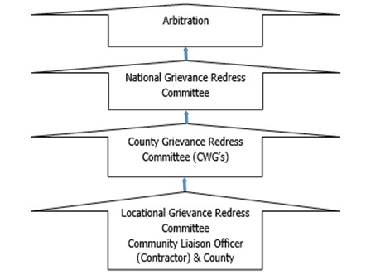

Figure 5: KOSAP Grievance Redress Mechanism
It should be noted that if complainants are not satisfied with the grievance process, even after arbitration they have the right to present their complaint through the court system.
It is expected that most disputes will be resolved at the lowest level-Locational Grievance Redress Committee and since most disputes arise during the Construction and operation period the contractor’s Environmental and Social Safeguard team specifically the Community Liaison Officer will work closely with the community to be able to resolve disputes.
Responsibilities of the Community Liaison Officer include:
- Monitor day to day Implementation of the Project
- Address grievances as they arise on the project.
- A member of the Locational and County Grievances Redress Management Committee to respond on issues that may have been brought to the attention of the committee before escalating to the National Grievance Redress Committee
      - Escalate grievances internally to get a lasting solution.

8.6.8 Existence of a Local Grievance Redress Mechanism in Elgolicha
A Local grievance redress committee was constituted in 2020. The LGRM was not active during the site visit. It is anticipated that the committee shall become active during the construction and operation phase of the project. The LGRM is composed of the following members of the project committee:
      - The area chief.
      - Youth representatives.
      - Female representatives.
      - Male representative; and
      - Vulnerable persons representative
      - A Village Elder.

Contractor will prepare an effective Grievance Redress Mechanisms (GRM) to address and respond to grievances from both the community, the workers, and any other stakeholder.
A Grievance Redress Mechanism (GRM) provides access to remedy and identifies procedures to effectively address grievances arising from project implementation. GRM provides an avenue where people can formally lodge their complaints and grievances and have them properly considered and addressed.

The mitigation measures shall include:
- Prepare a project level timebound GRM in consultation with relevant stakeholders.
- Ensure the project GRM incorporates existing local dispute resolution mechanisms at the lowest tier and allows access to administrative and judicial processes as well as to other redress mechanisms such as meditation/arbitration and the World Banks grievance redress service (GRS) and the Inspection Panel.
- Have a subproject level GRM Focal Point to be responsible for receiving, logging/registering, submitting to the responsible tier for resolution and responding to and updating complainants on resolution status.
- Sensitize all stakeholder categories on the GRM and encourage them to make use of it.
- Ensure the GRM is functional, culturally appropriate, and accessible to all stakeholders without any cost to them and without fear of retribution or reprisal.
- Ensure adequate and proportionate representation of VMGs and vulnerable individuals in the local grievances handling committee.
- Prepare a timebound Contractor’s GRM and sensitize community members and project workers its processes.
- Ensure all reported grievances are logged, dated, processed, resolved, and closed out in a timely manner, or escalated to other levels.
- Ensure the GRM provides for confidential reporting of particularly sensitive social aspects such as GBV, as well as anonymity for those who wish to report anonymously.

8.7 World Bank Grievances Redress Mechanism
The World Bank has established 2 grievance redress mechanisms that provide avenues for individuals and communities to submit complaints directly if there is belief that they have been, or are likely to be, adversely affected by a World Bank-funded project. In this project PAPs and other stakeholders have the right to know and access at no cost these GRMs as described below.

8.7.1 World Bank Grievances Redress Service
The Grievance Redress Service (GRS) is an avenue for individuals and communities to submit complaints directly to the World Bank if they believe that a World Bank-supported project has or is likely to have adverse effects on them, their community, or their environment. The GRS enhances the World Bank’s responsiveness and accountability to project-affected communities by ensuring that grievances are promptly reviewed and addressed. Complaints must be in writing and addressed to the GRS and sent through the following methods namely:

Those aggrieved or their representatives can report their complaints through the following mediums:
          - Online by accessing the online form;
          - (ii) Sending an Email to grievance@worldbank.org; or
          - (iii) Submitting a letter to the World Bank Headquarters in Washington D.C., United States or World Bank Kenya County Office.

8.7.2 World Bank Inspection Panel
The Inspection Panel is an independent complaints mechanism for people and communities who believe that they have been, or are likely to be, adversely affected by a World Bank-funded project. The Panel is an impartial fact-finding body, independent from the World Bank management and staff, reporting directly to the Board. The Inspection Panel process aims to promote accountability at the World Bank, give affected people a greater voice in activities supported by the World Bank that affect their rights and interests, and foster redress when warranted. In September 2020, the Board updated the resolution that created the Panel and added to the Panel functions. At the same time, the Board approved a resolution establishing the World Bank Accountability Mechanism (AM). The new AM began operations in early 2021 and houses the Panel to carry out compliance reviews and a new Dispute Resolution Service (DRS), which will give complainants another way to have their concerns addressed. Contacts for registration of complaints to the IP are.
- Tel: +1 202 458 5200: and
- (ii) Email: ipanel@worldbank.org.

8.8 Government Management of Land Acquisition Disputes
The Environment and Land Court, established under the Environment and Land Court Act 2011, is a superior court (with offices across the country) that hears and determines disputes relating to land and the environment. Likewise, the Land Acquisition Tribunal established under the Land Act 2012; (PART VIIIA 133A) has jurisdiction to hear and determine appeals from the decision of the NLC on the process of compulsory acquisition of land. Therefore, in the first instance, such appeals are referred to the Tribunal. However, a party dissatisfied with the decision of the Tribunal may appeal to the Environment and Land Court on a question of law only. The regulations to set the Land Acquisition Tribunal established under the Land Value (Amendment) Act of 2019 are underway. Besides, the Judicial Service Commission will chair the Land Acquisition Tribunal once operational.

8.9 Labour Influx Management Plan
The purpose of this plan is to provide a clear set of actions and responsibilities for the control of impacts linked to in-migration within the Project’s area of influence. This plan will be regularly reviewed and updated to reflect revised Project design, socio-economic changes and learning experienced during its implementation.
The objectives of this plan are as follows:
- Monitor the scale of project induced in-migration into the project area and specific in-migration ‘hotspots.
- Support local government and communities to manage both internal and external immigration into the project area; and
- Mitigate and manage any negative impacts and enhance and promote any positive impact related to labour influx.
The plan shall consider these measures:
- Prepare and Implement a Labour Management Plan (LMP) with policies and measures for ensuring that:
- Subproject managers and workers are sensitised on:
  - County/National Labour laws
  - County/National Child Labour laws
  - National/International Forced Labour laws
- Enforce:
  - The Code of conduct
  - County/National Labour laws
  - County/National Child Labour laws
  - National/International Forced Labour laws

8.10 Rehabilitation and Decommissioning Management Plan
The rehabilitation and decommissioning management plan include the following:

8.10.1 Planning for Closure
a) The implementing agency shall investigate practical options for closure of the facility at least one year before decommissioning and submit a report to relevant authorities NEMA included.
b) The KPLC shall develop rehabilitation and decommissioning plan in conjunction with relevant stakeholders at least one year before the end of facility’s operations.
c) The KPLC shall explore options of re-use and recycling of the facility’s components/structures.

8.10.2 Decommissioning
a) The KPLC shall take into consideration the health and safety of personnel, contractors, neighbours and the public during the planning and implementation of the demolition process.
b) The KPLC shall undertake a further survey to identify any contaminated areas and remediate them accordingly.

8.10.3 Post Closure
The KPLC shall ensure that the facility’s site is free of impacts associated with the closure and demolition.
The KPLC shall develop, rollout and implement a monitoring plan that includes:
a) Monitoring of the rehabilitated site to confirm whether progress is satisfactory.
b) Outline of how land improvement and future land use will be affected by the past operations and decommissioning of the associated infrastructure.

8.11 Institutional Implementation Arrangements for the Proposed Project
This section presents roles and responsibilities of proponent, implementing agency, supervision consultant and contractor. The project is jointly implemented by the Ministry of Energy and Kenya Power. Specific roles are presented below.

8.11.1 Proponent -Ministry of Energy and Petroleum (MoEP)
The MoEP will provide overall coordination and oversight of the project. MOE will be responsible for overall responsibility for safeguards due diligence, and compliance monitoring. The MOE will also provide funding for the project planning and implementation.

8.11.2 KOSAP Project Implementation Unit
The MOE has already put in place a Project Implementation Unit (PIU) to guide implementation of the project. The PIU is already implementing the project. In the PIU Environmental and Social issues are spearheaded by an Environmental and Social Safeguards Expert whose role is to coordinate and oversee implementation of safeguards. The PIU reports to the MOE.

8.11.3 The Implementing Agency (KPLC)
KPLC will be responsible for implementation and operation of the project on behalf of the MOE. Some of the key responsibilities include but not limited to are.
- KPLC will supervise construction works through a supervision consultant and also directly.
- Monitoring the progress of the project in terms of the safeguards and technical aspects.
- Monitoring of the ESMMP implementation
- Ensuring the project is on course in terms of timelines.

Note: The Solar Mini-grid will be installed operated and maintained by the contractor for the first seven(7) years and then handed over to KPLC engineers and operators. So, for the seven years KPLC will be monitoring the operations of the contractor.

8.11.4 County Government of Mandera
The County government is a key stakeholder. The roles of the county government include giving relevant approvals needed, assisting is process of allocating land for Mini grid, solving grievances that cannot be sorted at project level, monitoring progress of the project among others.

8.11.5 National Environmental Management Authority
This authority is responsible for approval of ESIA report and licensing and is free to check progress of implementation of ESMMP.

8.11.6 Roles and Responsibilities of the Supervising Consultant
- The consultant must appoint an ESHS officer who will be reporting on the ESMMP implementation supervision.
- The consultant ESHS officer be required to generate various reports including production of minutes of monthly site visits and quarterly supervision reports detailing environmental, health, social and safety compliance on quarterly basis amongst other technical aspects.
- Reporting on the ESMMP implementation progress and recommendations.

8.11.7 Roles and Responsibilities of the Contractor
- Implementation of the contractor related aspects of the ESMMP and regularly (monthly) reporting
- The contractor on his part will have to appoint an EHS officer and a Social Specialist to coordinate and report on the ESMMP implementation respectively.
- The contractor to engage a Community Liaison Officer to act as a link between the community and the contractor and support the Social Specialist.
- The contractor will also have the obligation of managing the E&S risks related to his/her operations.
- Maintaining the required level of stakeholder engagement and communication, including providing project schedule information to the public, accepting, and resolving public grievances, advertising, and hiring local workers.
- Maintain a working grievance redress mechanism.
- The contractor is to comply with all regulations and by-laws at the county level and other relevant regulations and laws.
- The contractor shall refer to ESIA recommendations and the ESMMP when preparing the contractors- ESMMP and the specific plans.
- The contractor shall provide water required for use in connection with the works including the work of subcontractors and shall provide temporary storage tanks, if required
- The contractor shall make his own arrangements for sanitary conveniences for his workers. Any arrangements so made shall be in conformity with the public health requirements for such facilities and the contractor shall be solely liable for any infringement of the requirements.
- The contractor shall be responsible for all the actions of any subcontractors whom he subcontracts.
- The contractor shall take all possible precautions to prevent nuisance, inconvenience, or injury to the neighbouring properties and to the public generally and shall use proper precaution to ensure the safety of the community.
- All work operations which may generate noise, dust, vibrations, or any other discomfort to the workers and/or visitors of the client and the local community must be undertaken with care, with all necessary safety precautions taken.
- The contractor shall take all effort to muffle the noises from his tools, equipment, and workmen to not more than 70dBA.
- The contractor shall upon completion of working, remove and clear away all plant, rubbish and unused materials and shall leave the whole site in a clean and tidy state to the satisfaction of the Proponent. He shall also remove from the site all waste.
- No shrubs, trees, bushes, or underground thicket shall be removed except with the express approval of the proponent.
- No blasting shall be permitted without the prior approval of the KPLC and the local authorities.
- Borrow pits will only be allowed to be opened up on receipt of permission from the approving authorities.
- The standard of workmanship shall not be inferior to the Kenya Bureau of Standards where existing. No materials for use in the permanent incorporation into the works shall be used for any temporary works or purpose other than that for which it is provided. Similarly, no material for temporary support may be used for permanent incorporation into the works.
- Disposing of the waste generated during construction activities in accordance with the ESMMP.
- The contractor EHS officer will report on ESMMP implementation during construction period. The aspect to be reported by the contractor will include safety issues i.e. hours worked, recordable incidents and corresponding Root Cause Analysis (lost time incidents, medical treatment cases), first aid cases, incidents and accidents, potential near misses, and remedial and preventive activities required (for example, revised job safety analysis, new or different equipment, skills training etc.); Environmental incidents and near misses; noncompliance incidents with permits and national law; Training on E&S issues (dates, number of trainees, and topics); Details of any security risks; Worker & External stakeholder grievances and E&S inspections by contractor, including any authorities.
Environmental and Social concerns need to be part of the planning and development process and not an afterthought, it is therefore advisable that all the risks and impacts of the project be prevented and mitigated at the earliest opportunity possible to ensure smooth implementation of the project. Finally, a comprehensive Environmental and Social Management and Monitoring Plan (ESMMP) has been prepared and will guide in implementation of mitigation measures.

8.12 Management of Impacts during Operation Phase
The operation phase of the proposed project will be mainly power supply, line maintenance and clearing of wayleaves. A contractor (contracted to run the plant for a number of years before handing over to KPLC) will be responsible for all the mitigation measures for negative impacts during the operation phase for the first seven years after which responsibility will be KPLC. This will be done by implementation of the following steps:
- Inspections.
- Corrective action.
- Reporting.

CHAPTER NINE

9.0 IMPACT SUMMARY AND CONCLUSION

9.1 Conclusion
During the preparation of this report for the proposed development, it is observed and established that most of the negative social and environmental impacts can be mitigated and have potentially short term low significant effects. The positive impacts are highly rated and will benefit the community at Elgolicha and the county at large. The project proponent, the implementing agency and the contractor must adhere to prudent implementation of the social and environmental management and monitoring plan. The contractor should commit to obtaining all necessary permits and licenses from the relevant authorities and have qualified and adequate personnel to do the project as proposed. The ESIA has proposed adequate safety and health mitigation measures as part of the relevant statutory requirements.

The analysis of the ESIA has demonstrated that the construction and operation of the proposed Solar Mini-grid will have positive impacts to the government and Kenyan society at large. The impacts will include Increase in reliable and sustainable clean energy, employment to local community members, increase in the national/local investment, increase in government revenue, improvement of standards of living for Elgolicha residents. However, despite the outlined positive impacts, the proposed development will cause some negative impacts such as; noise, dust generation, soil erosion, oil spills, fire hazards, electrocution, shocks, solid waste generation, occupational health hazards, social risks such as labour influx, demand for resources, gender-based violence, conflicts, public health impacts (HIV & AIDs, Covid 19) among others that need to be avoided, reduced and mitigated against.

It is the duty of NEMA to consider licensing the project subject to EIA study; in accordance with the Environmental Management and Coordination Act, EMCA of 1999 and its Amendment, 2015 and the Environmental Impact Assessment and Audit Regulations, Legal Notice No. 101 of 2003.

An Environmental and Socio- economic Management Plan (E&SMP) outline has been developed to ensure sustainability of the project area activities from construction through operation to decommissioning. The plan provides a general outlay of the activities, associated impacts, mitigation action plans and appropriate monitorable indicators. Implementation timeframes and responsibilities are defined, and where practicable, the cost estimates for recommended measures are also provided.

A monitoring plan that highlights some of the environmental performance indicators that should be monitored has been developed. Monitoring creates possibilities to call to attention changes and problems in environmental quality. It involves the continuous or periodic review of operational and maintenance activities to determine the effectiveness of recommended mitigation measures. Consequently, trends in environmental degradation or improvement can be established, and previously unforeseen impacts can be identified, or pre-empted and mitigation measures proposed.

From the findings of this study, the following conclusions are made:
- The proposed project will generate socio-economic benefits which would not be realized if the ‘NO development option’’ is considered.
- The beneficiary community has been consulted among other stakeholders and project information shared including the negative impacts and the views of the stakeholders is that the project is long overdue.
- The potential adverse impacts associated with the proposed project are possible to mitigate successfully. The impacts before implementation of mitigation measures are assessed as very low to medium low and the ratings are expected to improve further with the implementation of the proposed mitigation measures.
- The impacts that will be adverse will be temporary during the construction phase and can be managed to acceptable levels with the implementation of the recommendation of the mitigation measures for the project.
- The project will be designed, constructed, and operated according to the acceptable industry norms and standards. Successful implementation of the proposed ESMMP will ensure environmental sustainability.

The proposed project design has integrated mitigation measures with a view to ensuring compliance with all the applicable laws and procedures. The Solar Mini-grid and associated structures will be installed to the required planning/architectural/structural designs and standards. During project implementation, operation and decommissioning stages sustainable environmental management would be ensured, avoiding inadequate use of natural resources, conserving nature sensitively and guaranteeing a respectful and fair treatment of all people working on the project, general public at the vicinity and the expected beneficiaries of the project.

In relation to the proposed mitigation measures that will be incorporated during construction, operational and decommissioning phases; the development’s input to the society and environment; the project is considered beneficial and important.

9.2 Recommendations
It is strongly recommended that a concerted effort is made by the implementing agency in particular, to implement the Environmental Social Management and Monitoring Plan provided herein. Following the commissioning of the project, statutory Environmental and Safety Audits shall be carried out in compliance with the national legal requirements, and the environmental performance of the site operations should be evaluated against the recommended measures and targets laid out in this report.

9.3 Recommendations
- The KPLC and the contractor must adhere to relevant legal and regulatory framework to ensure compliance and success of the project.
- Adherence to the mitigation measures as spelt out in the ESMMP and monitoring of the same is mandatory to ensure environmental and social sustainability of the project.
- Cultivate and maintain a good working relationship with the community members.
- Ensure social inclusion of the vulnerable groups by paying attention to the most vulnerable and provide ready boards as spelt out.
- Contractor to plant trees in construction phase to promote environmental sustainability.
- Stakeholder engagement to the carried out throughout the construction and operation and decommissioning phases.
- Contractor to ensure grievance redress mechanism is established and operational.
- Environmental Audits should be carried annually or as prescribed by the Authority during the operational phase and invitation of Inspectors and Experts from NEMA to ascertain compliance with the provided ESMMP and set NEMA regulations and Standards.
- Diligence on the part of the contractor and proper supervision by the KPLC is crucial for mitigating the potential impacts and ensuring structural strength, safety, and efficient operation of the project.

9.4 Authorization Opinion
In terms of NEMA requirement the environmental practitioner is required to provide an opinion as to whether the activity should or should not be authorized. The expert is reticent to venture such an opinion since we are not an elected entity mandated to make decisions on behalf of authority. Nevertheless, in this section a qualified opinion is ventured and in this regard the Lead expert believes that sufficient information is available for NEMA to take a decision. The fundamental decision is whether to allow development which brings socio-economic advantages and is consistent with planning and certain development and social responsibility and upliftment of policies, but which may impact on an area as a result of negative impacts identified. The Lead Expert believes that the ESIA have shown that the applicant’s preferred alternative and technological alternatives are generally acceptable. The ESIA has also assisted in the identification of essential mitigation measures that will mitigate the impacts associated with the project to within acceptable limits.

In conclusion, the expert is of the opinion that on purely ‘environmental’ grounds (i.e., the project’s potential socio-economic and biophysical implications) the application as it is currently articulated in the applicant’s proposal should be approved provided the essential mitigation measures are implemented. It is in the opinion of the Environmental Consultant that the anticipated negative impacts can be readily and effectively mitigated, and the proposed project does not pose any significant threat to the Environment and may be licensed to proceed.

Appendix 1:ESIA Stakeholder meeting minutes
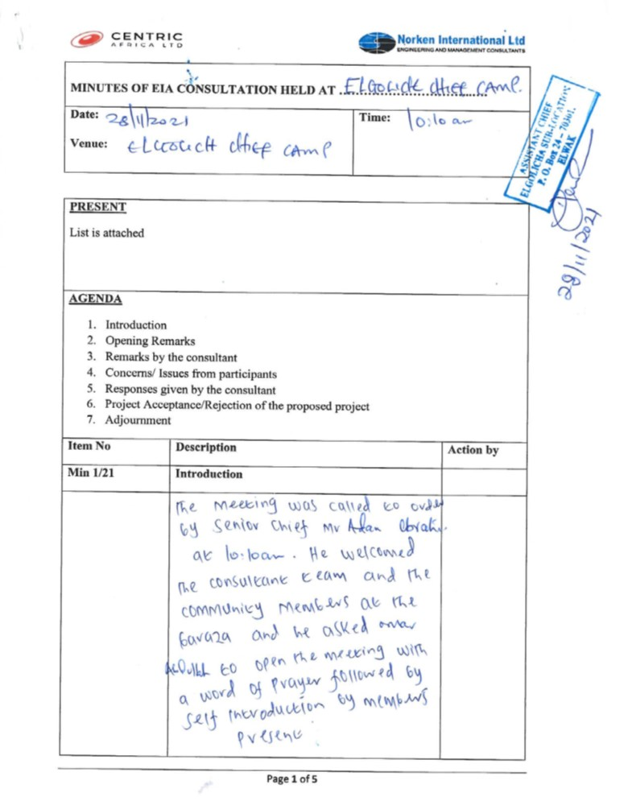
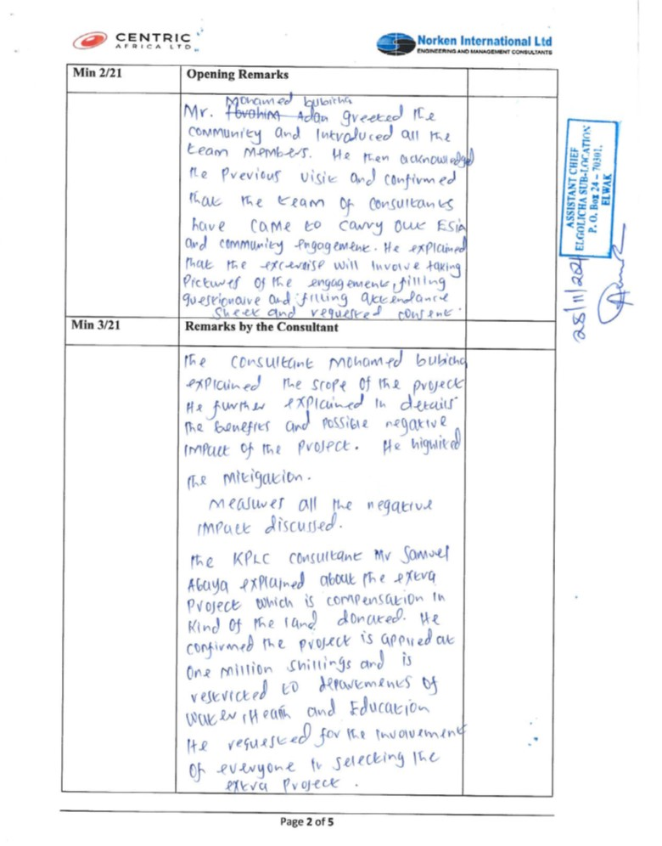
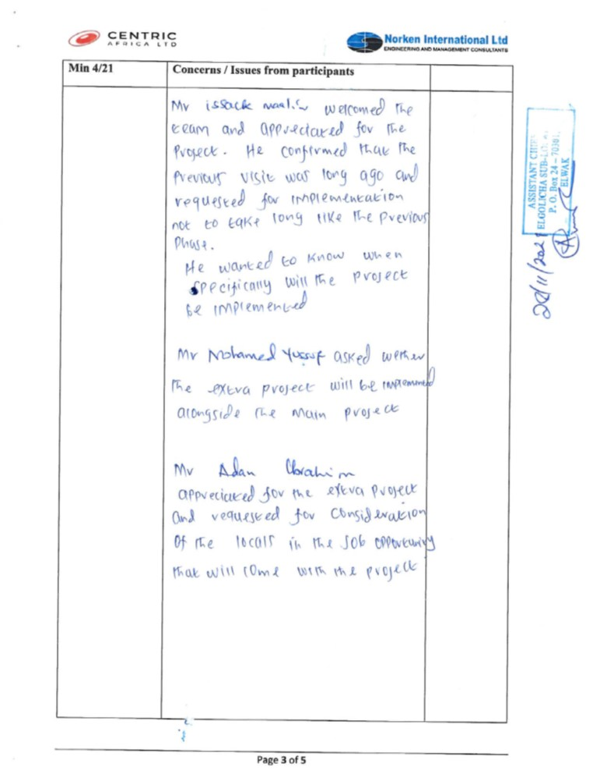
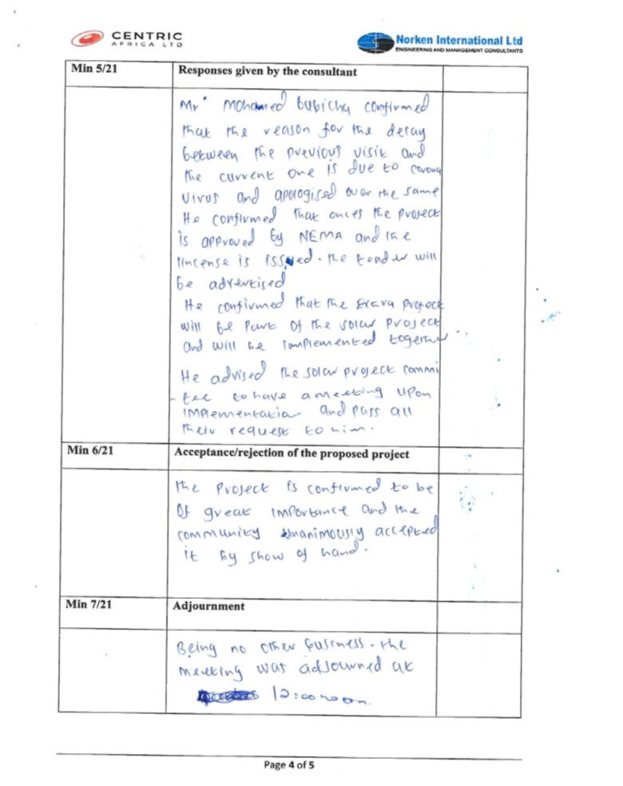
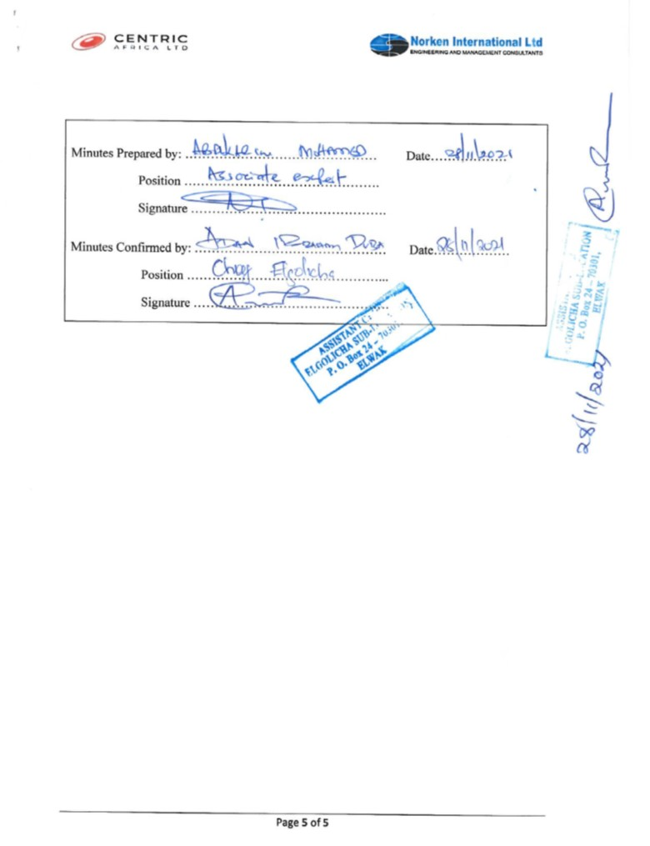

Appendix 2:ESIA Stakeholder meeting attendance List
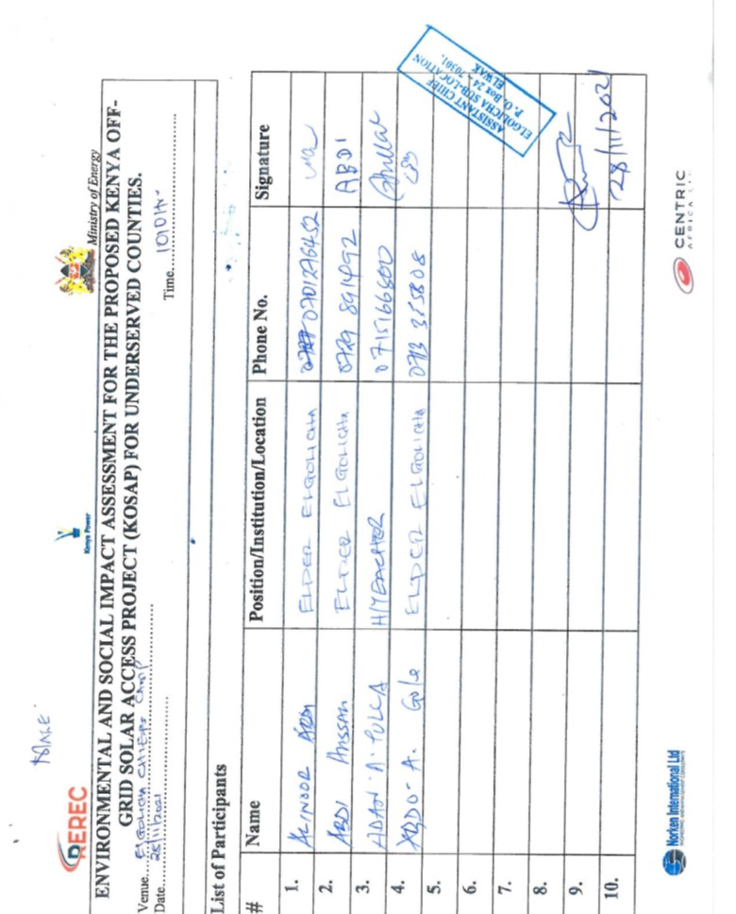
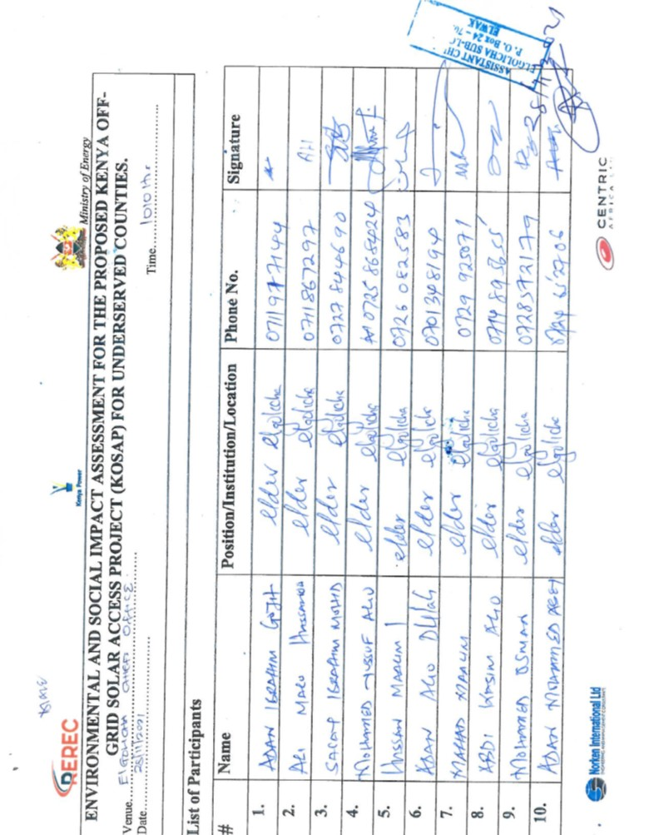
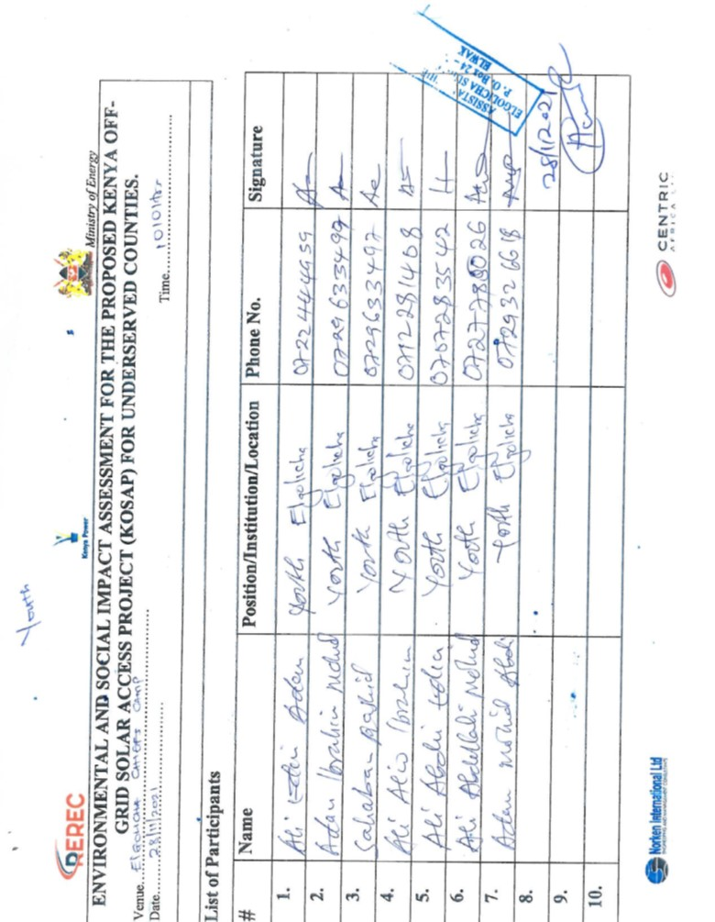
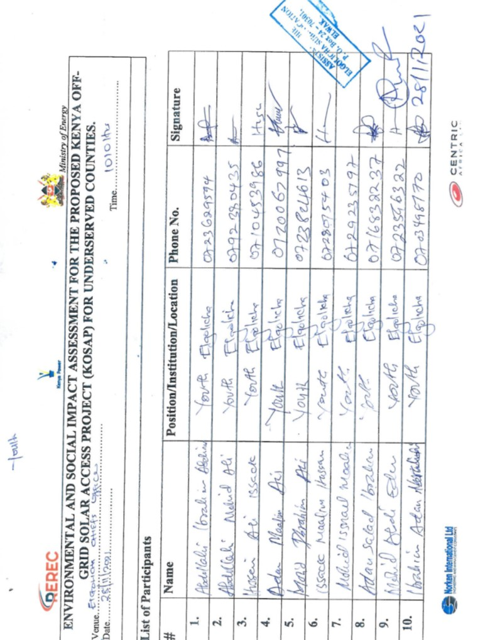
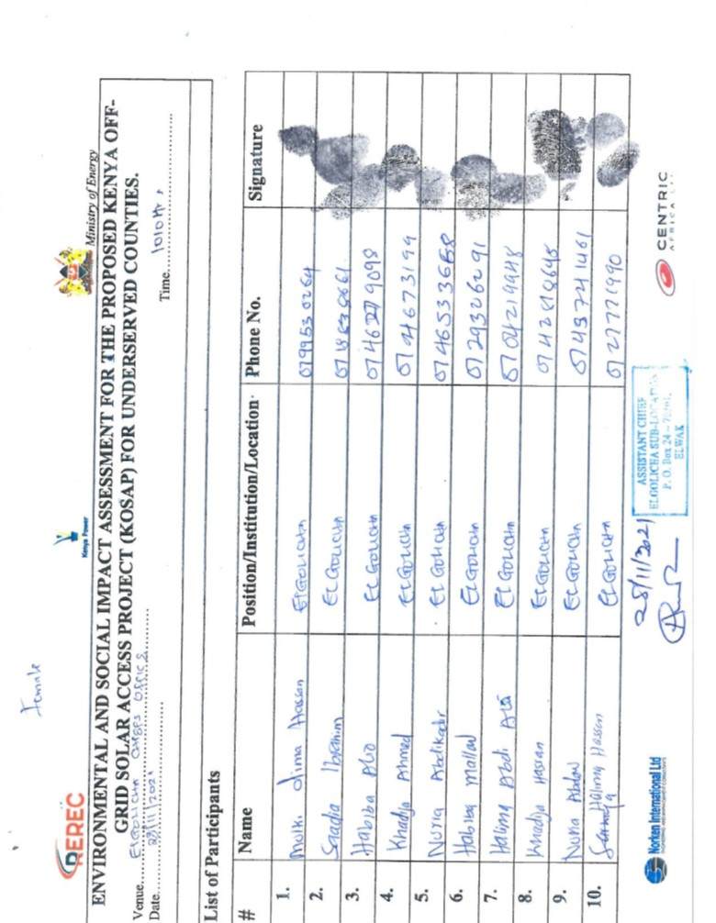
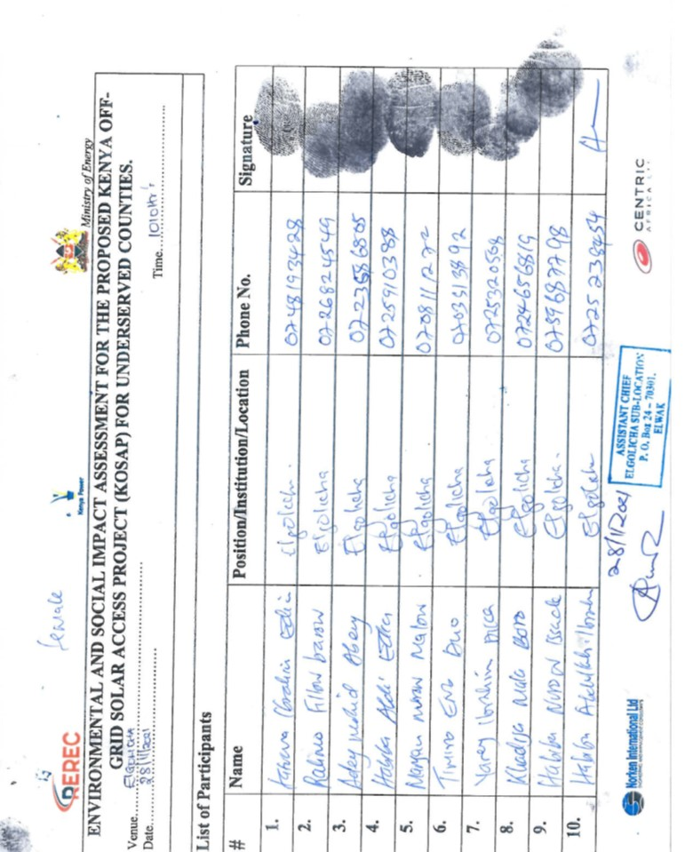
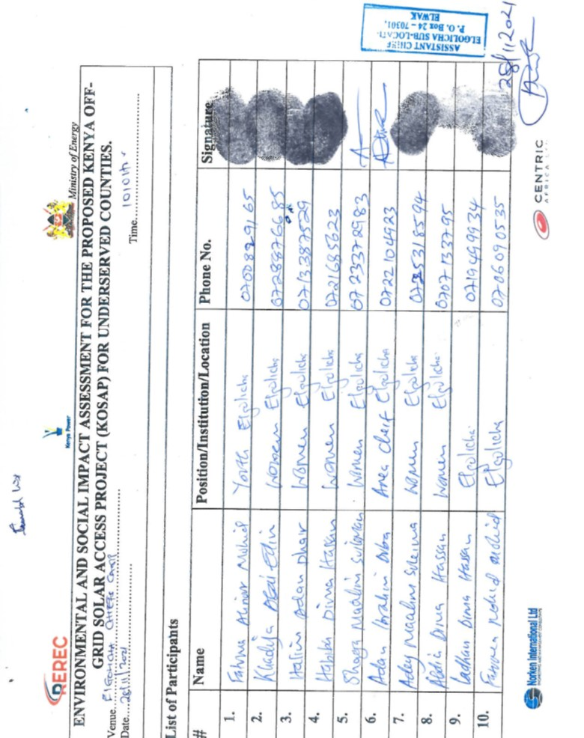
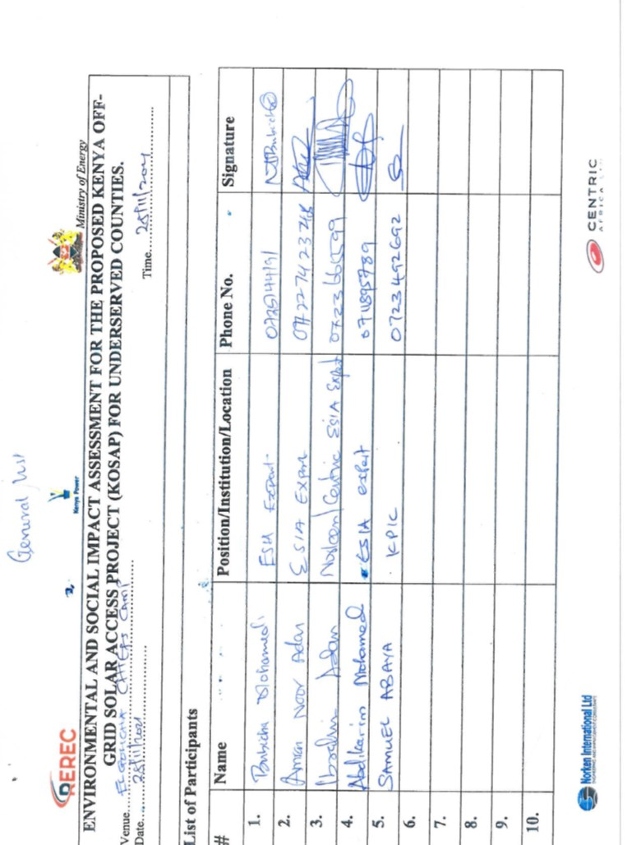
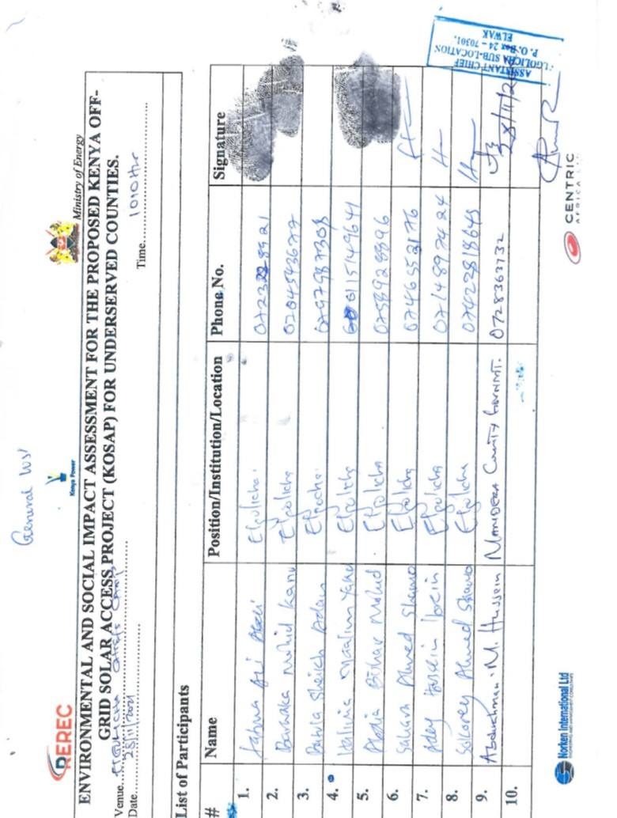
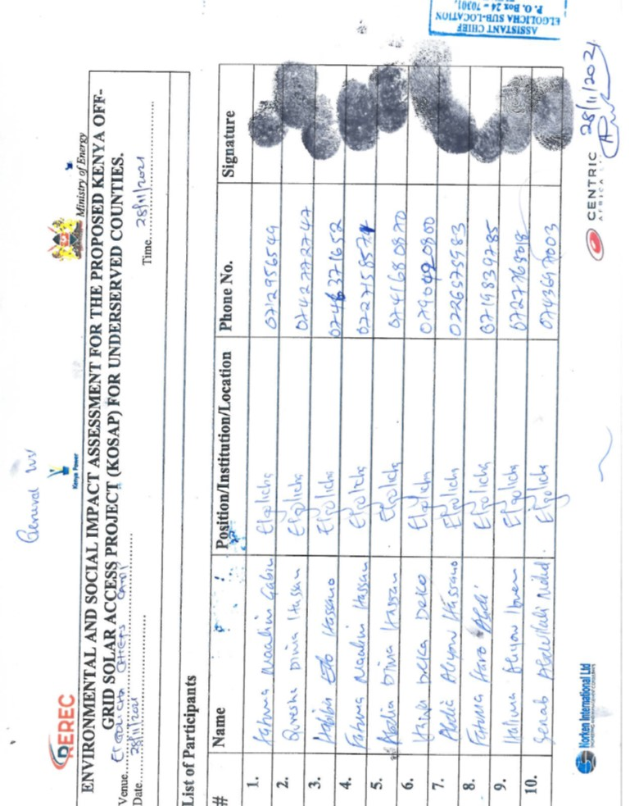
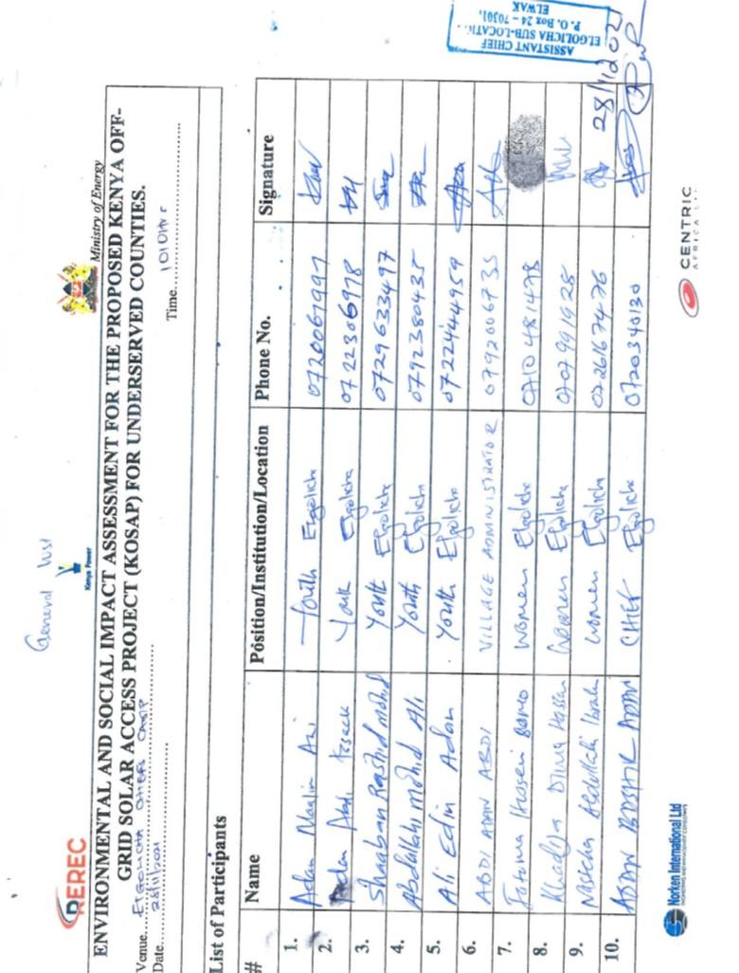
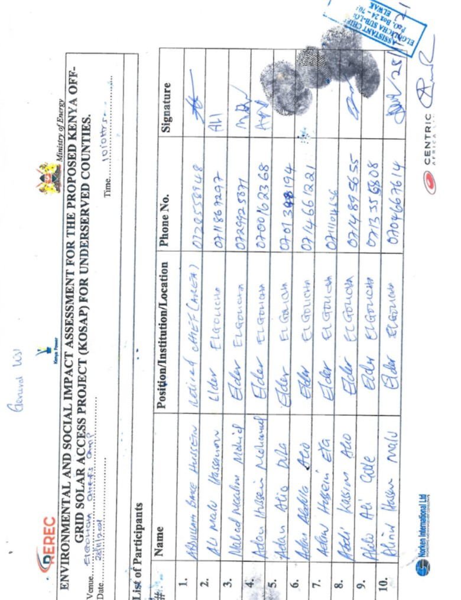
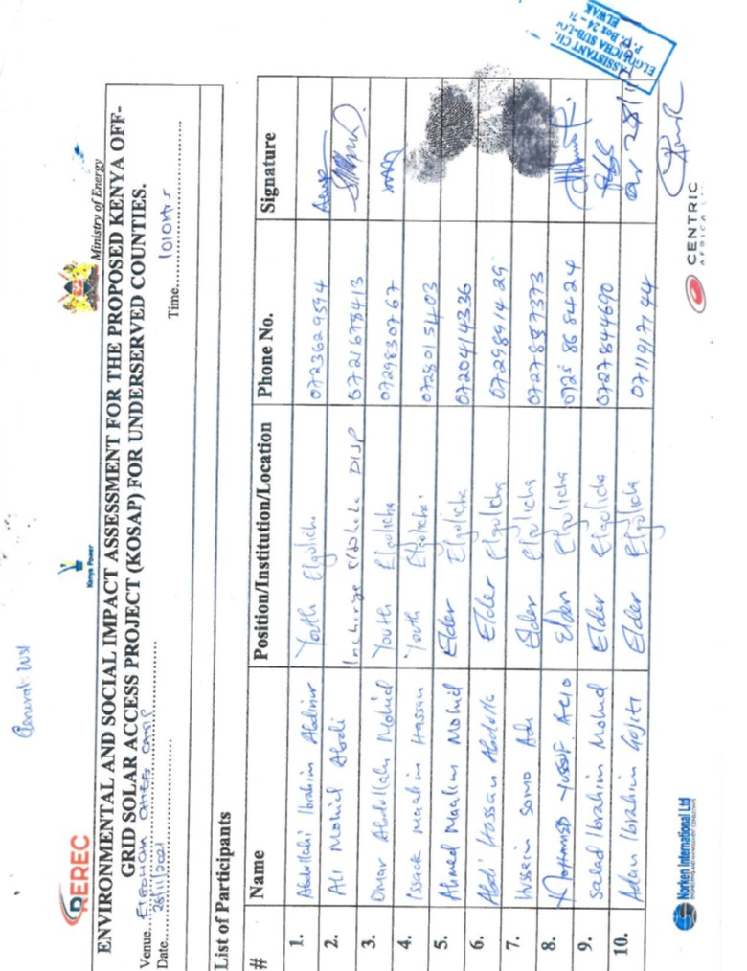

Appendix 3: Land allocation meeting minutes
Meeting with Mandera key stakeholders
a) Meeting with the County commissioner
The KOSAP project team (MOE, REREC & KPLC officers) paid a courtesy call with the Mandera County commissioner on 24th February 2020. The main agenda was to brief him on the objective of the project team’s visit to the County. The Commissioner welcomed the team and asked someone to pray before the introductions. He asked the County Executive Member (CEC) for Energy to introduce the project team and invite the team leader to give the agenda of the visit. Brief introductions were done and the CEC noted that the county welcomes the project and indeed the project team and are in full support of the project and because the county had low electricity access levels which also hinders economic growth. He invited the team leader Dorothy from (MOE) to give the agenda of the visit. She appreciated the welcome to the county and noted that the National Government had partnered with World Bank and conceptualized a project by the name KOSAP (Kenya Off-grid Solar Access Project) which is targets 14 counties in Kenya that have been defined as marginalized or underserved by the Commission on Revenue Allocation (CRA).

She said the proposed project is being implemented jointly by the Ministry of Energy, the Kenya Power and Lighting Company (KPLC) and the Rural Electrification and Renewable Energy Corporation (REREC) in partnership with the World Bank as a development partner, County Government as a partner and the communities in Off-grid areas being the beneficiaries. She added that Off-grid areas are those places where the National Electricity Grid has not reached, and whose electricity access has been very low. The reason for choosing solar energy was because these area are far from the national grid and the fact that the area is well endowed with natural sunlight for many hours. She further explained that the proposed Solar Mini-grid will be put up and low voltage electricity lines which will be constructed to enable connection of electricity to beneficiaries/household.
She noted that NRECA (a consultant) had visited the area earlier to check demand for the project and said that the County will benefit from 30 Solar Mini-grids to be funded by the KOSAP project. She said that the project was in the preliminary implementation stages and outlined the agenda of the visit was to:
- Undertake an environmental and social screening of the proposed sites to check suitability in terms of environmental, technical, social and health requirements.
- Undertake community engagement to sensitize the community on the project including its positive and negative impacts
- Explain the land requirements for the project and sensitize the community on their rights in regard to land donation and let them know that they have a right to either donate the land or not to the project so that they can make an informed decision.
- Need to set up Grievance Redress Mechanism for the project.
- Guide the community in electing Grievance Redress Mechanism committee members and sensitize the members of their work during project implementation

Dorothy briefed the commissioner on the progress of KOSAP project and noted that the project was at the stage of land acquisition for the solar Mini-grids. She noted the project appreciates various methods of land acquisition and in KOSAP the government was extending a hand of partnership with the community by asking the beneficiary community to voluntarily donate land for the proposed solar Mini-grid project.

The commissioner noted that his office is in support of the project including providing security during all the phases of the project. He noted consultations with the target community is very crucial because it helps in creating ownership of the project among community members and support from the same community.

b) Meeting with the Mandera County Secretary
The KOSAP project team (MOE, REREC & KPLC officers) met with Mandera county secretary who was holding brief for the Governor on 24th February 2020. The main agenda was to brief them on the progress of KOSAP project and on the need for community engagement in regard to the project. The main agenda was to brief him on the objective of the project team’s visit to the County. The county secretary welcome the team and thanked the County Executive Member (CEC) for Energy to introduce the project team and invite the team leader to give a brief of the agenda of the visit.

She noted that NRECA (a consultant) had visited the area earlier to check demand for the project and said that the County will benefit from 30 Solar Mini-grids to be funded by the KOSAP project. She said that the project was in the preliminary implementation stages and outlined the agenda of the visit was to:
- Undertake an environmental and social screening of the proposed sites to check suitability in terms of environmental, technical, social and health requirements.
- Undertake community engagement to sensitize the community on the project including its positive and negative impacts
- Explain the land requirements for the project and sensitize the community on their rights in regard to land donation and let them know that they have a right to either donate the land or not to the project so that they can make an informed decision.
- Need to set up Grievance Redress Mechanism for the project.
- Guide the community in electing Grievance Redress Mechanism committee members and sensitize the members of their work during project implementation

The Secretary appreciated the team and noted that the project is long overdue and needs to be fast tracked. He noted that the County supports the project and is looking forward to its full implementation.

c) Meeting with the Deputy County Commissioner (DCC) Mandera West
The KOSAP project team (MOE, REREC & KPLC officers) was divided into three teams to carry out the assignment at the Sub county levels. The team that was sent to Mandera West Sub-County paid a courtesy call to the DCC on 25th February 2020. The main agenda was to brief him on the objective of the project team’s visit to the sub-county. The main agenda was to brief him on the progress of KOSAP project and on the need for community engagement in regard to the project. The DCC welcomed the team and asked them to be free while working in the sub County. The team leader (Wilfred-KPLC) gave a brief of the agenda for the visit by highlighting the following;
He noted that the MOE had contracted NRECA (a consultant) who had visited the area earlier to check demand for the project and said that the sub county would benefit from six solar Mini-grids to be funded by the KOSAP project. He said that the project was in the preliminary implementation stages and outlined the agenda of the visit was to:
- Undertake an environmental and social screening of the proposed sites to check suitability in terms of environmental, technical, social and health requirements.
- Undertake community engagement to sensitize the community on the project including its positive and negative impacts
- Explain the land requirements for the project and sensitize the community on their rights in regard to land donation and let them know that they have a right to either donate the land or not to the project so that they can make an informed decision.
- Need to set up Grievance Redress Mechanism for the project.
- Guide the community in electing Grievance Redress Mechanism committee members and sensitize the members of their work during project implementation

The DCC told the team that his office was ready to support the project especially on providing security to the team as they do the community engagements. He asked the team to be free and consult his office anytime to ensure the project is a success. He also asked the team to fast track the project so that the communities can enjoy clean source of power.

Minutes of community consultation meeting leading to voluntary land donation and Grievance Redress committee constitution

Project: Proposed Elgolicha Solar Mini-grid
Venue of meeting; Elgolicha village in Mandera South Sub-County of Mandera County

Date: 2/3/2020

AGENDAS
- Preliminaries
- Project description
- Positive Impacts of the project –Solar Mini-grid
- Negative Impacts of the project and mitigations measures
- Need for land for the project
- Grievance Redress Mechanism for the project
- Environmental and social screening of the sites

Minute 1/KOSAP/2020: Preliminaries
Opening prayer by Sheikh while translations into the local language was done by Siyad and one of the elders.
The chief called the meeting to order at 11.00 a.m. He welcomed the project team and also the community members and thanked all for attending the meeting. The chief then welcomed Mr. Siyad Director from the Ministry of Energy Mandera County to give the agenda of the meeting and introduce other officers in the project team.

Siyad thanked the elder and the community members for turning up for the meeting. He explained that he had come with other officers to talk to the community on various issues in line with the proposed Solar Mini-grid. He allowed the other team members to greet the people and make brief introductions. He told the community that each would be given a chance to talk on specific areas in line with the project. During this session Siyad was speaking in the local language while the chief was translating into Kiswahili. Below is a list of KOSAP team members and county officials present.

KOSAP team
S/No | Name | Profession | Organization/County
1 | Siyad Mohammed Ali | Director -Energy water and natural resources (Environmentalist) | County government of Mandera
2 | Hussein Abdinoor | Surveyor | County government of Mandera
3 | Wilfred Koech | Environmentalist | Kenya Power & lighting Company -KPLC
4 | Rachel Kisiangani | Physical planner | KPLC
5 | Roseline Njeru | Socio Economist | KPLC
6 | Innocent Nyangau | Engineer | REREC

Siyad (director) explained that the national government is implementing KOSAP in partnership with County Government in 14 counties that are far away from the national grid. He said the proposed project is called KOSAP-Kenya Off-grid Solar Access Project. He said that the project was in the preliminary implementation stages. He noted that the NRECA and the county government in partnership with the community elders of the different areas had identified about 30 sites in Mandera County to set up the Solar Mini-grids.

He further noted that the agenda of the visit was to undertake an environmental and social screening of the proposed sites to check suitability in terms of environmental, technical, social and health requirements. He said the second objective was to undertake community engagement to sensitize the community on the project. The other objective was to explain the land requirements for the project and the need for a project grievance redress mechanism. He reiterated that the county government of Mandera is in support of the project and that they are open to give assistance and information about the project to the community members during office working hours. He then invited Wilfred (KPLC) to explain and give more details about the project

Minute 2/KOSAP/2020: Project Description
Wilfred from KPLC described the proposed project i.e. Solar Mini-grid under KOSAP as follows.
He informed the community that the project called -KOSAP is being implemented jointly by the Ministry of Energy, the Kenya Power and Lighting Company (KPLC) and the Rural Electrification and Renewable Energy Corporation (REREC) in partnership with the World Bank as a development partner, County Government as a partner and the communities in off-grid areas being the beneficiaries. Off-grid areas are those places where the national electricity grid has not reached, and whose electricity access has been very low. The current project is being implemented in fourteen (14) counties in Kenya.
The reason for choosing solar energy was because the area is far away from the national grid and the fact that the area is well endowed with natural sunlight on high temperatures. He explained that the government’s target is to achieve universal access to electricity by 2022 using various sources and solar energy is one of the identified sources because it is also clean energy. He further explained that the proposed Solar Mini-grid will be put up and low voltage lines will also be constructed to enable connection of electricity to beneficiaries/customers.

Mini grids will entail the installation of solar PV (panels), battery storage and a backup thermal diesel unit. He explained to them that once constructed the Solar mini-grid will be operated by the implementing agencies either KPLC or REREC and the community will be expected to pay for connection of electricity (one thousand shillings) and do wiring in their houses. He told them that once connected, the beneficiaries will be expected to pay for electricity consumed.

He noted that the proposed Mini-grid will have a capacity of about 50kWp and the low voltage/supply lines will cover a radius of 3km from the solar plant to connect the target customers. He told them that once connected, the beneficiaries will be expected to pay for electricity consumed and that the tariff employed will be the same as what other Kenya Power customers are paying.

He told them that connection of power will involving passing of electrical lines along the roads in order to reach their house and the route for passing the lines is called way leave. He noted that once the designs are done, the community will be notified of the exact routes during future consultations and that they will be required to give consent. He noted that the project will not compensate for way leaves due to budget constraints so that they can make an informed decision when the time comes.

Mr Innocent –Engineer from REREC cautioned the community members against interfering with the electricity poles and stays to avoid accidents. He requested them to support the contractor during construction works to enable timely delivery of the project.

Minute 3/KOSAP/2020: Positive Impacts of the project
Koech explained that, every project has both positive impacts and negative impacts. Our assignment is to explain to you the impacts of the project so that you understand how the project will benefit you and the community at large and also explain to you the negative impacts of the project and the mitigation measures. The project benefit both direct and indirect are as follows:
- Better source of lighting- replacement of Kerosene lamp and small de-lite lamps with electricity lighting which is clean and has better lighting
- Benefits to education- provide source of lighting which enables pupils and students to take advantage of longer hours of preps/study in school and at homes. Electricity will be useful in availing power needed to enable use of radio and television sets. Once parents are able to buy these gadgets pupils can access electronic educational forums and materials even through cyber cafes
- Business opportunities-Power provides energy needed to power some gadgets that are difficult and expensive to power with generators. Access to electricity will therefore allow the community to take advantage of new business opportunities and enhance the existing ones e.g. Barber shops, salons, posho/maize mills, welding, photo copying, printing, fuel stations, milk coolers and fridges to preserve meat among others. He asked the community to take advantage and set up some of these businesses
- Employment and wealth creation- community members will get opportunities to provide non-skilled and skilled labor during construction and operation phases of the project
- Local Material Supplies and other requirements- the proposed project provides opportunities to supply some materials available locally
- Up Scaling Electricity Access to the off-grid areas- this area is far away from the grid and so the proposed project helps to reach this area faster and in a cost effective manner as opposed to grid connections.
- Impact on HIV/AIDS-due to availability of power, communities can purchase communication equipment like radios and televisions which in turn provides access to information on various issues such as health topics on HIV/AIDs, nutrition, farming and the current Covid-19 pandemic among other information
- Health benefits of the project- health benefits of the project includes replacement/elimination of use of kerosene lamps and candles, no need to use fuel generators which emits smoke causing respiratory diseases, the health Centre will also benefit from power that can be used to preserve drugs and vaccines alongside powering other medical equipment.
- Improved standard of living- Living standards of the community is bound to improve as they take advantage of small house hold appliances like e.g. TV, Fridges, radios, blenders, iron boxes e.t.c.
- Security- Enhanced security due to improvement in lighting up of the area through the street lights. Improved security also means more hours of business. The place will also be safe as lighting puts off opportunistic thieves who take advantage of darkness.
- Communications- improved communication due to availability of electricity to charge phones, opportunities to set up information communication and technology related business like cyber cafes, access to E-government services among others.
- Presence of electricity will also attract other business investors to invest in the area

Minute 4/KOSAP/2020: Negative impacts of the project
Koech told the community that projects also have negative impacts. The proposed solar Mini-grid will have the following negative impacts and I will present them alongside their mitigation measures.

 | Negative impact | Mitigation measures by contractor
1 | Vegetation clearance | - Clear only the areas that are needed to put up the mini-grid  - After construction, do landscaping with grass to areas that have no electrical installation as opposed to living areas bare  - Planting trees
2 | Air pollution dust from construction activities | - Fence off construction site to reduce dust going to the public  - Use of masks for workers
3 | Air pollution dust from construction vehicles | - Limit vehicle speed to minimum possible when passing residential areas
4 | Air pollution from vehicle emissions | - Maintain vehicles/service vehicles  - No idling of vehicles
5 | Solid waste | - Clear all solid waste and dispose appropriately
6 | Land use. | - Land acquisition is being progressed through WB guidelines on Voluntary land donation (explained to the community)  - The MOE has guided that not physical relocation of families or assets should take place  - If you choose to donate land ensure the land identified will not result to relocation of persons or households ad or assets.  - The current uses of land will not be available once the solar plant is installed so put that in consideration
7 | Occupation safety and health hazards e.g. accidents, fall from heights, pricks by sharp objects | - Allocating work according to skills  - Use of proper personal protective equipment like gloves, overalls, helmet, safety shoes  - Toolbox talks to workers to identify hazards and risky activities
8 | Social Risks Related to Labour Influx - With an increase in the population of the area boosted by the project employees the social set up of the area may be affected including conflicts related to pressure on resources | - Recruit from the local community as much as possible to reduce labour influx  - Conduct periodic sensitization forums for employees on the need to respect the values for community  - Consultations with and involvement of local communities in project planning  - Contactor shall make provision to provide resources needed by the workers if the need for such resources in the community may result to competition e.g. water  - Establishment of an effective Grievance Redress Mechanism accessible to community members  - Working closely between contractor and the project grievance redress committee to address complains on time.
 | HIV/AIDS, communicable and sexually transmitted diseases (STDs). | - HIV/AIDs awareness to community  - Offer guidance and counseling on HIV/AIDS and other STDs to employees.  - Provide condoms to employees
 | Gender-based violence; Sexual Harassment and Abuse and Sexual Harassment (These are potential impacts of a project related to labour influx. | - Awareness to community  - All cases should be reported to chief or the grievance redress committee members or to community elders  - contractor to have code of conduct for the workers  - GBV management action plan, including mitigation, response and a GRM  - Ensuring survivor based approach in responding and managing of GBV incidences
10 | Child labour | - Employment of children is illegal  - Report any case to the chief’s office
11 | Demand for Material/resources e.g water | - Contractor to consult with elders before using the water resources in the community to avoid conflicts  - Source materials from approved sites
12 | Oil Spill Hazards | - Contractor not to repair vehicles or equipment on site  - Maintain vehicles and equipment in good state
13 | Storm water and erosion | - Contractor to put measures to harvest rainwater and control erosion during construction
14 | Wastewater/ effluent | - Provide sanitation facilities for workers
15 | Noise resulting from excavation machinery, vehicles and workers | - Work only during the day  - In case of blasting contractor to give notice to community through the village elders and chiefs office
16 | Open excavations | - Barricading any open excavations with tape  - Controlled access to the construction site
17 | Visual Impacts | - Fencing off the solar power plant to keep off
18 | Hazardous materials from damaged Panels- Photovoltaic panels may contain hazardous materials, and although they are sealed under normal operating conditions, there is the potential for environmental contamination if they were damaged or improperly disposed upon decommissioning.  -Batteries | - Proper planning and good maintenance practices can be used to minimize impacts from hazardous materials.  - Proper disposal of used or Damage solar batteries and panels using NEMA registered disposers for such wastes
19 | Fuel (oil)/ storage on site | - Proper maintenance fuel storage tanks and dispensing system  - Bundled wall 1.5 times the fuel storage tank

Public safety in regards to electricity
Koech educated the community by highlighting the importance of using electricity safely. He said electricity is good but failure to take the precautions while interacting with it can result in electric shocks, fires and even electrocution/death. He emphasized the following precaution/preventive measures to observe in order to prevent risk of electric shocks, fires and electrocutions.
- Engage a certified technician to do wiring in your premises
- Use quality materials while wiring
- Do not engage in individual illegal extensions of power lines to other houses
- Don’t touch sockets and switches with wet hands or wipe with wet cloths
- Do not tie your livestock on electric poles
- Do not cut earth wires that run along some electric poles
- Do not touch any electric wire if you find it fallen on the ground
- Report any incident regarding electricity at the local office –staff in charge of operating the Mini-grid
- Vet all new people coming to the village by checking whether they registered their presence with the office of the chief.
- In case of a black out do not open sockets or switches

Minute 5/KOSAP/2020: Land requirements for the project
NOTE: the project team together with community members visited the identified sites before converging for the meeting.
Rachel explained that the proposed project requires about 2-5acres to set up the solar mini-grid. She noted that basic requirement is that the land need to be fairly flat, accessible, and free from disputes/encumbrances; not affected by shadows from natural features like hills and or structures, within 3km distance to the target beneficiaries; and not on the road/riparian reserve.

She added that there are three main land categories in Kenya which are private land, public land and community land. She told the community that from the discussions held during the site visits land in their area can be categorized as community land. She added that such land and its use and management is governed by the Community Land Act 2016. According to the said Act, the County Government of Mandera holds the land in trust for you/community especially if the land is not yet registered. However, the County government cannot sell, dispose, transfer, and convert for private purposes or in any other way dispose off any unregistered community land that it is holding in trust on behalf of the communities for which it is held. The rights of ownership of land when it is communal land it belongs to the community.

She educated the community on the following issues in regards to their rights, entitlements and roles in the project;
- The various forms of acquiring interest in land such as; allocation by the owner, land adjudication process, compulsory acquisition, settlement programs, transfers, donation and long term leases.
- Importance of public participation by key stakeholders including community members during the planning and operation phase of the project.
- You have a right to give your views, opinions or fears on a proposed project
- You have a right to accept or refuse the project
- You have a right to compensation for your land under the Kenya law. The various options for compensation for land include land for land, cash or in-kind compensation
- If you donate land, the ownership of the land will be transferred to KPLC and that the project will be managed by KPLC
- You have a right to choose whether to donate land or not to the project
- The community/beneficiaries of the project will pay Ksh 1000 for power connection and also pay for consumption of power to KPLC
In the event the community seeks compensation the options include cash payment in line with the Community Land Act 2016, on how cash compensation for unregistered community land is managed. The county government holds in trust for a community any monies payable as compensation for compulsory acquisition of any unregistered land. The monies are deposited in an interest earning account. Once the community is registered, the county government then releases to the community such monies payable for compulsory acquisition including the interests earned. The second option is compensation for land which involves identifying another piece of land to be purchased. The third option is compensation in kind e.g. getting a project in exchange.

She asked them about the ownership of the portion they had identified and proposed to donate to the project. One of the elders noted that another team had come to the village before on the same project and we had showed them the two sites so that they can choose one because all the land here belong to us as a community.

She reiterated that the government of Kenya had secured a loan from it development partner i.e. World Bank to implement the KOSAP project. She explained that the government was extending a hand of partnership with the community to donate land for setting up the solar mini-grid and that the government was not in a position to pay compensation for the land due to budgetary constraints.

Land required –criteria.
The impacts must be minor, that is, involve no more than 10 percent of the area of any holding and require no physical relocation.
- The land required to meet technical project criteria must be identified by the affected community, not by line agencies or project authorities (nonetheless, technical authorities can help ensure that the land is appropriate for project purposes and that the project will produce no health or environmental safety hazards).
- The land in question must be free of squatters, encroachers, or other claims or encumbrances.
- Verification (for example, notarized or witnessed statements) of the voluntary nature of land donations must be obtained from each person donating land.
- If any loss of income or physical displacement is envisaged, verification of voluntary acceptance of community-devised mitigatory measures must be obtained from those expected to be adversely affected.
- If community services are to be provided under the project, land title must be vested in the community, or appropriate guarantees of public access to services must be given by the private titleholder. KOSAP project proposes to have the land donated to be registered under one of the implementing agencies of the project i.e. KPLC but be assured that public access to services is guaranteed to the community members.
- We need to set up a Grievance mechanisms to help in addressing any issues/grievances that may arise in the course of the project implementation.

Rachel asked the community to confirm that the land is communally owned and whether they had agreed to donate land for the Mini-grid. The community members unanimously confirmed that the land belongs to the community and agreed to voluntarily donate the land for the solar Mini-grid. As a sign of commitment, the community elders signed a land donation form on behalf of the community to indicate that they had agreed to donate the land voluntarily.

She also explained to them that the ownership of the land where the project will be put up needs to be registered under one of the implementing agencies (KPLC/REREC).

Survey of the land and request for advance possession.
The surveyor (Hussein) explained to the community that once agreed the surveyor will need to pick exact GPS points of the agreed area so that the process of land acquisition may start leading to titling of the land. He noted that the process of land acquisition, land surveying and land transfers are long and requested the community for advance possession. The community agreed to the advance possession.

The team leader (Wilfred) explained to the community that the rationale and importance of sharing all that information was to facilitate the community in making informed decisions about the project and also on land donation. Further, he made it clear to the community that they had the power of choice on the project which meant that the community had the option to agree or disagree with the land donation request.

Minute 6/KOSAP/2020: Grievance Redress Mechanism
Roseline explained that in a project, grievances may arise and it important to have a grievance redress mechanism that is known to all the community members, accessible with no costs to the community members. Before explaining how to set the GRM, Roseline asked the community to explain how they deal with grievances/issues at the village level.

Existing grievance redress mechanism in the village.
One of the elders noted that there exist elders in the community who provide leadership to the community. These elders are responsible for dealing with conflicts or grievances or any issue in the village. Any of the grievances that is difficult to resolve is referred to the office of the chief. He added that most of the grievances are solved by the elders and we rarely have any cases going to the chief.

Project GRM:
Roseline explained to the community that it is important to put in place a project grievance redress mechanism (GRM). She noted that the GRM to be set should borrow heavily from the existing conflict resolution structures in the community. She explained that the need for a GRM is to provide the community and other stakeholder’s opportunity to share project information and raise questions and grievances about the project. She told the community that they are free to raise any complain or request information about the project. She explained that the project will have a three-tier grievance redress mechanism as follows.

- Locational grievance redress committee. This is the community level/site specific/project committee whose members were chosen by the community during the community engagement meeting. The membership comprises; elders, representatives from women youth, special needs (persons with disability), religious leader-sheikh and the chief. This will be the first stop for receiving information and raising grievances. It is hoped that most of the grievances will be resolved at this level.
- The second level of grievance redress will be the county Grievance Redress committee comprising members of the county working group. This committee is at the county level and will resolve complains or issues that could not be resolved at the locational/project level. The community Liaison officer together with a representative of the community from the Locational GRC will forward issues/ complains to the county grievance redress committee and will also be responsible for giving feed back to the local committee.
- The third level will be the National GRC comprising of KOSAP project implementation Unit at the ministry of energy and the implementing agencies. Matters that could not be resolved at the county level will be escalated to the National GRC.
- The last level of the GRM for the community or project affected persons will be arbitration or legal redress in a court of law.

She explained further that members of the project/ grievance redress committee will be chosen by the community members themselves. The committee chosen will be in charge of giving project information to the community and be a focal point for reporting project related issues of concern or grievances. She added that the composition of the committee should have representatives from all groups in the community including men, women, youth and persons with disability.

The chief then invited the Elwak sub county police commandant (who together with other officers had accompanied the project team due to security issues) to give some remarks. He said that security is of importance and they should raise any issue in good time to that the project is not delayed because of security issues. The sub county criminal investigator told the community that they need to support the project because they are the main beneficiaries.

Plenary session
Siyad explained to the community that community engagement and consultations will continue throughout the lifetime of the project. He then summarized the agenda of the meeting and the proceedings and invited community members to a plenary session to ask questions and or make any comments. The outcomes of the plenary are presented in the table below.
Question and answers
Name of Person making the contribution (e.g. comment or question) | Question, Comment, Suggestion | Feedback/Responses by project team | Response by agency on how feedback will be used or acted upon
Zahgra Hassan | We thank you and the national government for bringing us power. | Noted | Need to fast track the project will be communicated to project coordinator.
 | Now that you have brought us power can we use it to pump water because we have some shallow wells | Yes if the well is within th project coverage of 3km. we shall bring the power then you buy the pump and make arrangements to pay for electricity consumptions | -
 | We don’t have many questions we just need the power | Noted | -
Maalim Mohammed | We thank the national and county government for the project |  | -

Appendix 4: NEMA ESIA Expert License
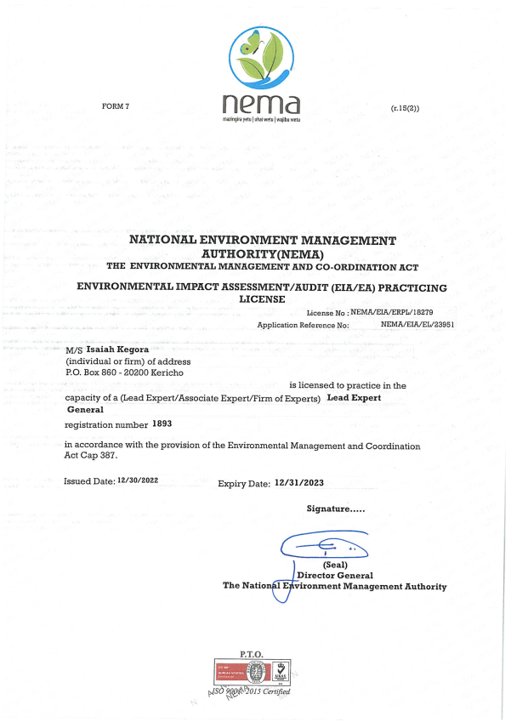
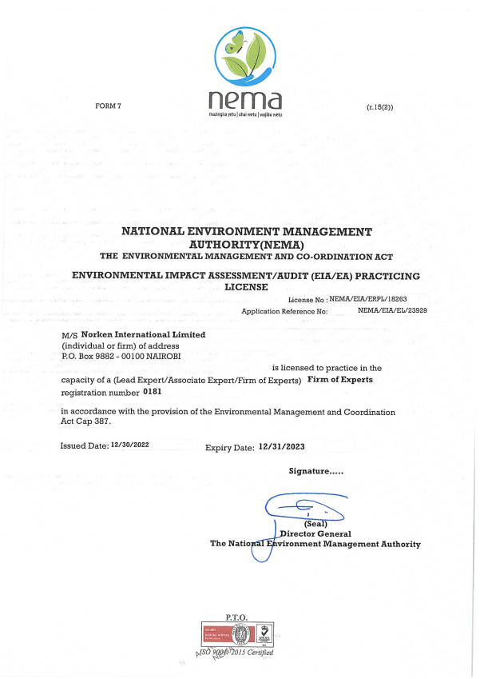

Appendix 5: Abbreviated Resettlement Action Plan(A-RAP)

- Elgolicha Sub-project Site
The Elgolicha sub-project site is on unregistered community land and held in trust by the County Government of Mandera on behalf of the community, in line with the Community Land Act 2016. The proposed site is uninhabited, has no structures, community facilities, or encumbrances, utilized by the community for grazing. Consultations leading to the identification and selection of the sub-project site are captured in the Environmental and Social Screening report for Gas. Refer to Chapter 4 of the ESIA for the comprehensive socio-economic profile.

- Actual Census Survey of PAPs and Valuation of Affected Assets
The number of project-affected persons (PAPs) is 2000 (approximately 200 households). The land acquisition-related impacts are loss of land and pasture. Mitigation measures include in-kind compensation for loss of land and pasture, and designing power distribution lines to avoid impacting trees, crops, structures, and community facilities. No physical displacement is anticipated; however, there is minimal loss of pasture occasioned by the acquisition of land utilized by the community for grazing. The 2.02343 Hectares identified for the sub-project will be acquired compulsorily by the National Land Commission (NLC). The proposed site will be valued and compensated in line with the provisions of the Resettlement Policy Framework (RPF) prepared under KOSAP. Refer to section 2.2 of the ESIA for project location (Figure 2: Proposed site for the Elgolicha Solar Mini-grid.)

- Compensation Measures Agreed with the PAPs and other Resettlement Assistance to be Provided.
The proponent requested the community identify three priority projects, whereby one out of the three would be provided as in-kind compensation for loss of land and pasture. The Elgolicha community proposed drilling of community boreholes within the village. The value of the priority community project will be proportional to or higher than the value of land under acquisition. In addition, loss or damage to crops, trees, structures, and community facilities will be compensated in line with the provisions of the RPF, and as summarized in the entitlement matrix below.

3.1 Entitlement Matrix

Types of Impact | Person(s) Affected/Eligible for Compensation | Compensation/Entitlement/Benefits | Responsible organization
- Loss of Land
Loss of unregistered community land. | Community. | Compensation in-kind as prioritized by the community. | KPLC
Loss of land in unregistered group ranches. | Group ranch members. | Compensation in-kind as prioritized by the community.
Loss of land in registered group ranches. | Group ranch members. | Compensation in-kind as prioritized by the community.
Loss of land owned by the National Police, county governments and the Ministry of Interior | Government agencies. | No compensation for public land allocated to another government body.
Loss of land owned by the Kenya Forest Service (KFS) and Kenya Wildlife Service (KWS). | Government agencies. | No compensation for public land allocated to another government body. However, payment of conservation fees to KWS and KFS as stipulated under their respective regulations is foreseen.
- Loss of Use on Land
Loss of use on public land (e.g., grazing, farming etc.). | Communities utilizing public land. | Communities do not own public land; however, they utilize public land with consent from the relevant agencies. The project will implement the infrastructure project prioritized by the community as compensation for the loss of public land use. | KPLC
Loss of use on unregistered community land, unregistered group ranches and registered group ranches ( e.g., grazing, farming etc.). | Communities utilizing unregistered community land, unregistered group ranches, and registered group ranches. | Compensation in-kind as prioritized by the community.
- Loss of /Damage to Assets on Land
Trees | Community members on unregistered community land; community members utilizing public land; members of registered and unregistered group ranches and government entities. | During detailed design for power distribution lines and construction of the mini grid and community project, any crops, structures, trees, and community facilities shall be avoided to the extent possible. However, loss or damage to the above will be compensated/restored at full replacement cost, in line with the provisions of the RPF. | KPLC
Crops
Structures
Community facilities e.g., water sources (earth pans, boreholes etc.). | Community members on unregistered community land, community members utilizing public land, and members of registered and unregistered group ranches.

4. Consultations with PAPs About Acceptable Compensation Options and Alternatives that have been Considered
Detailed consultations with PAPs on land acquisition and compensation, including the modalities of acquiring land and compensation options, were undertaken during the Environmental and Social Screening, Environmental and Social Impact Assessment, and the NLC land valuation process. The following sections provide a summary of the consultations.

4.1 Engagement of Project -Affected Persons (PAPs)
Local administration and County Renewable Energy Officers (CREOs) supported the proponent and implementing agency (IA) to mobilize community members and other stakeholders for public consultations and engagement activities. National and county government entities, community segments (men, women, youth, elders, persons with disability, vulnerable and marginalized groups, etc.), NGOs, and local leaders were engaged through key informant interviews, community meetings, and focus-group discussions. The proponent and IA implemented appropriate measures to ensure PAPs effectively participated in the consultations. Refer to Chapter 6 of the ESIA on public consultation and engagement.
Once the compensation award and Bill of Quantities (BoQs) are known, the Implementing Agency (IA) will engage the community and agree on the community project to be executed as in-kind compensation. During these consultations, the IA and the community will define the roles and responsibilities of the community in monitoring the implementation of in-kind compensation and maintenance once the IA hands it over to the community. Thus, the IA and the community will effect an agreement to be signed by the local leadership; representatives of the Grievance Redress Committees at the locational, county, and national levels; A-RAP Implementation Committee, and Implementing Agencies.

4.2 Identification of Community Representatives
The Elgolicha Locational Grievance Redress Committee (LGRC), constituting a chairperson, secretary, and three members, was formed through community consensus. The committee’s membership comprises men, women, youth, persons with disabilities, and ethnic minorities. The LGRC is responsible for engaging PAPs and resolving complaints. Refer to Chapter 8.6.7 of the ESIA on the Grievance Redress Committees. Further, the community will constitute the A-RAP Implementation Committee responsible for coordinating community engagements on the A-RAP and monitoring the implementation and closure of the A-RAP. The representation of the committee will consider gender, vulnerability, and intergenerational sensitivities.

4.3 Summary of Consultations on Land Acquisition and Compensation Options
Date | Objective | Implementing  Entities | Land Acquisition and Compensation Aspects  Discussed | Key Issues Raised | Responses  Given
February 27th 2020 | Environmental and Social Screening.  Voluntary land donation (VLD).  Constitution of the Locational Grievance Redress Committee (GRC). | Ministry of Energy (MoE)  Kenya Power (KPLC)  Rural Electrification and Renewable Energy Corporation (REREC) | Site identification and land allocation for the sub-project.  Criteria for VLD.  Community entitlements (forms of compensation and implications for each). | None | None
November 28th 2021 | Environmental and Social Impact Assessment. | Consultants  MoE  KPLC  REREC | Land acquisition through compulsory acquisition (not voluntary land donation).  Selection of three priority community projects, whereby one is to be implemented as in-kind compensation for land. | Community requested for drilling of community boreholes within the village. | The proponent has set aside KES 1 million to implement the priority in-kind compensation project.  The value of the project will be proportional to or greater than the value of land.  NLC will determine the value of land.
TBC | Compulsory Land Acquisition. | NLC | Site inspection and inquiries.  Land valuation.  Award of compensation.

5. Institutional Responsibility for Implementation of the ARAP
Entity | Role
Ministry of Energy | - Coordinate A-RAP implementation and provide budget for in-kind compensation.
National Land Commission | - Implement the statutory process for compulsorily land acquisition, including site gazettement and inspections, inquiries, valuation, and award of compensation.
Kenya Power | - Monitor all land acquisition and compensation aspects (including A-RAP closure), complemented by a third-party monitor.  - Provide budgets for stakeholder engagement, grievance management, and monitoring, including the facilitation of the Land Acquisition and Compensation Implementation Committee, and the Grievance Redress Committee.
Mini-grid Contractor | - Implement in-kind compensation concurrently with the solar mini-grid project.
Supervising Consultant | - Monitor and report on implementation of in-kind compensation, and overall project compliance with social safeguards.
Grievance Redress Committees | - Formed at the locational, county, and national levels, and responsible for resolving complaints, including A-RAP related grievances.
A-RAP Implementation Committee | - Coordinate A-RAP engagements at the community level, monitoring A-RAP implementation and closure.
Affected Community | - Responsible for the operation and maintenance (O&M) of in-kind compensation project. An agreement stipulating the O&M roles and responsibilities of the community will be affected.

6. Procedures for Grievance Redress
The Project procedures for grievance redress were established through a public consultation process and informed by the existing conflict resolution structures in the community. The Grievance Redress Mechanism (GRM) comprises tiers at the project, county, and national levels. Refer to Chapter 8.6.3 of the ESIA for a detailed GRM.

7. Implementation Timetable and Budget for the ARAP Implementation

7.1 Timelines
The proponent will commission the community project by May 25th, 2025, before operationalizing the mini-grid. The mini-grid contractor will implement the mini-grid and the community project simultaneously. The Supervision Consultant and IAs will implement a commitment register to ensure the mini-grid contractor can achieve the agreed-upon milestones. The register will be complete with clear and practical timebound indicators, which can be monitored by all parties – the PAPs, IAs, the Ministry, third-party monitor, and the Bank.

7.2 Budget
The proponent has set aside KES 1 million for the community project (budget captured in the ESMP). The compensation award from NLC and the Bill of Quantities will inform the final cost of the community project. The costs for in-kind compensation, stakeholder engagement, grievance management (including the facilitation of the GRCs and the A-RAP Implementation Committee), and monitoring are covered under the project.

A cost basis that will yield compensation sufficient to replace assets, plus necessary transaction costs associated with asset replacement).

